This is our style image to be used on the front of T-shirt



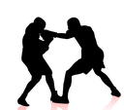

KICKBOXING

----- Australian Institute of Combat Sport ------

Below are the links to the images I have found on the internet


http://pixgood.com/kickboxing-vector.html

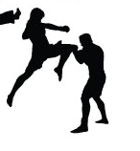

http://arsenal.gomedia.us/product-tag/muay-thai/

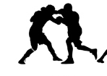
http://www.vectorstock.com/royalty-free-vector/boxing-silhouettes-vector-1216951

