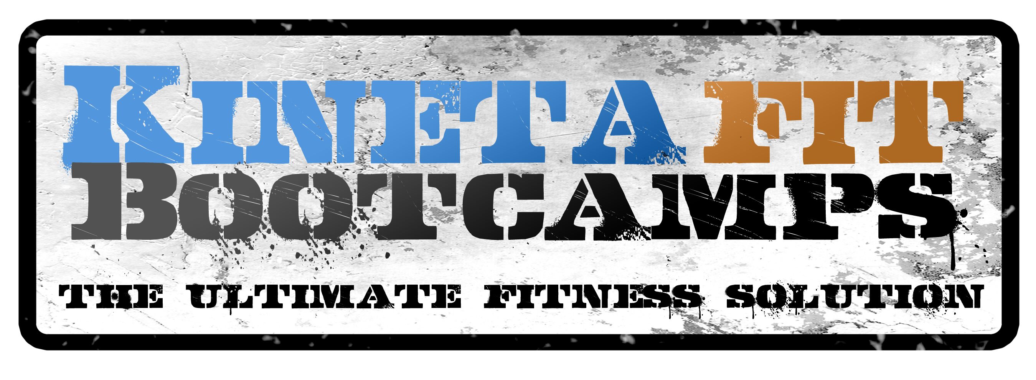

Fitness Boot Camp Schedule

Monday-Friday

6am, 8:30am, noon, 4:30pm, 5:30pm, 6:30pm

Saturday

9am

Sunday and Major Holidays

Closed

*All Boot Camps are 50 minutes in length

