Project: Create logo for Mirus Global

Business name | Mirus Global
Description of Business | We are a global venture acceleration network investing in technology, healthcare, and education
Industry | Financial
Keywords | venture capital, venture capital funding, entrepreneurs, startup, multi-stage investment firm, early stage, growth equity, Mirus Global, venture capital India, venture capital Israel, venture capital Singapore
Values to Communicate | - Corporate/Professional  - Modern  - Edgy but Classy  - Quiet  - Simple  - Subtle
Branding Ideal | Elements set in a dynamic tech savvy aesthetic that communicates a cutting edge yet professional essence. Interweaving elements subtly hint at ideals of networking and a coming together of knowledge and resources. Vibrant colors accent stoic corporate tones to balance the perception of fresh thinking with reliability
Preferred Logo Types | - Mixed (Combination Mark): Includes an image or shape that is easily recognizable.  - Image or icon to be used in future App and potential background image  See samples below:  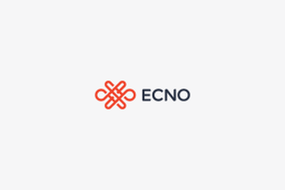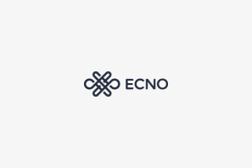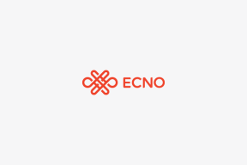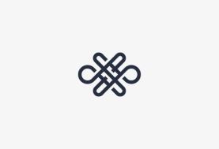  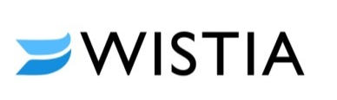    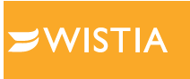    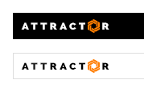
Sample Logos | 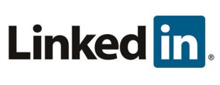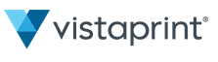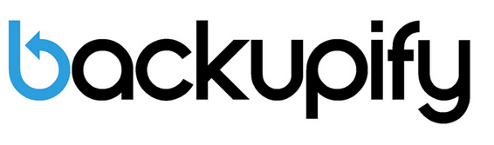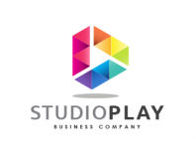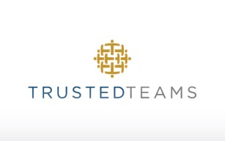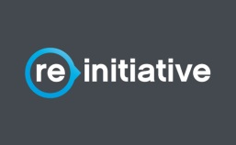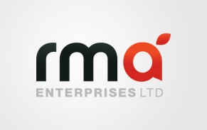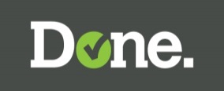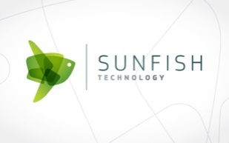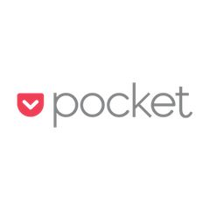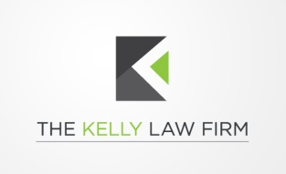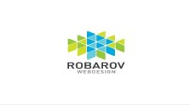
Color Preferences | Blue, Green, Orange - but we are open to something new and fresh.  Preference for one or two color logo, that can be easily used on white or color backgrounds
To Be Used On | - Print (Business cards, letterheads, brochures etc)  - Online (Website, online advertising, social media, banner ads etc)  - Signs (tradeshow displays, building signs, billboards etc)
Format Needed | Designer to provide:  - type face and color pallet (HEX, RBG, PMS, CMYK )  - Color logo, b/w logo, and greyscale  - Files:  - AI, illustrator native  - EPS, printing vector  - JPG print  - PNG web format  - SVG web format for responsive design  - TIFF uncompressed print format  - PDF high res, print

