Percheron Logo Inspiration Photos
I would like an abstract logo of a Percheron horse that is inspired from either a side view or front view of the horse. Ideally the logo is a simple series of lines that conveys the strength of this horse. Please note that the Percheron is a particular breed of horse that is stronger and more muscular looking than the typical horse—please ensure this is expressed in the logo design.

Front View Option:
For this version, I would like a partial front view like the first example below.
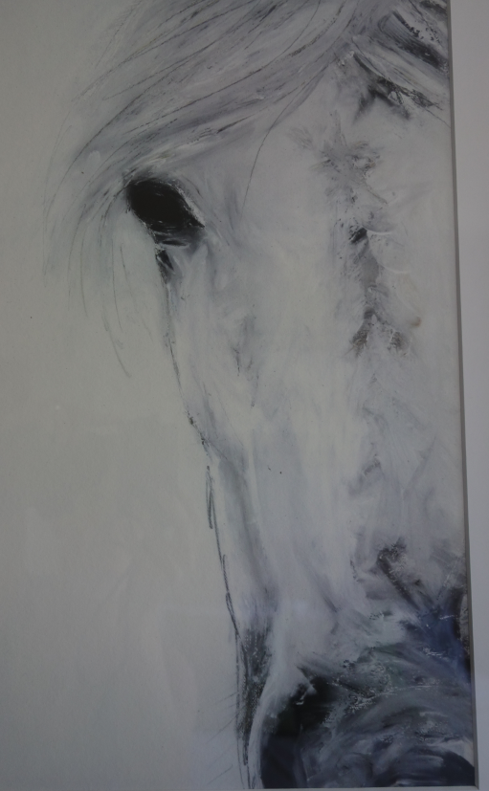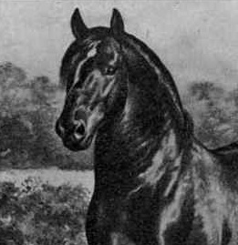

Side view option:
Side view should be facing right as in the first example below.

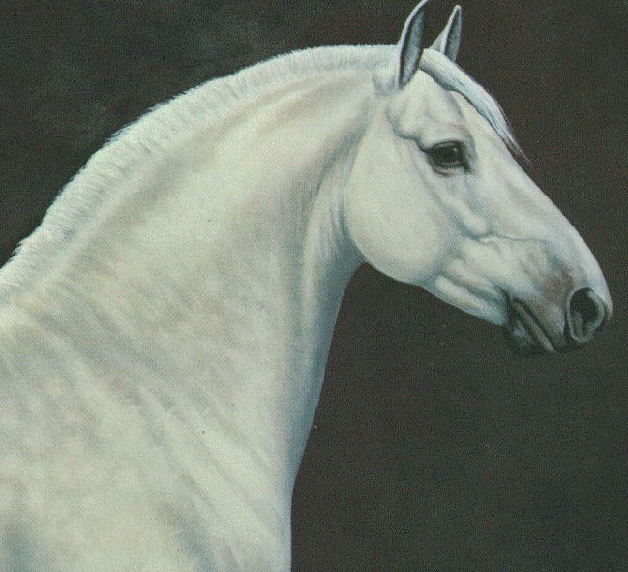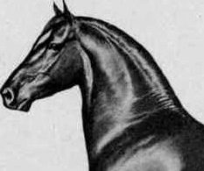

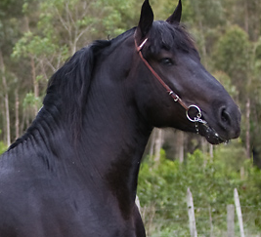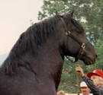
(no bridle or halter in the graphic please—these two are just for inspiration)

Desired Logo Style:
Horse Graphic
PERCHERON
CONSULTING

