Our Network
Interoute owns the largest pan-European lit-fibre Next Generation Network, covering the majority of Europe, from London to Warsaw, from Stockholm to Sicily and beyond into the emerging economies of South Eastern Europe.
The network is also linked to North America's major telecoms hubs through our transatlantic capacity, and we serve as a bridge between Europe, North Africa and the Middle East, with a fully operational Point of Presence in the Arab world's most dynamic international hub, Dubai.
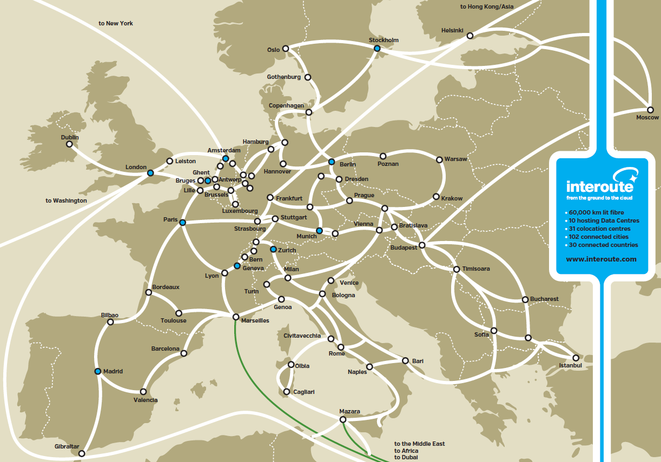
NETWORK FOOTPRINT |Fully owned and close to your offices
The network footprint runs more than 60,000 kilometres with backbone/long-haul connectivity to 100 cities and metropolitan area networks (MANs) in 21 of those cities. The building assets comprise over 100,000m² of space ranging from carrier specification up to world class Data Centre grade.
With operations in 30 countries, and with over 200 points of presence (PoPs), Interoute has both the extensive reach and the depth to meet customer requirements at minimal cost. The combined assets represent a total investment in excess of €2.7 billion.
Why Interoute?
“We are a professional and innovative company that actively looks to the future when developing and producing durable household goods. Interoute has shown that it can take into account our need for support with our time critical business applications. That is one of the reasons why we opted for Interoute when selecting a network operator."
Robert Borst, ICT Manager at Brabantia

