Bull Work Bench ™

Model TTLS730
Strong, Durable, Affordable.
- Australian Hardwood bench top.
- The Bull Work Bench is made from a 40 mm galvanized and powder coated tubular steel.
- 1800mm long, 730mm width, and 900mm height.
- Benches can be supplied with quality lockable roller castors.
- This model is fitted with a lower shelf for additional storage space.
- Bench tops are available in Australian Hardwood, Steel and Stainless Steel.
- A range of powder coated colours are available.
- Designed and Manufactured in Australia.
- Vice displayed is an optional extra.

USES.
- Sawing, Sanding, Painting, Drawing, Carpentry, Sheet metal work, Mechanical repairs.
- Sowing, Quilting, Gardening, Electrical Hobbies, Soldering,

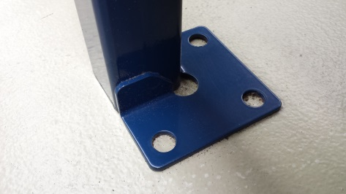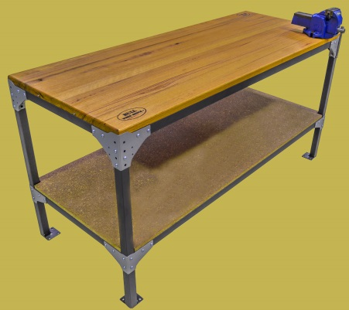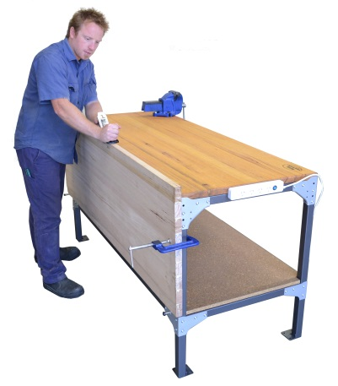
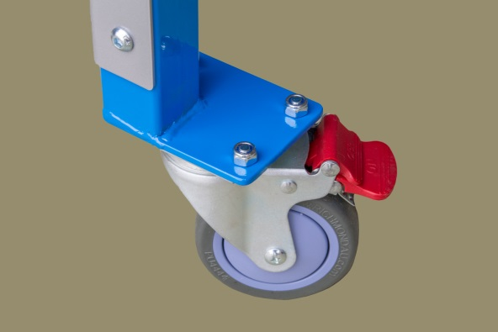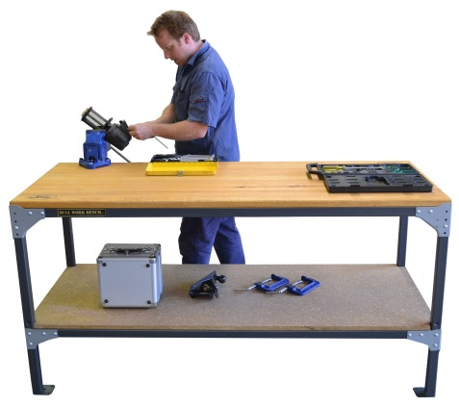
www.bullworkbench.com.au
03 9785 2274
sales@bullworkbench.com.au

