Brand Identity Development

1). Company Name Kindermatica Ltd.
Mobile app developer, specializing in apps for kids (aged 1-8 years).

2). The main mission of the company is to assist parents and teachers in education, development and upbringing kids, defining their abilities and talents with the help of modern technologies (with priority given to mobile apps).

3). Main products: Apps for kids
The company is developing of a range of apps that are united in one educational program which covers all main knowledge and skills of kids up to 7-8 years. The program will offer a set of age appropriate apps/tasks with the target on specific skills or knowledge and will enable parents to control kid’s progress and control the program itself, assisting busy parents in education and engaging kids in useful activities

4) Main features of the company products:
- QUALITY CONTENT MADE BY EXPERTS IN EDUCATION AND KIDS APPS DEVELOPMENT – each app is developed together and under control of reputable educators to ensure the product is age appropriate, confirmed with the modern teaching methods and develops the targeted skills in full
- QUALITY ILLUSTRATIONS – universal (acceptable for every country), high quality, kids-friendly illustrations
- GAMIFICATION of the educational process – using age appropriate game plays as the main method of teaching kids and keeping them engaged in the educational process. LEARN WHILE PLAYING
- EASY TO USE – interface easy to understand and use for kids and parents
- SAFE FOR KIDS – no outer links accessible for kids
- MODERN – use of the latest technologies in the educational process
- PROGRESS CONTROL by parents

5). Elements of the brand to develop
a) brand logo
- flat design - iOS 7/8 style
- universal (suitable for every country in style)
- attractive for kids and parents
b) app icon with brand logo element – a small element in the corner of each app icon to make the apps of the brand recognizable
c) FB icon

ANALOGUES
(in the order – logo, app icon, FB icon)

Many logos of developers are here - https://momswithapps.com/meet https://momswithapps.com/meet

TOCA BOCA


TAB TALE
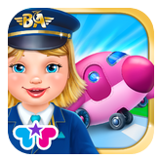

PBS kids

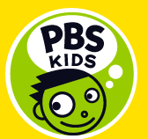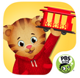

Busy Bee studios


Trois Elles Interactive


Duckie Deck
