#Cheers4Chairs at Community Boating!
Community Boating, Inc. (CBI) is a 501(c)3 non-profit. We are the nation's oldest public sailing center located in the heart of Boston's beautiful Back Bay. Our mission is the advancement of "sailing for all" by minimizing economic and physical obstacles to sailing. We currently serve over 2,000 children, 4,000 adults and 175 UAP sailors a year.
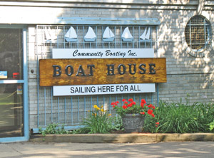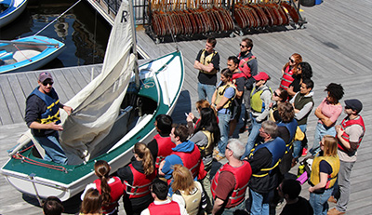
In 2007, we launched our Universal Access Program (UAP) enabling members with disabilities new opportunities to sail.
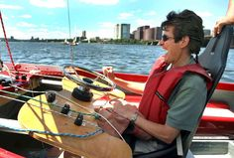
The program is amazingly successful. Last spring, we had an article published about our program in a prestigious scientific journal. While we’ve had great success; our technology is now 7 years old and given the advances in technology, we know we can do better.

We knew we had found the perfect partners to re-vamp things when we met Richard Ramos and Aleef Mahmud. Richard is a long time CBI UAP sailor and Aleef is a talented engineer. Together, we believe we have assembled the team that can build something amazing. Our dream is really big. We want to build systems that we can share with the world. Our ultimate goal is to enable anyone, regardless of their disability, to get out on the water and become part of the sailing community. We have the expertise, the experience, the facility and the team – now we need your support to make it happen.

What We Need & What You Get
Monies raised will fund:
$25K = Engineering and manufacturing costs for a new chair design that has even more versatility than the current chair design. We're taking everything we've learned, teaming with Richard and Aleef to accomplish this goal.The current chair belongs to Richard and he is kind enough to let CBI borrow it from time to time. The $25K will fund a chair for CBI - one chair for one boat.
Yes, we have stretch goals - it's true, we're pretty ambitious because of our passion for this project. If we are lucky enough to exceed our goal, the additional funds will be used to expand and accelerate our long-term plans. More money = more chairs + more boats + more qualified staff hours = ability to expand the program to accommodate even more disabled sailors with a wider array of physical limitations. start a racing program, build a program endowment fund to ensure the program's longevity and get the word out to the disabled community.

The Impact
Today there are very few technical solutions that allow people with physical limitations to sail. Even fewer solutions for those who want to compete. Richard and Aleef's prototype is one of a small handful worldwide. Yet there is a lively, active global movement to present the disabled community with alternative ways to get active, socialize and participate in caring communities.
While we're thinking of this technology for sailing, the concepts we're working on have broader implications. It is possible our experience could be applied beyond sailing to other physical activities as well.
We have the expertise. We have a technical solution that is proven and in demand. We're already gotten calls from as far away as Israel as the word gets out. We want to accelerate this process, present and communicate the solution so people with disabilities don't have to work so hard to find it.

Risks & Challenges
We already have a working prototype that we can readily replicate. However, this campaign is all about raising the funds necessary to redesign and improve the current chair. The existing prototype is completely tailored to one person, Richard Ramos. Our engineering goal is to build a more versatile prototype that would be accessible to folks of all ages and specifications. While this is a greater engineering challenge - we believe by combining our UAP expertise with Richard and Aleef's experience we have reduced the associated risks.
While we are prepared to do the hard work necessary to have this versatile working prototype by the time we re-open our UAP program in the spring of 2015; it's hard to predict unforeseen factors we might encounter along the way. There is a risk that the final product may not have all the versatility we are striving for in our current plan. Regardless, we know we have the basis for an improved prototype that will move us closer to our ultimate goal and we're ready to take on this new challenge. When we have our launch party next spring, we're confident we'll be one step closer to our goal. For us, the size of the step matters less than the progress forward.

Other Ways You Can Help
Community Boating's non-profit mission is to provide sailing that is accessible for all. We're very passionate about it. This means reducing ALL barriers including physical, social and economic barriers. Our UAP members (and our junior sailors) pay what they can based on their economic circumstances. Because we understand the challenges that they may face and because we are committed to provide access we work hard to find creative ways to fund access. We never want to deny any member access to the water for any reason.
To support our mission, we have a scholarship program that allows economically challenged Junior Program sailors to sail for a whole summer for just $1. We are always on the lookout for new ways to increase funding for this program. We currently serve about 2,000 children during our summer sailing season so there is always a need.
In addition, we have developed a wide array of STEM programs that run in conjunction with corporate and educational partners like Google, MIT and others that create learning programs with ties to sailing. Since sailing incorporates physics, math, water science and engineering this is a natural fit. We are always exploring innovative ways to expand this work through active partnerships with cool people doing cool things in these fields and engaged funders who appreciate our mission.
CBI is a 501(c)3 non-profit organization that depends on it's committed, energetic volunteers. We have a HUGE volunteer program that makes it possible for us to keep things "ship-shape". We welcome new members willing to contribute time and expertise in a varieties of areas. Volunteers become part of our lively community. It's a fun and exciting way to meet new people and learn new stuff while you contribute. If you live in Boston, we hope you'll consider joining us and having some fun!
Even if you live elsewhere, we ask that you help us share our message with as many people as possible. We're active on Facebook, Twitter and Instagram. We'd love to hear from you! Please help us spread the word for our #Cheers4Cheers campaign to provide #Sailing4All at Community Boating. The Indiegogo share tools also make it really easy - please help us spread the word! And when you do come to Boston, stop by for a visit, we'd love to show you around our beautiful river!
You can also find and follow us at www.facebook.com/communityboating, www.twitter.com/sailcbi, and www.instagram.com/sailcbi, or sign up for our newsletter on our website at www.community-boating.org. Help us help others enjoy the freedom and life-changing experience of sailing.
Thank you for giving us your time, good vibes, and positive energy!

