Packaging brief

Create premium package design for fishing accessories

Packaging design is required for a premium brand of fishing accessories selling on Amazon and our own website. It is not for retailers or bricks and mortar stores.

Target is men and some women (gift buying and for the few women who fish). However, the predominant feel should be masculine and strong to address the mainly male market. Clean lines, not fussy.

A logo has been done. It is provided in black, but can be different colours if that works better – though no camoflauge!

We want a premium brand look and feel, but we will not use expensive, special materials or those that may need special diecuts for example.

The accessories will vary in size and volume. The first requirement is for pliers, followed by fish grips, sunglasses, rod holders, fishing scales. Please view these items on Amazon so you can see the differences.

It is possible that larger accessories will include tackle box, fishing vest, fishing net.

Ideally, don’t want blister packs as they are so hard to open. Want something that is easy to open and helps to protect the product.

Must be strong enough to last a sea or air freight trip from China to USA – expect rough handling. It needs to arrive in the hands of customer without looking like it has travelled the world.

However, the weight of the packaging is a factor as is the size because an increase in these elements mean higher shipping costs.

Some items may come with a pouch (eg: pliers) or a case (eg: sunglasses) but we need generic branding to go over that packaging. Other products will not come with any packaging except perhaps a general type plastic bag, which is not appropriate for a premium brand.

Packaging must be able to have barcodes adhered to the outside (such as stickers or printed on) and printing of logo and design elements.

The logo is attached. With the logo, but not a part of the logo, is a tag line “Great Gear, Great Fishing!” This can be used on packaging as well to differentiate it.

In addition we need a layout for an insert that will go into each package. This can vary in size, depending on the packaging, but the content will stay pretty much the same for every package. The insert is to include:
Logo
The Fishing Tree
tag line
Content will be on both sides of light cardboard insert

EXAMPLES:

There just doesn’t seem to be a lot of fishing packaging that doesn’t look like comic book stuff and that’s not the look I want.

I like the strip of card across the net and the bag below. This enables some branding for difficult sized products. However I cannot present these items like this as Amazon requires complete packaging of some sort. Also, there is the insert to be included, although that could be included on the back of a strip of paper instead of as an insert! Depending on the size of course.
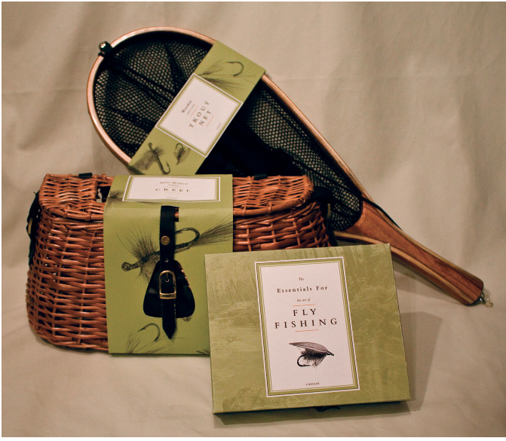

I like this total packaging below for a number of items. The box looks substantial and may be too heavy to accommodate the lightweight requirement. And at this stage I am only selling single items, though at some future stage there may be a bundling of items. Certainly room to add an insert.

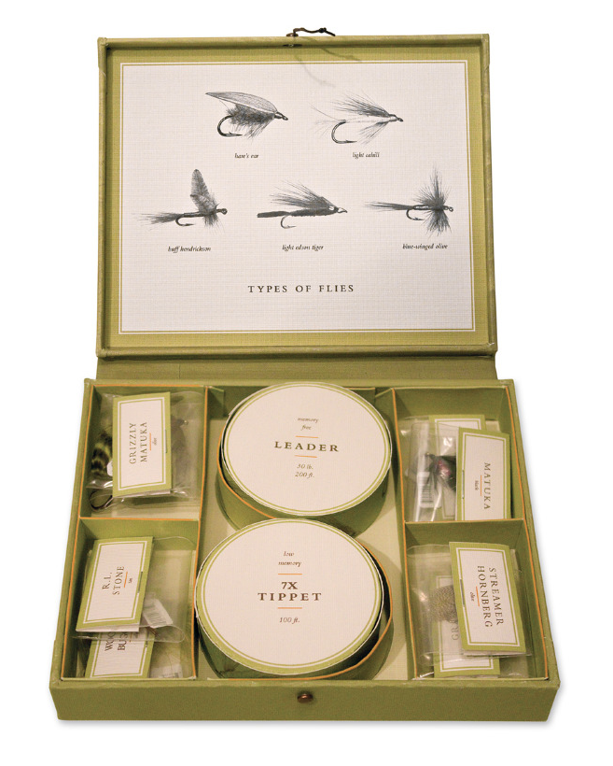

I like the see through window in this box, though I don’t think it looks very premium. That may be the colours though. I think this is a lightweight option that could be designed around a specific item. I’m not sure this would be costly to manufacture in small batches though. Room for an insert.

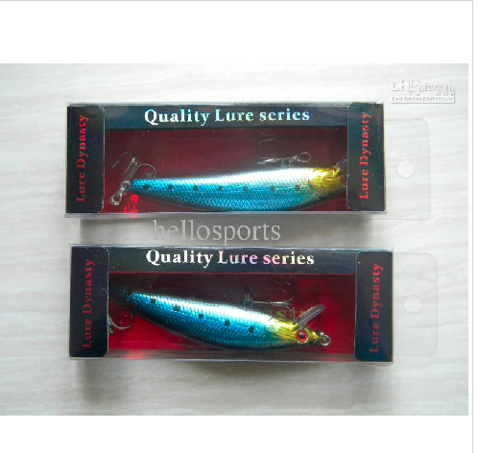

If you visit Amazon.com and search for fishing equipment or fishing pliers or fishing sunglasses, you will notice that there is very little in the way of packaging. I want to make sure The Fishing Tree brand stands out in that market and packaging is super important to that.

I want visitors to look at my product and look at the packaging and feel that my product is better than any of the others.

I like this packaging, especially the plastic window which allows you to see the product. Unfortunately the pic of the plastic window is a little out of focus! I like the simplicity of the packaging and the cleanness of it. The cardboard is robust.

