SCRUBB STARTER KIT
“Go the Extra Mile”
Welcome to Scrubb
It is our pleasure to welcome you to partner with the Scrubb cleaning business. Scrubb presents something new to the Australian cleaning market, offering a fully digital way to book a cleaning professional. In this dynamic but sometimes chaotic industry, Scrubb represents reliability, quality, and efficiency. In you, we have found a partner that shares these qualities. Together we are sure we will both succeed.

From John and Chrisanthe
Founders of Scrubb

What We Expect from You
Scrubb expects service of the highest quality. With both a smile and a can-do attitude, we need to focus on keeping our customers happy. This means always arriving on time, and keeping to our appointments. It also means having attention to detail.
If the customer is unhappy, we expect our cleaning professional to go back to the customer’s residence within 2 days to correct.

What you can Expect from Scrubb
Scrubb will pay you on time, one day per week. When a customer rates your job as “5 stars”, Scrubb promises same-day payment (same day as the rating is received).
Scrubb will be marketing and advertising its digital booking system. This will provide you with a convenient platform that brings customers straight to your smart phone.
Scrubb offers you the flexibility to manage your own lifestyle.

What to do if there is not enough time.
If the property is particularly unclean and you do not believe the allotted time is enough, you can do one of three things:
- As the customer what they want you to focus on in the limited time available.
- Advise the customer to “edit” their booking by logging back into their account via the app or www.scrubb.com.au
- Call John or Chrisanthe.
Uniform Guide
You must wear the t-shirts provided by Scrubb for every Scrubb job. You may wear long-sleeve “skins” underneath the Scrubb t-shirt for warmth etc.
Trousers may be blue or black, and denim is permitted. Shorts are permitted in summer, though neutral colours must be worn. No floral or surfer shorts.
No ripped jeans. Closed shoes should be worn. No flip flops.
Scrubb encourages the concealment of prominent tattoos and piercings.

Do’s and Don’ts
Don’t finish early.
Do walk through the house for a final check before leaving.
If the customer queries, advise the customer that the quoted time in the booking is for one person. eg if 2 people attend, the time will be halved.
Do Smile.
Do arrive on time.
Do ask the customer what they want you to focus on.
Do assess if you think you will have enough time when you first arrive. Alert the customer to any concerns you have about time and advise the customer to contact Scrubb.
Don’t discuss money with the customer.
Do refer customers to www.scrubb.com.au or our land line number (02 98445485) if there are any queries.
Do focus on customer service and the customer experience.
Do only accept jobs that you know you can do and your scheduling allows. If you accept the job (one off or recurring) you are making a commitment to Scrubb and the customer that you will turn up each time.
Don’t poach Scrubb customers.
Don’t be late.
Do always wear the Scrubb t-shirt.
Do only allow a maximum of 3 cleaners to attend any property (except end-of-lease where more cleaners can attend).
Don’t allow any cleaners or staff that have not been police-checked by Scrubb enter the home of a customer.
Do call Scrubb if you are unable to attend a job you have accepted. A $30 penalty will be deducted for cancellations within 24 hours prior to the job.

There will be random quality spot checks done by us at any time, and we will be contacting the customers to ensure they are happy with the service they are receiving.

How to Accept a Job
Jobs can be accepted by (1) logging on to the Scrubb website, or (2) logging on to the Scrubb App.
- Accepting a job Via the Scrubb Website
“Log In” at www.scrubb.com.au
Go to the Scrubb Noticeboard (see below). “Job Notifications” represents available jobs for you to accept. “Upcoming Jobs” represents jobs that you have already accepted.
Click on View Job.
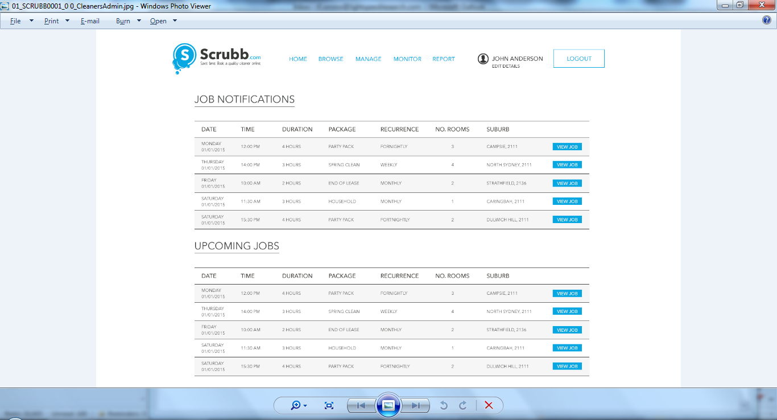
Click on Accept Job.
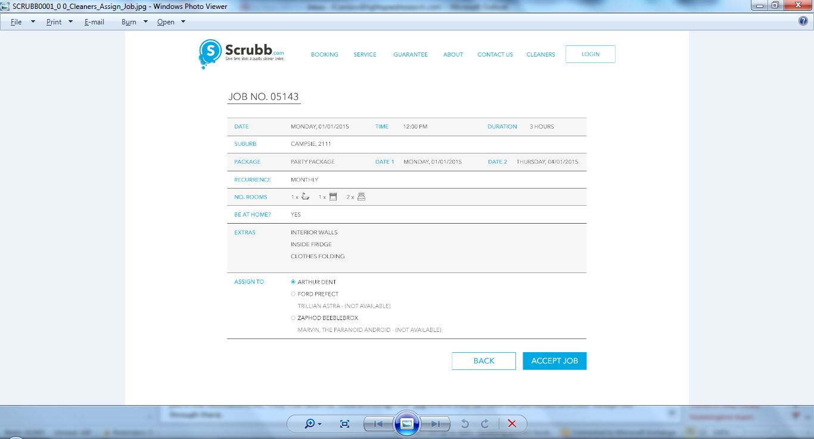

- Accepting a job via the app
Details to follow.

Contact Us
John 0414660278
Chrisanthe 0408682809

