‘Home Made Ice Tea or Lemonade with or without fresh mint
Glass 60
Carafe 120
* With a dose of rum or vodka 120/240
Farru-Quito Sangria
Authentic recipe revealed by a friend from Barcelona
Glass 120
Carafe 240
Marinated Rums and Spirits 120
Wondering what’s in those mysterious jars sitting on the bar? Marinated rums and spirits! A blend of alcohol, sugar syrup and fruits served on ice. Dangerously delicious!!
Treat yourself all the way with our cool desserts!

Fruit Salad Bowl 80
Ice Cream 80
Ask for available flavors
Crème Caramel Flan 80
Ice Cream Cookie Sandwiches 100
Chocolate Brownie 100
Served with ice cream
Carrot Cake 110
Served with cream cheese icing

New York Cheesecake 130
With raspberry or chocolate sauce
Happy Coffee 160
Coffee with your choice of alcohol (Bailey’s, Khalua, rum,
whisky…) topped with whipped cream

We appreciate your comments.
Please visit TripAdvisor.com and take a second to write about your experience @
CRAVE Restaurant and Lounge, Ko Phangan

The Tuna 180
Veggies, egg & tuna with creamy dressing

The Greek 170
Lettuce, tomatoes, cucumbers, onions, olives & feta cheese
The Cesar 180
Veggies, croutons, cheese, egg & bacon
Extra chicken breast….. .50 Extra smoked salmon….. .60
The Med - Chicken or Tuna 200
Veggies, feta, olives & hummus
The Cobb 200
Veggies, chicken, bacon, blue cheese & egg

BBQ Sangsom Pork Ribs 230
Served with fries & coleslaw
Hamburger Steak 220
Two beef patties topped with fried onion and gravy Served with fries and salad
Macaroni & Cheese 160
Nacho Style…………..60 (with minced beef, jalapenos, tomatoes & sour cream)
Beef Kebab Wrap 200 With sliced beef, hummus, Ranch mayo, veggies & fresh coriander Served with salad

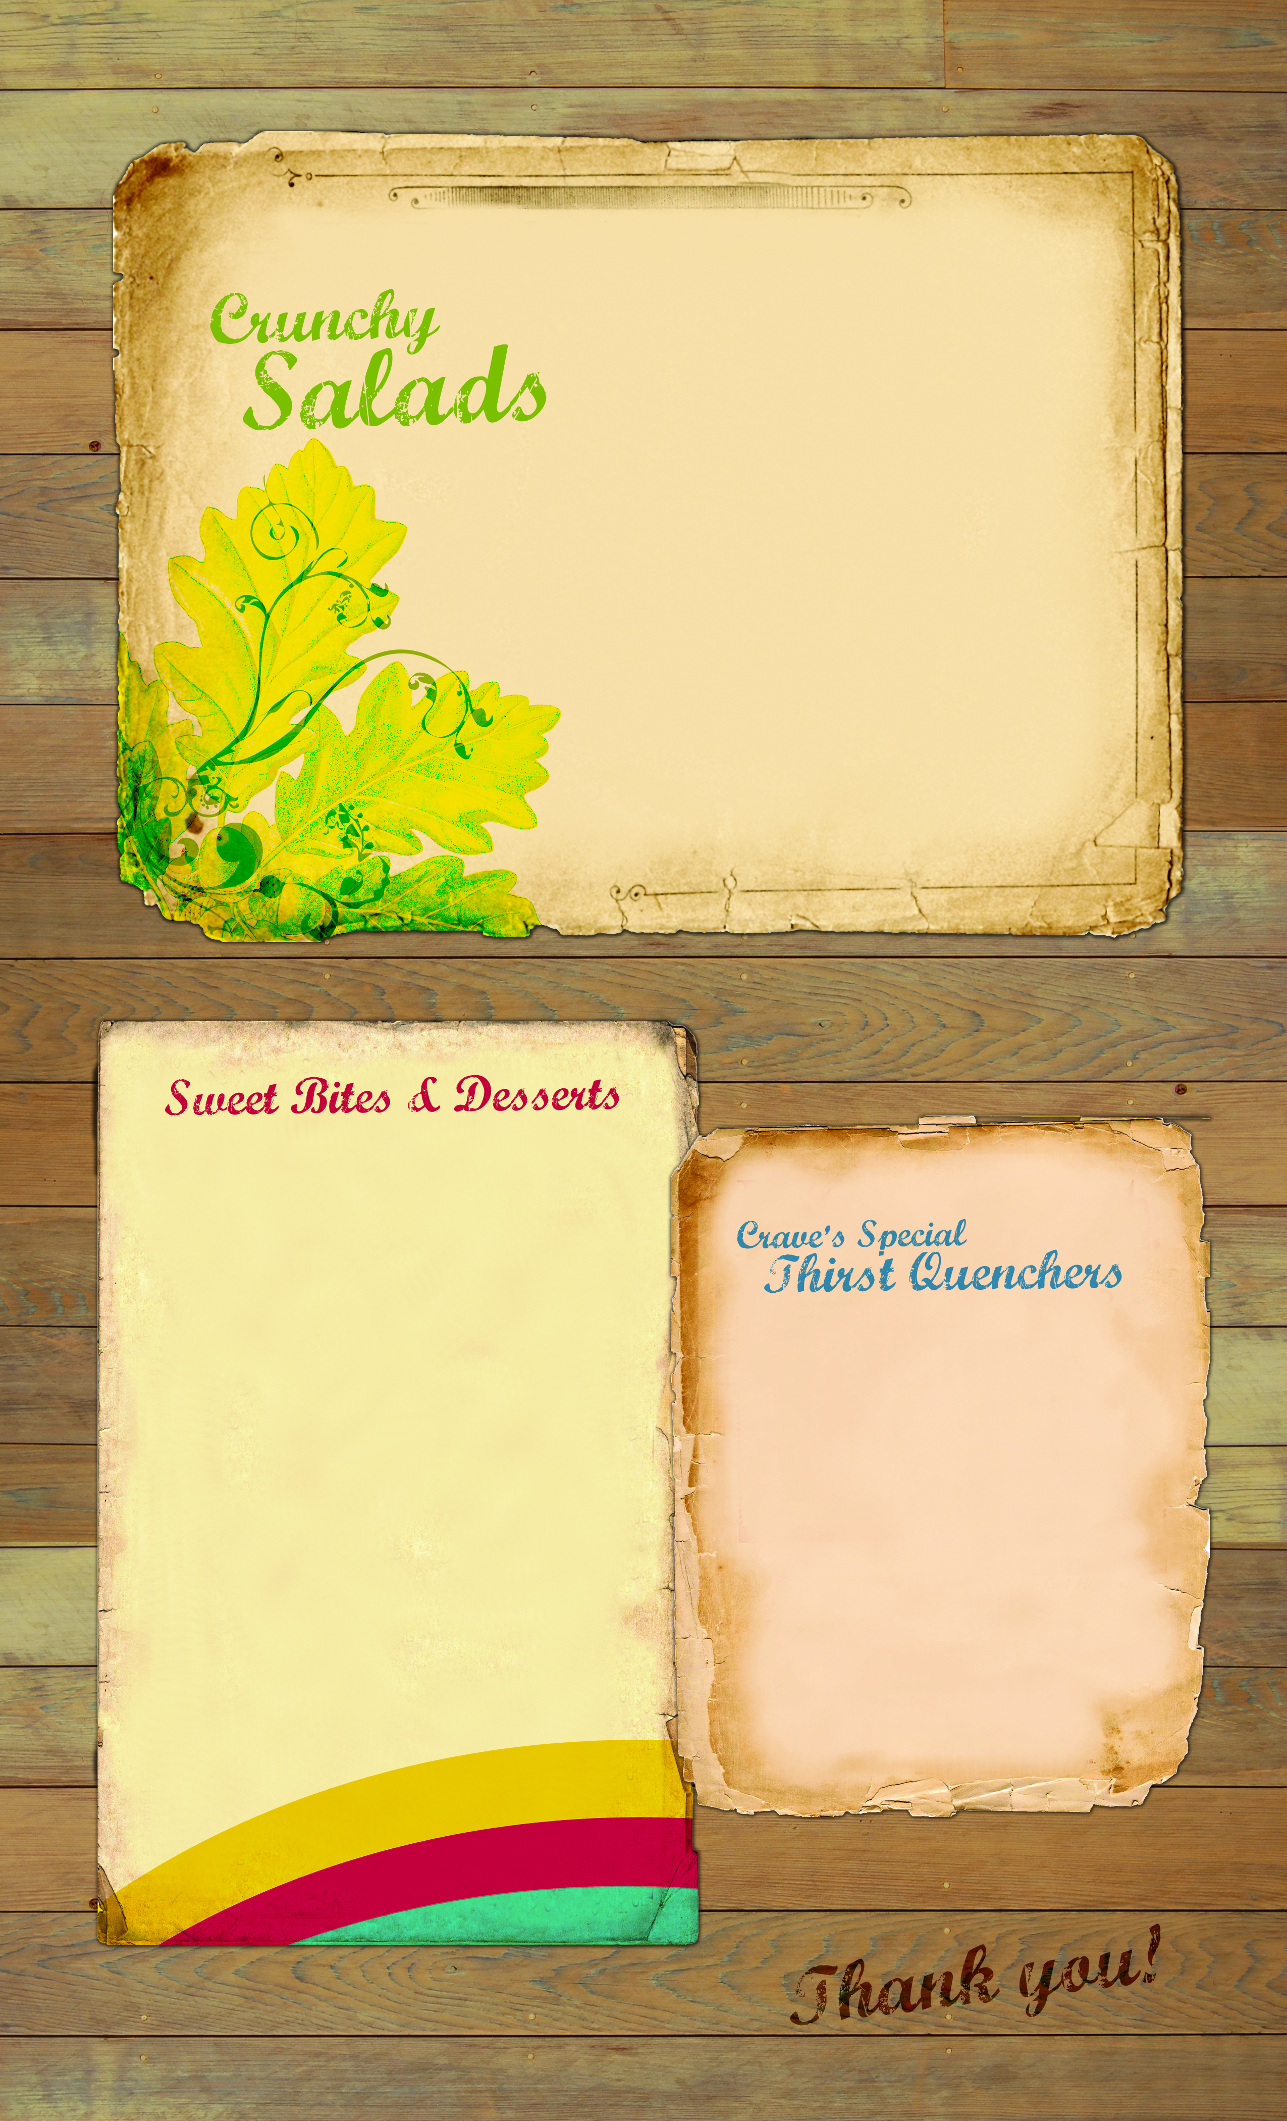
^{Tasty meals}
!

