GFS logo | Servicing clients New Zealand wide  (map of NZ with sunny circle and enlarged region showing Gisborne)  Located in sunny Gisborne | Smart financial decisions for today and for your future  Insurances / Investments / Financial Planning  0800 868 8313 | 06 868 8313
Home About What We Do What Life Stage are You? Insurances Investments FAQs Consultation Contact/Map
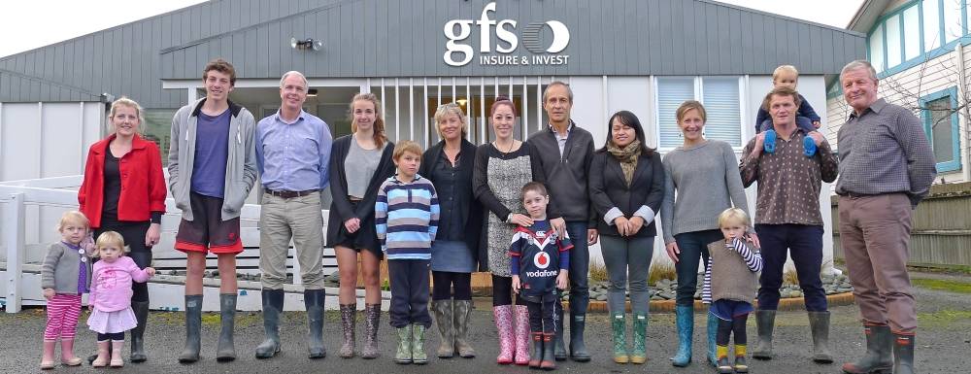
Insurance…  An overview of insurance from the point of view of benefits to the customer of working with GFS will be in this space….. Relevant keywords such as the types of insurances e.g. life insurance, travel insurance etc will be mentioned… Should be inviting to both new and current customers….  (button)  Insurance icon.jpg  Find out more… | Investment…  An overview of investments from the point of view of benefits to the customer of working with GFS will be in this space….. Relevant keywords such as financial planning, investment advice and KiwiSaver will be mentioned… Should be inviting to both new and current customers….  (button)  Investment icon.jpg  Find out more…
What life stage are you at?
18-30 years…  Image: 18-30 life stage  - Should I start financial planning now?  - What insurances do we need?  - What is the best way to save?  (above in a speech bubble – or 3 speech bubbles? – above or around image) | 30-45 years  Image: 30-45 life stage  - How do we create a balanced financial plan? - Have we got the right insurance cover?  - Which investments are best for us?  (above in a speech bubble – or 3 speech bubbles? - above or around image) | 45-65 years  Image: 45-65 life stage  - Are we on track for retirement savings?  - Is our health insurance cover enough?  - Have we correctly structured our business?  (above in a speech bubble – or 3 speech bubbles? - above or around image) | 65+ years  Image: 65 plus life stage  - Can we take our dream holiday?  - Should we consider downsizing the house?  - How often should we revise our will?  (above in a speech bubble – or 3 speech bubbles? - above or around image)

Would you like GFS to call you? Fill in the form and we’ll be in touch…

First name: ____________ Last name: ______________ Email: _________________ Contact phone: ________________
Message:______________________________________________________________________________________________ SEND button
_________________________________________________________________________________________________________________

Home  About  --Meet the Team  --Testimonials  What We Do  FAQs  Consultation | What Life Stage are You?  --Life stage 18-30 years  --Life stage 30-45 years  --Life stage 45-65 years  --Life stage 65+ years | Products/Services  -- Insurance  - Life insurance  - Trauma insurance  - Disablement cover  - Income protection  - Health insurance  - Business insurance  - Fire & General  - Travel insurance  -- Investment  - KiwiSaver | Contact/Map  333 Childers Rd, Gisborne  New Zealand  PO Box 1273, Gisborne  Office Hours: 8.30 – 5pm  After Hours: Please phone:  0800 868 8313 | 06 868 8313  Google Map of location  F (Facebook link)

Note for designer: Do not box in the design so it looks like a rectangle – any section background can extend out beyond the 1100 pixel width content section.

