Logo-Inspiration
Castaneda Trial Lawyers is a boutique litigation firm advocating for people and businesses in civil and criminal matters.

Logos & Brand
Name: Castañeda Trial Lawyers or Castañeda Trial Attorneys

Logo Ideas from Lawyers
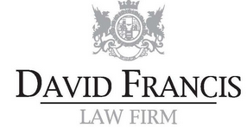

Inspiration
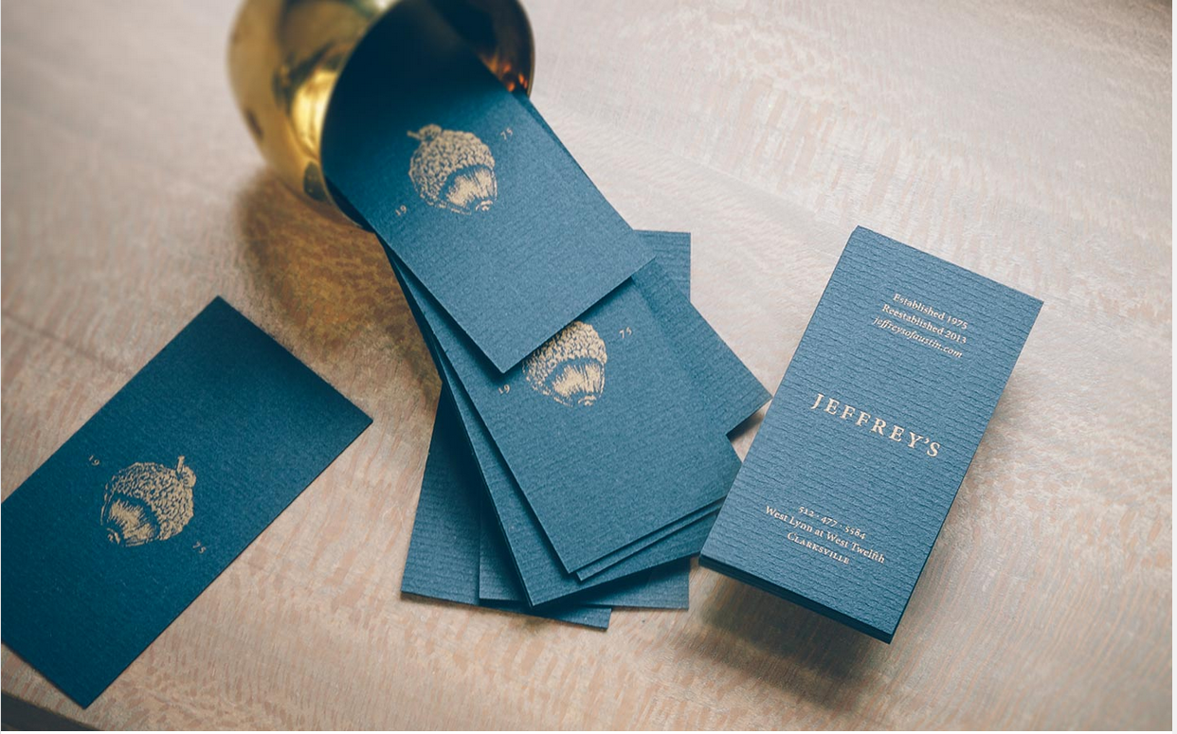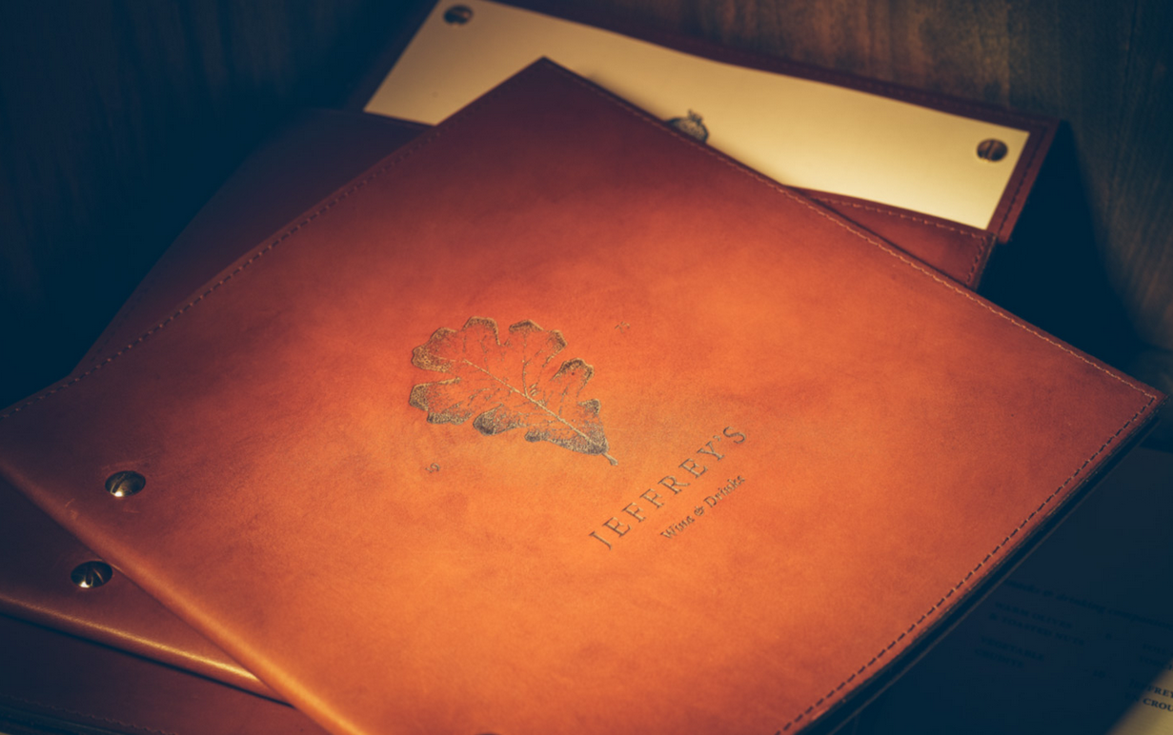
see: http://www.fodastudio.com/main/project/123

My Style Inspiration
I went to Notre Dame and I like the branding behind it.

I like this blue above and also like the texture behind it.

Below are the university’s primary colors.
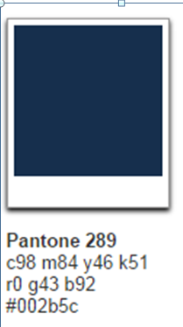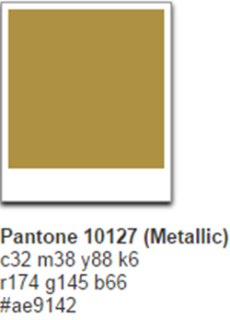

Also, the typeface is Adobe Garamond. I’d like to see a version of my logo that incorporates the blue and white and maybe a hint of the metallic gold in the same font.
I’m also from Santa Barbara and I like its style--Rich, lush and historical with modern flair. I also get inspiration from classic kennedy-style.
