Overview
triple3recruitment is a new start-up recruitment business arm (part of the Future Prospects Group and an agency partner of the CML Group, the largest recruitment network in Australia) based in Sydney – now specialising in the not-for-profit (NFP) sector [=target market]

[Future Prospects] opened for business in 1981. Since then, our focus has always been on delivering top performing candidates for our clients. We believe it’s people talent that drives organisational growth, delivering intrinsic value and impact on the triple bottom line.

Our broad experience of 30-plus years covers recruitment for non-profits in areas such as:
- Sales, Marketing & Communications
- Design & Creative
- Environment & Sustainability
- Human Resources
- Accounting
- Compliance
- Admin & Business Support

Our attention to detail, client care, honesty and integrity has helped us develop long term relationships with our clients. Our commitment to them is to make the whole recruitment process as smooth, seamless and easy as possible.
Our personable steadfast and consistent service is what makes us stand out from our competitors. (We are not high volume, quick & fast to just fill seats/positions.)

We would like to leverage our existing:

1. Brands –

2. [NFP] Client base – eg. Cancer Institute, Electoral Commission of NSW, Fred Hollows Foundation, Bicycle NSW,
Catholic Education Office, NSW Business Chamber, Sydney Water, Cancer Australia

to attract new candidates and service new clients - to grow our business, as well as theirs.

What we stand for
triple3recruitment - “do the best job” [USP]
people – purpose – performance – personable
Aligning people talent with purpose and business growth
>>> Our focus is on working with organisations to raise their overall talent/ human capital and
performance levels.
We will try to recruit top performers for our clients every time (which we believe has an effect on their business’ triple bottom line)
Do the best job... make a difference

NB – triple3 derives from operating in The Third Sector (another commonly used name for the NFP sector); and the impact human capital has on a business’ triple bottom line (referred to above – as well as being advocates for CSR – corporate social responsibility).

Mandatory inclusions
triplE3recruitment – we would like the E3to be mirrored – which can also be used as a stand-alone symbol.
It does not need to be in the middle of the business name (eg. triplE3 might be on one line and recruitment underneath – triplE3
recruitment

Colours
Per parent company colour - Teal
MP colour=R: 0 - G: 136 - B: 172

and something close to this

Style guide
Example ONLY 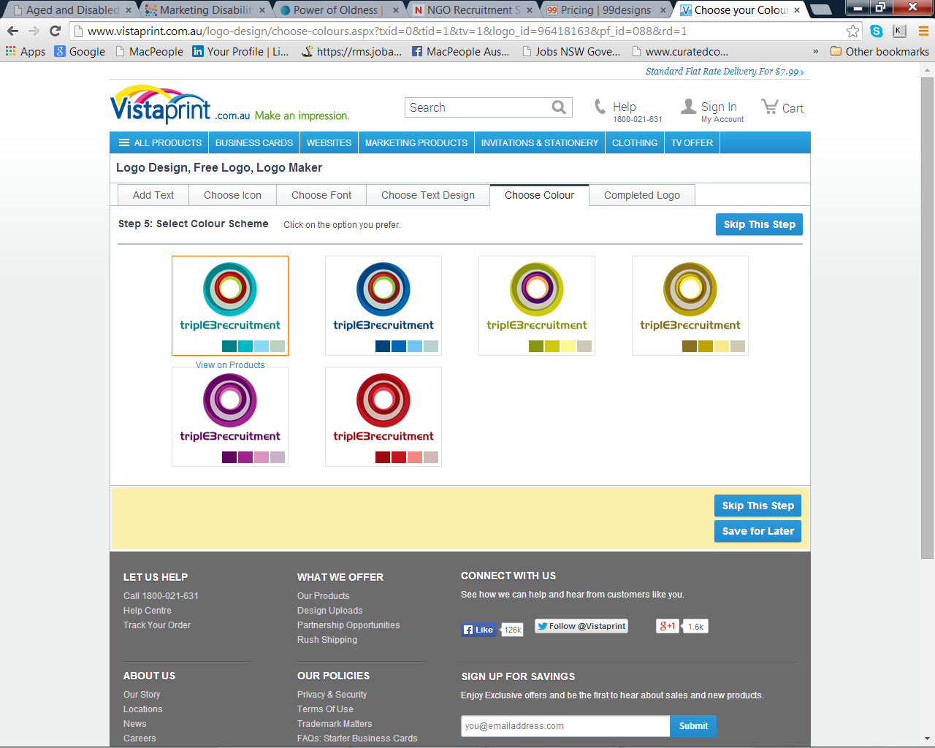
(open to other suggestions)

Production requirements
The Logo will be required for print and web application, including website development, email, business cards and marketing collateral.

triplE3recruitment
Level 6, 301 George Street, Sydney NSW 2000
T: +61 2 9223 xxxx | F: +61 2 9223 3133 | E:oriella@xxxxxxxxxxx.com.au | www.t3r.com.au | www.future-prospects.net
triplE3recruitment - part of the Future Prospects Group | agency partner of CareersMultiList | member of RCSA, AIMIA, AIG and more



