END-TO-END COSTING
Theory
Because of the size, diversity and constant change of the Ricoh supply chain it is not easy to understand and map costs to individual logistics networks. The shared logistic responsibility between the Ricoh sales companies and the supply chain organization causes additional complexity.
While more and more logistic activities are centralized and short-term interests vary among sales companies, it remains a delicate issue to work on a European “SCM cost control” model. Additionally the Ricoh sales companies have their own logistic solutions and a corresponding ERP system. Finally, the constant hustle and bustle in the operation causes insufficient priority for an integrated approach to cost control.
Ricoh Project Approach
The introduction of a logistics costs reporting system for all Ricoh organizations in the EMEA region, lead to more attention for costs in the various logistic networks.
In a pilot group, with a limited number of parties, a first draft was made for a comprehensive “SCM cost control model”. This created strategic support for the further roll-out.  Linking information from financial systems with information from transport and warehouse systems was a prerequisite for reliable management information. | 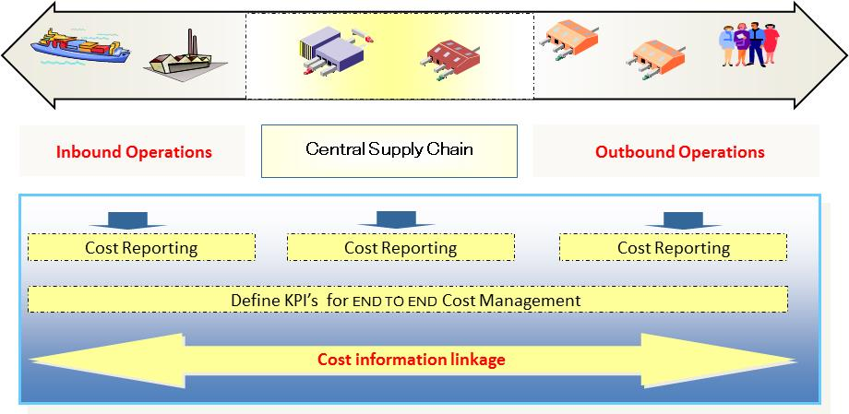
Accuracy and completeness are crucial when calculating logistic cost prices. This covers the cost in the general ledger, the number of orders and order lines from the warehouse systems and the weight and volume from transport systems.
With the help of a visual representation of the logistic networks, we have identified “cost drivers” per network and per product. We distinguish between fixed and variable elements of inventory, transportation, warehousing and overhead costs. A proper balance between activity- based costing principles and traditional cost accounting methods is the basis of a solid “SCM cost control”.
Results
In addition to the monthly financial ledger consolidation at Ricoh Europe HQ, we have developed a parallel supply chain costs consolidation system. This consolidation of the logistics cost is the basis for the achievement of the following results:
- Identify best practices through cost benchmarking between logistics networks of Ricoh sales companies.
- Evaluate saving opportunities based on scenario analyses where costs are related to service levels and sourcing alternatives
- Calculation of the END TO END supply chain cost prices for a final mile printer and toner delivery.
---------------------------------------------------------------------------------------------------------------------------------
About Ricoh Europe Supply Chain  Ricoh Europe Supply Chain is responsible for forecasting, procurement, storage and delivery of products for the Ricoh sales organizations in Europe, the Middle East and Africa (EMEA).  The product range consists of copiers, printers, faxes, scanners and toners. Production takes place in factories in Asia, France and England. Ricoh Europe Supply Chain delivers products on behalf of the Ricoh sales companies directly to end users, dealers and distributors in the EMEA region. Ricoh Europe Supply Chain operates two European distribution centres in the Netherlands, Bergen op Zoom and Schiphol-Rijk, and a dozen satellite centres. | 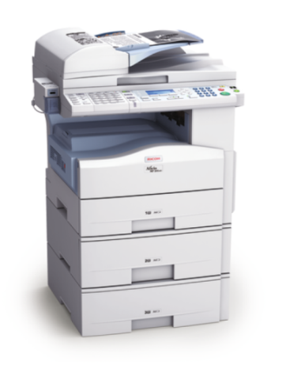
The location in Bergen op Zoom covers over 50,000 square meters and daily processes more than 12,000 orders. There are also multiple assembly lines for copiers. At Schiphol-Rijk service items are stored and shipped to Ricoh service engineers and dealers.
About Quantalus
Quantalus B.V. is based in Utrecht end delivers solutions on the edge of Information Technology and Finance. Our expertise touches upon logistic, commercial and financial processes. We focus on specific needs in your organization and distinguish ourselves with an exceptionally good analysis and clear presentation. During the implementation of our projects we provide a motion, which invokes change. We develop together with our customers practical solutions to daily problems.
Our projectplan is always concise, communicative and result driven.

