1. What would be the preferred colours for the logo.
> Pastel colours with a very classy / English feel to it. Would want to avoid the use of very bright / in your face colours. Don't want to limit ourselves to specific colors only. But to give an idea, the creative use of pinks / yellow / greys / greens / purples would be ideal. 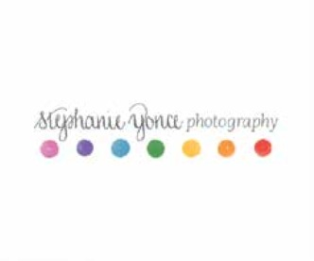

2. What is the name of your company/brand that you want on your logo?
> The name of the company is ‘Marry-Go-Round’ Therefore the name of the company should be the logo. Also since the name is not an original word, and instead is a tweaked one, we want it to be distinctly legible. It should not get mixed up with any other word (Merry-go-Round:
which it is derived from)

3. Do you have a caption/slogan/tagline that you want on your logo?
> Nothing currently. But we like to look at ourselves as conceptualizers for “boutique weddings”. We are open to anything else you might like to suggest.

4. Describe what your company/brand does, the core business and your target audience.
> Marry-go-Round offers tailor made wedding concepts for the distinct individual to be wed. We, are therefore wedding conceptualisers and not planners. We talk, interrogate, scrutinise and create concept weddings that will bring alive the idea of dream weddings for every couple and their families.

From destination to themes to complete execution; we will undertake the end to end of weddings for to be weds.

Target Audience: People who have an individual personality, are urban and distinct in their thought process and nurture the desire to have a wedding that is unlike what they or their loved ones have ever attended. Emotions, Friends, Family and celebration is at the centre of their wedding desires. For these couples, money is not about flamboyance; but about class. This is completely for dreamers who intend to live their dream in this lifetime.

5. Who are your main competitors?
> We do not believe that we have any competitors, as we are not entering into this business as wedding planners or event managers. We are conceptualizers who engage with our clients in a more personalized manner, creating concepts that are reflective of their personalities. Therefore, our attempt is to ensure that no two weddings are alike.

6. What feeling or message do you want your logo to convey? Do you have any specific imagery in mind?
> We want it to be creative yet direct, simple and classy, and importantly bring out the “fun and celebratory” aspect of love and weddings. The logo should showcase a distinct and intriguing thought process in the fun/love/ wedding/ celebration space. It should be the right combination of Fun+Love+Celebration

7. Favourite logos
> We have made 2 categories in this for you to understand better.

> A) Love the following logos as they're very creative yet they simply and cleanly communicate what they stand for.

> B) Love the following for the look/feel/color
A 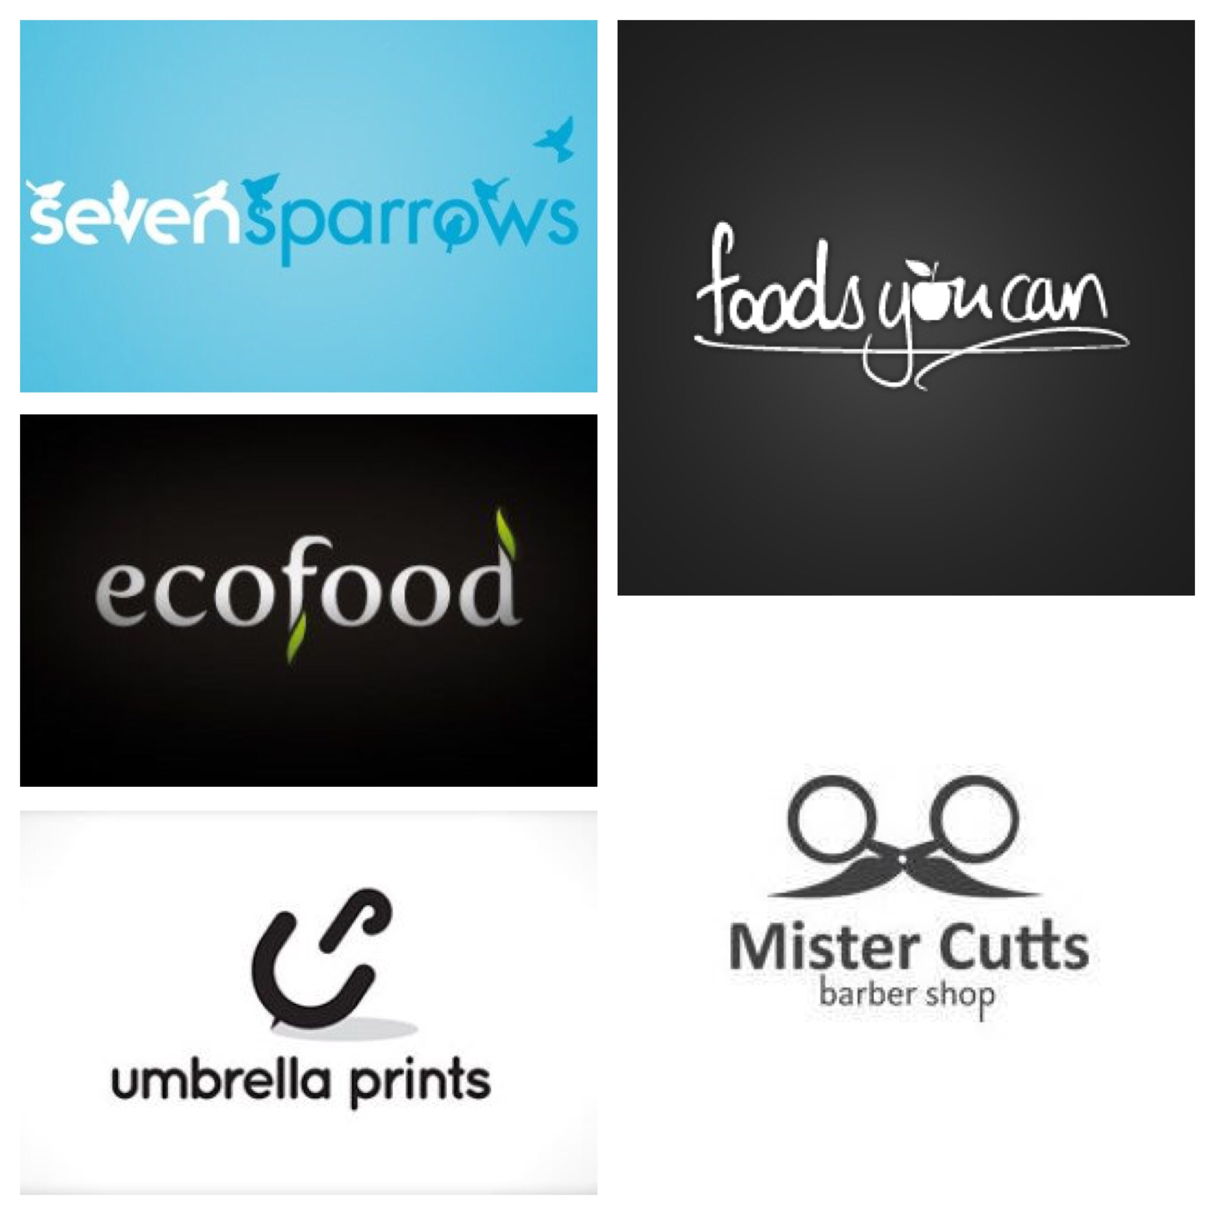
B 