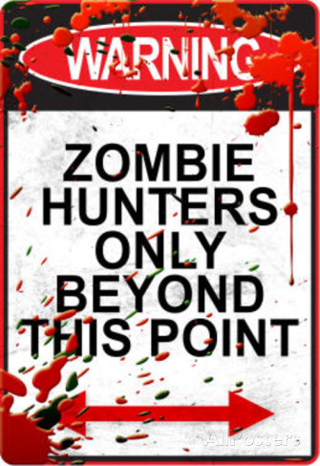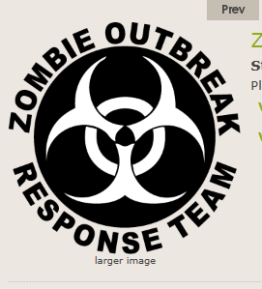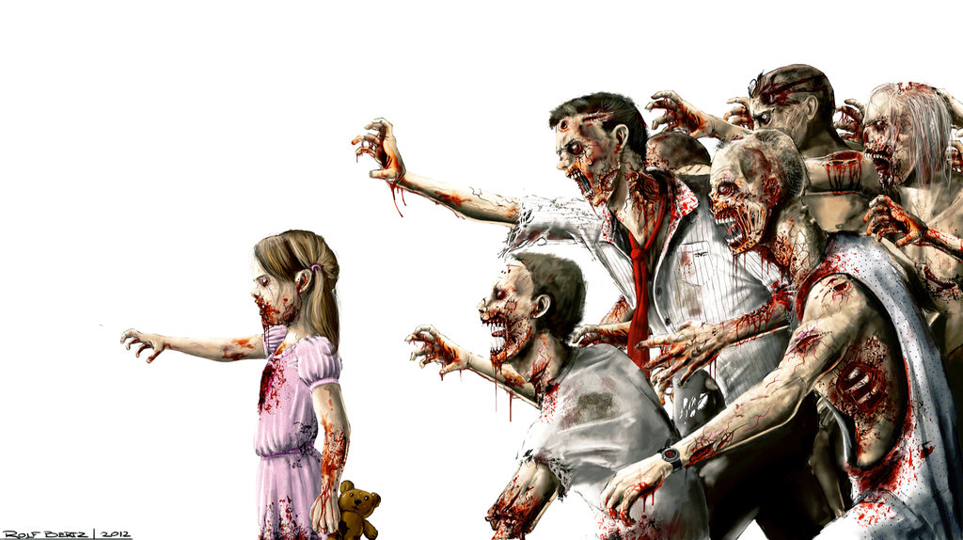

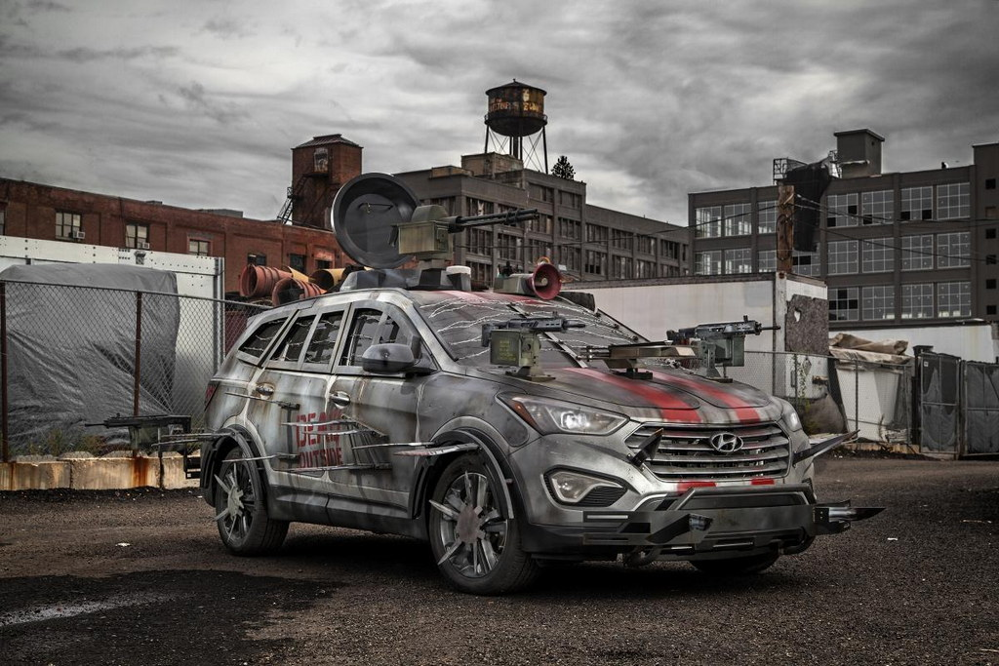
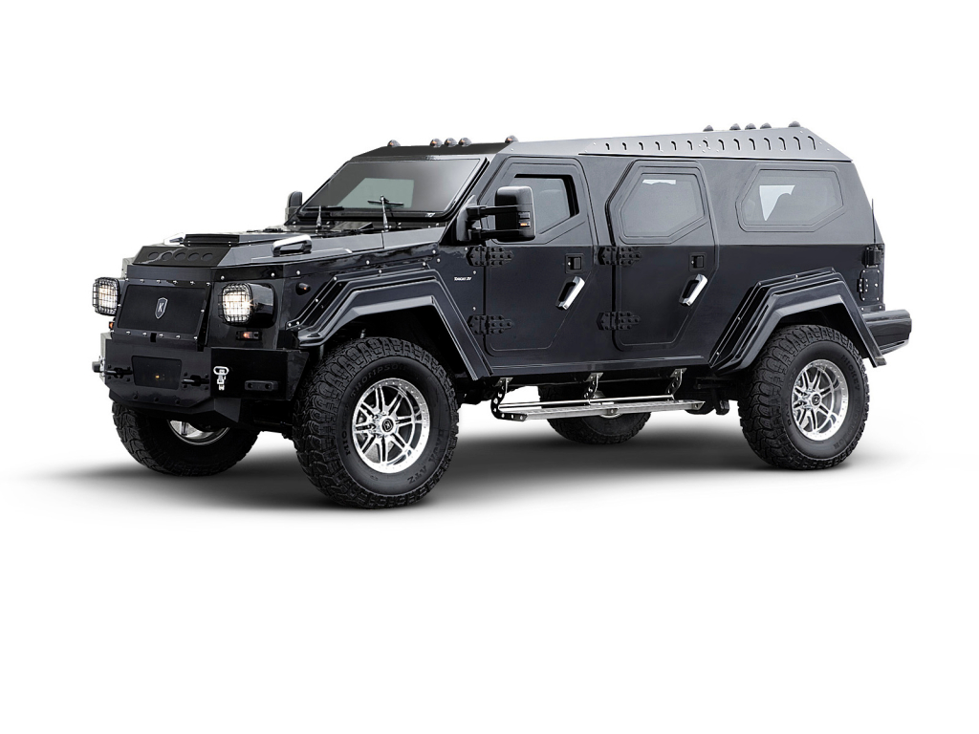 .
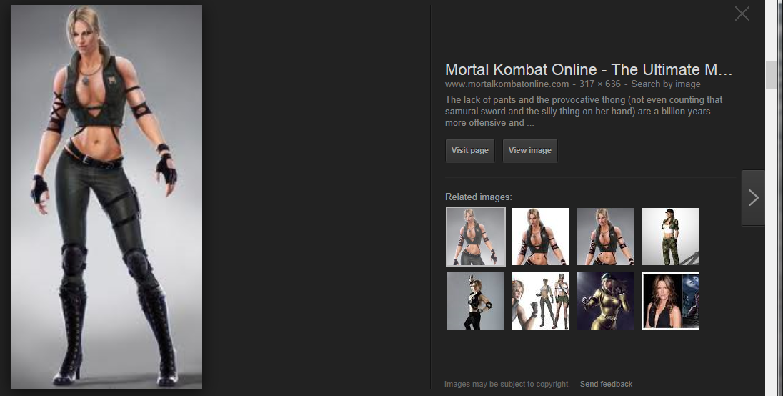
Give her a samurai sword. Hand guns on her thighs. More cleavage.
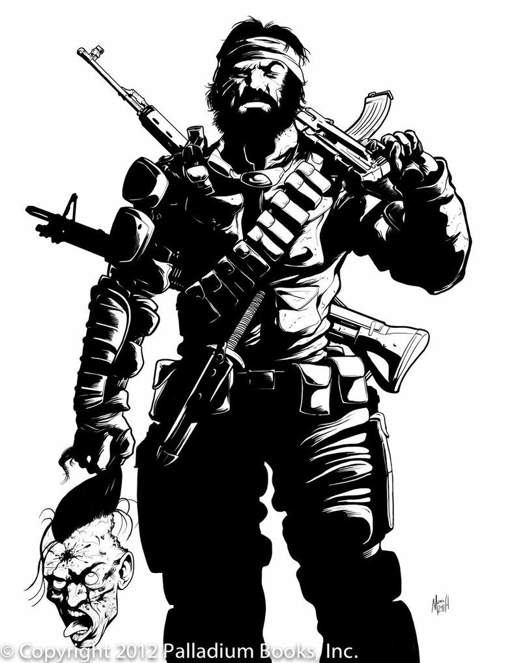One strong HULK, terminator, Mr.T
The muscle of the group. Show less armor and more muscle. AT least one very big scary gun and lots of ammo.
I like the headband and beard. It shows he works hard and has no time to clean up. I love that he is holding a head.
The last member will be the “brains” 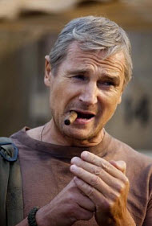 not so strong. Well armed but not over armed, he is the brains. Knife on his belt.

