

High Ground Protection
The Extended Service Contract Game Changer

Project Scope
To build a fully functional website utilizing Word Press that potentially uses Parallax effects and animation to deliver a state of the art experience for our visitors and subscribers.

Company Mission
We provide an innovative and unique service contract protection program direct to consumers. This program provides monthly coverage for all electronics purchased in the last 2 years and all electronics the consumer purchases in the future for a low monthly fee. The overall design should communicate a sense of legitimacy, ethics, and superior customer service and support (in an industry that has a huge PR issue to overcome).
Electronics is the first product group, other product groups with different price points to launch in the future (i.e. automotive, Home Appliances, etc.).
Creative Brief
The product and service that we are offering we believe is unique and disruptive to the service contract and warranty industry. From a product perspective a monthly fee for all electronics that you have purchased for the past 2 years and any electronic device (phone, tablet, TV, etc.) that you purchase in the future for a low monthly fee has never been done before.
So our design should also be unique, and have a balance between eye catching, animated, elegance and functional form.
Our customer service and our approach to paying claims and/or fixing our customers devices will be the most equitable and fair in the industry. We want all our customers happy, and we want to ultimately change the perception of this industry. So the design should also convey an element of legitimacy, trust, and longevity.
Remember that any and all devices get covered - so navigation by type of product is not necessary on the home page, emphasis should be placed on the concept of just registering your product and adding it to your protection portfolio and all your products are protected for that low monthly fee.
SEO and building awareness and a smooth conversion process for signup and payment processing are critical. SEO best practices need to be considered in designing and building the website.
Some pages will only be available for subscribers after login and an account is created. For example;
Product registration page, List of Registered Products, etc.

High Level - Functional Requirements
Visitor Site
- Home Page – eye catching and communicates value proposition effortlessly
- Content Static Pages with signup now buttons
- Plan Coverage – Value of Plan – Why High Ground Protection?
- Call to action messaging
Signup and Payment Processing
- News letter/ Lead email capture
- Blog posts
- Industry News
- Customer ratings
- FAQ’s and About Us static pages

Member Site - Login
- Ability to manage account
  - Edit account profile information
  - Easy cancellation of subscription
- Automatic email confirmation after signup
- Automatic email if no products registered (weekly) after signup
- Product Registration form (add, delete, update new and old products purchased)
- Registered Products List
- Ability to add receipt at time of registering new product
by attaching a digital copy of paper receipt, or forwarding the retail purchase confirmation email.
- File a claim online / Claim status
- Contact Customer Service email

Home Page Objectives

- Communicate key elements of value proposition tying in the high ground metaphor.
  - Instead of current model whereby a consumer buys an extended contract for each product they purchase at a big box retailer or ecommerce site. High Ground Protection provides one contract or plan for all the electronics products you purchased in the last two years and all products you purchase in the future for a low monthly fee.

  - In the full width slider I envision a cool and engaging design that shows through parallax and or animation – starting at the bottom of the slider depicting buying a per product contract at (i.e. a TV for $200.00, and Ipad for ?) and then moving to the top of the slider (high ground) and showing multiple products for a price of 19.99/mth.

  - Sign up now call to action (prominent)

- Next section can show 3-4 blurbs describing Why High Ground Protection:
  - Superior Coverage
  - Revolutionary Protection
  - Hassle Free Customer Service
  - Competitor Comparison
- Next section(s) in no particular sequence (with links to detail content for each)
  - Customer ratings of service
  - Customer Testimonials (vimeo integration?)
  - Blog Post Gallery
  - Twitter feed section
  - Follow us on FB

Sign up Page – This is just a representation of fields required and payment processing. Please design consistent with creative brief. Pricing should have flexible grid like module to add different plans.
See Pricing table as example on next page.



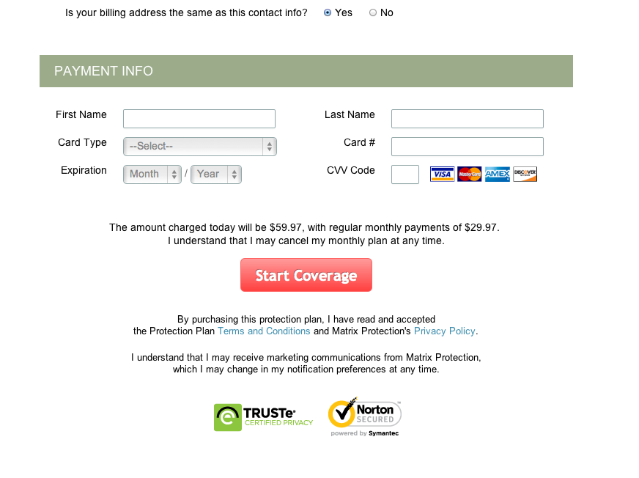

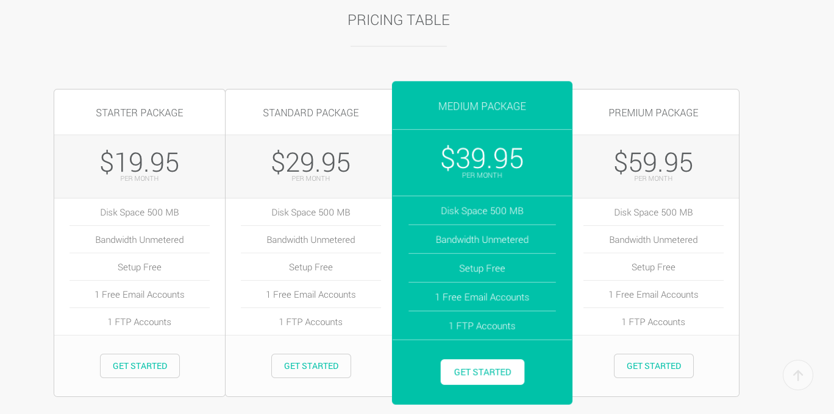

Competitor Comparison Slide

- Square Trade
- Esurranty
- eCommerce vendors (Amazon)
- Big Box Retailers
- Cell phone Providers (Verizon, AT&T,)
- Apple Store

Add New Product (Register a product for coverage

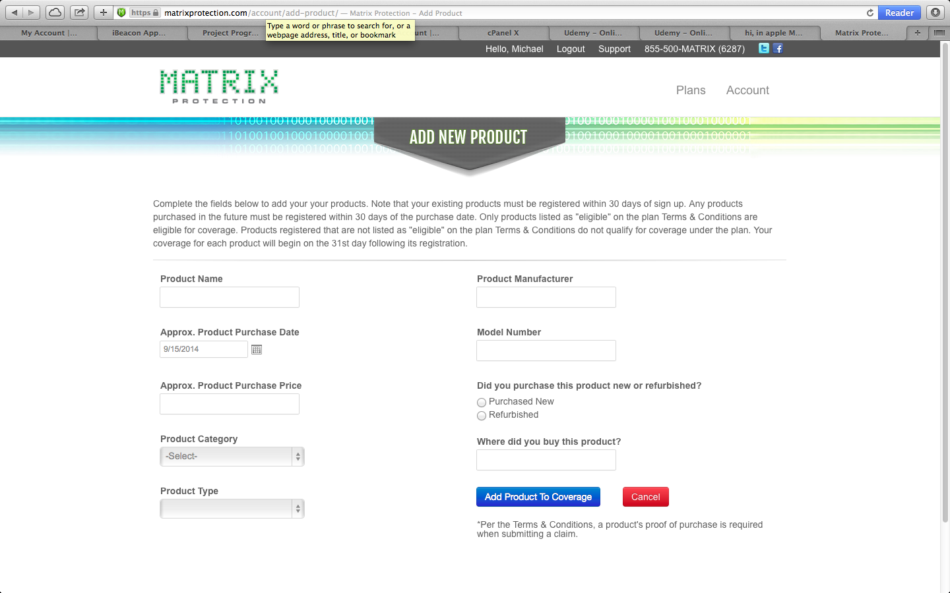
Field editing needs to be done on all forms and server side editing on available electronic products based on file that will be provided.
Column widths and file formats will be documented by a logical database schema that will be supplied for development of physical database.

My Account Page



Registered Product List

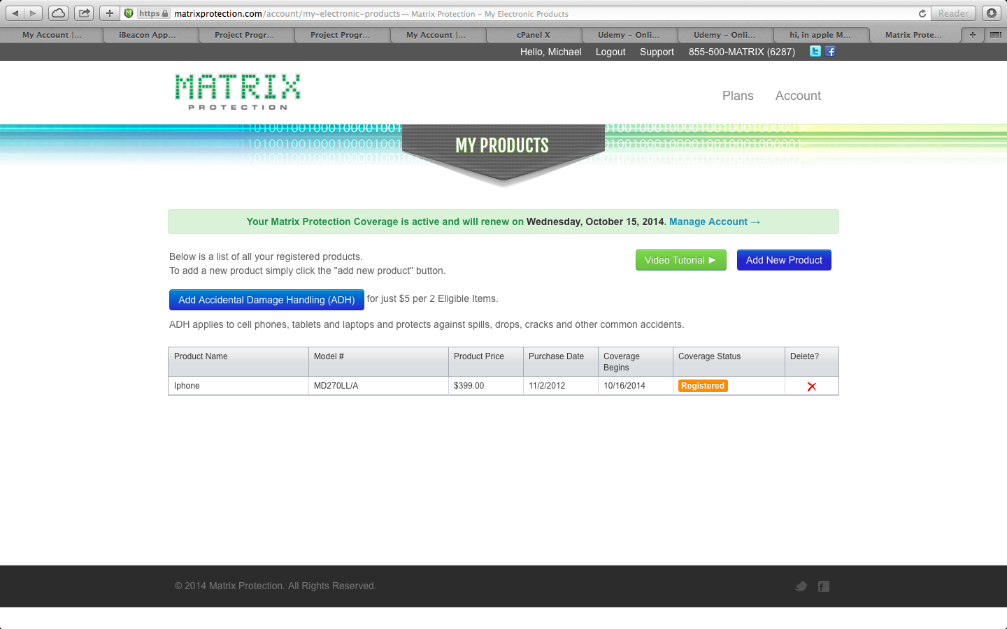

File Claim online – For information and process flow only not design

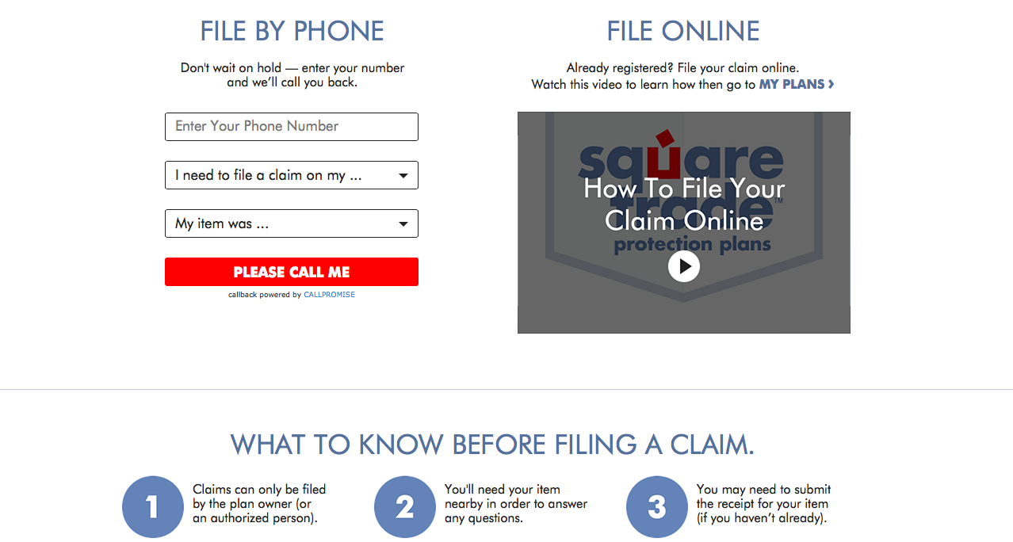

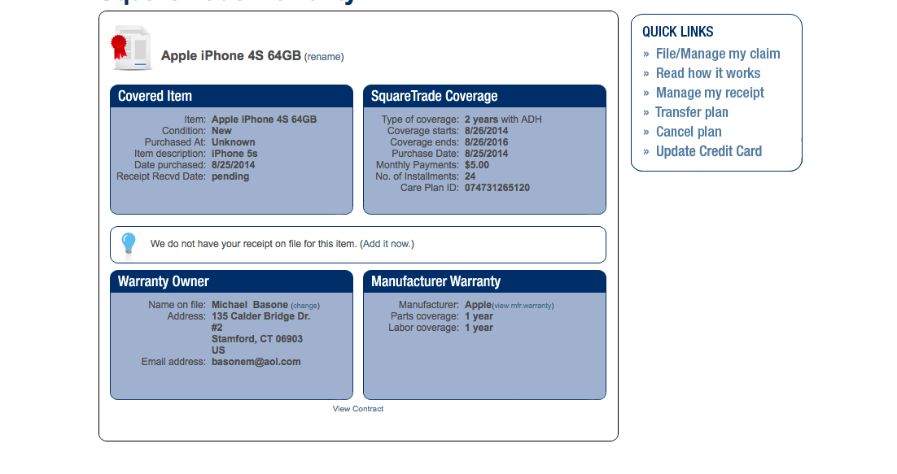

Need detail claim filing page –TBD

IT Requirements

- Secure CC transaction (SSL )
- Site Backup and Restoration Process
  - Development, Staging, Production environments (vendor recommendation)
- Content Management and Marketing capability via plugin
- Lead Page generation via plugin
- SEO best practices
- Use of Affiliate networks (tracking)

