Dear designer,

We are a manufacturing Taiwan company, with factory & branch in Hong Kong and China.
Our website is www.zhjb.com, present logo isor
Just “JINBO” letters in Arial Black font, it is too simple to be a logo, now we want our logo to be still just letters but to be more stylish, we admire the below designs.
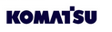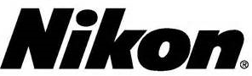

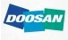


Our products are Transformer and Power Supply, something like your laptop power supply or mobile phone power supply, function is the same, and different is ours are for lightings not laptop or phone. The text to be designed is JINBO
We want to express the below concepts of our product.
- Very good and reliable quality
- Can work for long time, very few defective rate
- Trustable performance.
And:
- Logo can be in below in red (prefered), or blue (alternative), but not black please.
- Can be 2-color logo as long as the feeling is not bad.
- Our product is selling in many oversea countries through our international distributors, so we wish the logo has international big company feeling.
- As our product is heavy and is an industrial product, we prefer a logo has stronger (thicker) lines in the text. Examples like below:
- For more information, please be free to contact me.
The logo can be together with some side-slogan maybe:
- Behind your light
- Power Supplies
- Since 1993
- Original Power Source
But must be able to be individual LOGO without side-slogan also
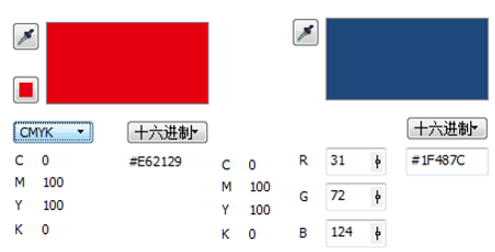
Thanks a lot and best regards,
Jeff Gao
Skype: jeff0756
Email: sign343@hotmail.com

