- H&H Services

“Convenience in a Company”

- The multi-unit housing market is growing. Give your complex a competitive edge with H&H Services’ doorstep valet trash pickup!

- Taking out the trash is an UNPLEASANT task:

heavy bags, messy leaks, awful smells, inclement weather

- Let US do the dirty work for YOUR resident satisfaction!

- What is Valet Trash Service?
- We collect your tenants’ trash from their doorsteps and dispose of it in the onsite dumpster.

H&H Services Offers:
- • Doorstep Trash Pickup 5 Days Per Week
- • Trash Cleanup Around Compactor and Breezeways
- • Complimentary H&H Services Trash Bins
- • Local, Accessible, and Efficient Customer Service
- • Professional Employees
- • Doorstep Recycling 1 Day Per Week (Optional)

Benefits for Property Managers
- Top ranked amenity
- Improves retention
- Appeals to potential tenants
- Ancillary revenue
- Clean area around disposal zone
- Controls odor and pest problems
- Keeps breezeways clear and sanitary
- Friendly to the elderly and handicapped friendly
- Additional security
- Deters crime; H&H employees work at night, providing extra eyes

Benefits for Tenants
- Convenience
- No more lugging heavy trash bags downstairs to the onsite dumpster
- No more using your vehicle’s seat, roof, or side mirror to transport trash
- No more carrying trash during inclement weather
- All tenants will use this service (unlike amenities such as pool and gym)
- Provides lidded trash bins
- Improves the environment with H&H Services’ recycling program
- Increases safety by eliminating nighttime trips to the dumpster

- Doorstep Pickup
- Simply place trash outside door… We'll take it to the onsite compactor

- Five Days a Week
- Never have a buildup of trash again!

- Say Goodbye to the Dumpster
- No more long, messy walks to the dumpster

- Weekly Recycling
- Be environmentally conscious with our weekly recycling program

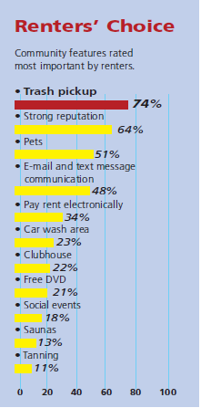
- Why Valet Trash?
- According to a survey conducted by the National Apartment Association (NAA), 74% of renters considered valet trash pickup to be the most important amenity offered by apartment complexes.

- Uncertain of Tenant Interest?
- Send us a request, and we will happily survey your residents to assess interest!

- About Us

- Holland & Husain Services, LLC is a company created by University of South Alabama alumni, James Holland and Zehra Husain. Based in Mobile, Alabama, H&H Services was created with a vision to assist in adding value and convenience to apartment living. Our first priority is always customer satisfaction. We are confident that both property managers and tenants will appreciate what H&H Services has to offer.

- Contact Information

- Address: P.O. Box 91664

Mobile, Alabama 36691

- Phone: (251) 235-1768

- E-mail: info@hhtrashservices.com

- Visit us at www.hhtrashservices.com for more information!

