We like the clean look and the easily changeable color and images to coordinate with various flavors.
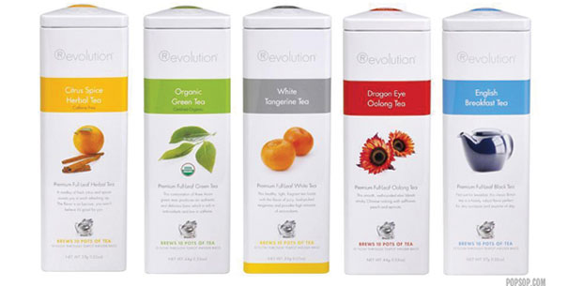
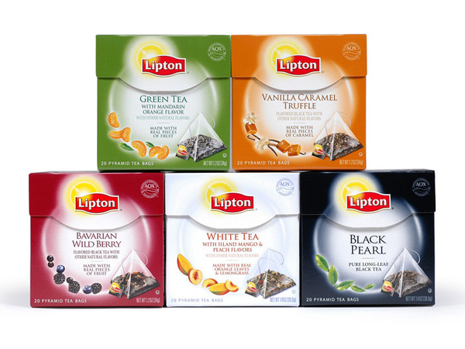

We are not particularly fond of the strong colors that is the entire packaging. What we do like about this is the uniform placement of the company name (mama chia) and the product line (Chia Squeeze). It also has a special place for the flavor to be changed.
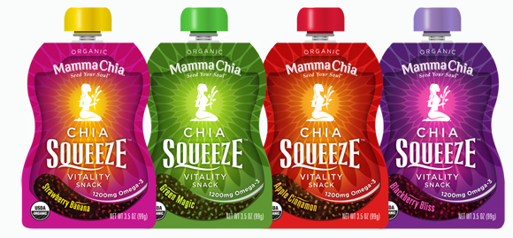

Below with Trachealth, we like the color schemes and clean elegant look. For our particular packaging however we would like a little more graphics.
