Green Whole Health Logo Brief

I would love a logo that emphasizes how nourishing food can be and that it really is medicine as well as promoting a greener way of living through nutrition articles and how to guides. I need it to be friendly to welcome people new to this space but also to have a clean yet nurturing feel.

I think of all the design elements out there, I love this one. The wood, the fonts, the balance of fun and clean fonts, the colours and the simplicity. Hopefully that gives you an idea of my style and the branding I want to go with.

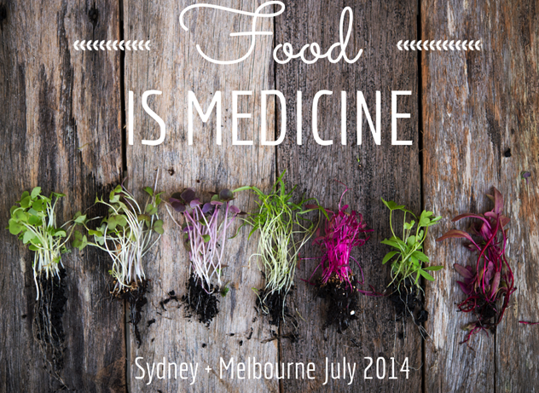

Logo
I love that this logo implies how food is nurturing but I would also want my logo to show that green whole health is a holistic approach to health, its about educating people on the greener options to living – nourishing the mind, the body and the spirit.
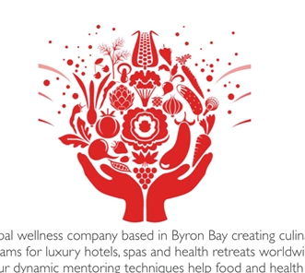

I would love to emphasise this kind of green or something slightly more vibrant like it in the first image:


I quite like these tones as well as the natural colours in fresh produce like kale, leafy greens, shades of flowers like peonies, dahlias, daisies, calendula:

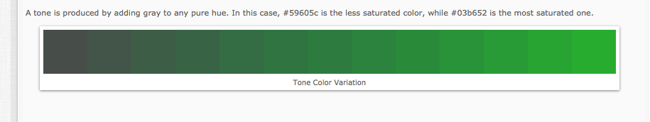

Fonts: I love the 2 fonts used in the first image the most and then I also I like these ones:
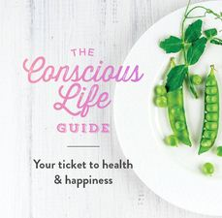

I think this font is similar to the above but I like it too:



