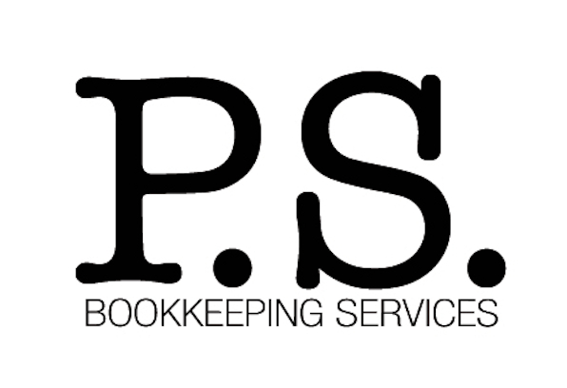

P.S. Bookkeeping Services is a full service bookkeeping solutions company in Nashville, Tennessee. We provide experienced, affordable and dependable bookkeeping services to businesses in the Middle Tennessee area. We have over 30 years’ experience in the bookkeeping field. This allows us to take care of your books, so you can concentrate on your business, while generating profits.

P.S Bookkeeping Services specializes in bookkeeping solutions for small businesses in various industries. We tailor our options directly to your business needs for the most effective and efficient solutions. P.S. Bookkeeping Services provides personalized service virtually or in person at your preference and discretion. Our outsourced bookkeeping benefits businesses by freeing-up valuable time, saving money by cutting employee overhead expenses, and having focused experienced staff to accomplish the work you pay for, nothing more, nothing less.

Peggy is the Founder of P.S. Bookkeeping Services. Over the years, she has worked as a CFO, Controller and Accounting Manager for several different businesses. She has worked for small, large, private, and non-profit companies, in different types of industries. Over time, Peggy decided to get back to what she loves doing the most, small business bookkeeping, and that is how P.S. Bookkeeping Services began.

SERVICES
• Account Analysis
• Accounts Payable
• Accounts Receivable
• Annual & Monthly Budgets
• Audit Preparation
• Balance Sheet
• Bank Deposits
• Bank Reconciliations
• Consulting
• Corporate Tax Return Preparation
• Credit Card Reconciliations
• Evaluate Accounting Software
• Inventory
• Invoicing
• Loan Schedules
• Payroll
• Payroll Tax Returns
• Personal Tax Return
• Prepare W'2s and 1099's
• Present Financials to Boards, Committees, etc.
• Profit & Loss Statements
• Property Tax Returns
• Small Business Loan Paperwork
• Variance Analysis

SOFTWARE
• QuickBooks
• QuickBooks Online
• ADP-Payroll
• ADP- Auto Dealership Software
• Ceridian
• Great Plains
• Home Accounting Solutions
• Intacct
• IOI
• MAS 90
• PayChex
• Paycom Parish Data Systems
• Peachtree
• Sage
• Sansio
• TAM
• Quicken

PRICING

* Flexible hourly, monthly, and project rates are available

REFERENCES

Michael Yates
PO Box 3429
Brentwood, TN 37024
Office 615-373-8290
Cell 615-569-1994
myates@tabstn.com

Chris Erlanson
168 Management
PO Box 680004
Nashville, TN 37206
Office: 615-469-1182
Cell: 615-573-3375
chris@168management.com

Scott Hammrich
Get MAD
4521 Michigan Ave
Nashville, TN 37209
Cell: 615-403-0886
madcarwash@yahoo.com

Tim Evans
Red Feather Gallery
916 8th Ave.
Nashville, TN 37203
Cell: 615-598 1963
Office: 615-598-2074
redfeathergallery@gmail.com

