Logo Theory (Precision Dental)
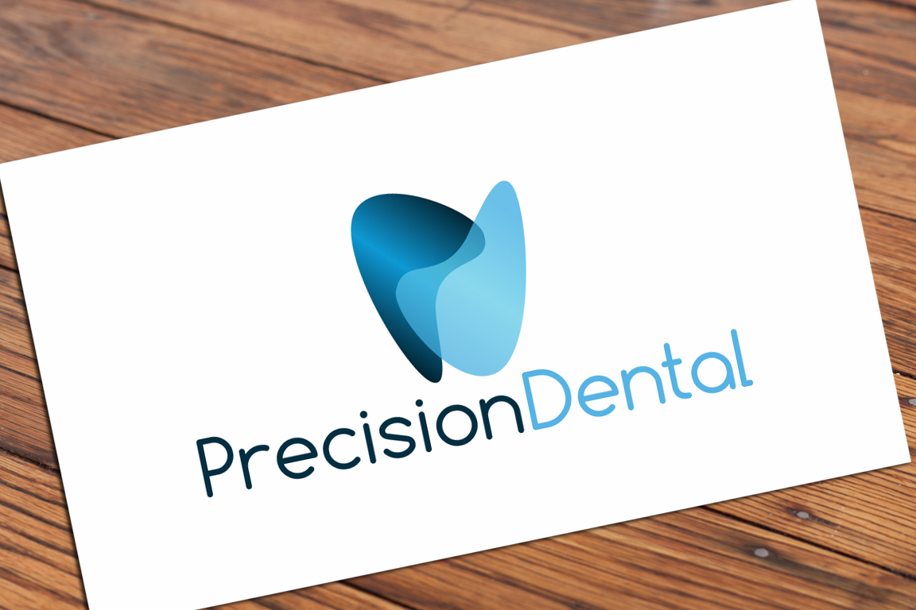
Design Concept
Logo is made with the two symbols referring to two letters ‘P’ – Precision and ‘D’ – Dental. The ‘P’ symbol is made solid (non - transparent) because it stands for the company name (Precision) while the ‘D’ symbol is made a bit transparent to make the teeth shape and to express dental industry.
Fonts
The fonts so chosen are “Comfortaa”. This font is one of the top fonts for modern dental industry. Font colors are matched with the logo to give a brand feel. To download the fonts please go to the following link: http://www.dafont.com/comfortaa.font

