

THE CALIBRE TECHNOLOGY
ACOUSTIC & VIBRATION CALIBRATION CENTRE

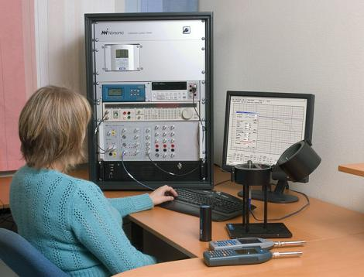The Calibre Technology Acoustic & Vibration Calibration facility offers third party accredited acoustic calibrations, and is the only NATA accredited acoustic calibration laboratory in QLD.  The facility is NATA accredited to complete calibrations in accordance with a range of International and Australian standards including:  - IEC60672.3  - AS 1259.1 & 1259.2  - IEC 60804  - DIN 45657 (statistics)  - IEC 61260  - AS/NZS 4476  - AS IEC 60942  - AS/NZS 2399 | The turnkey calibration system used by Calibre Technology was supplied and installed by Norsonic, one of the worlds leading specialist Acoustic instrument manufacturers.  Calibre Technology specialists have been trained by Norsonic to provide NATA accredited calibrations of the full range of acoustic instruments:  - Sound Level Meters  - Dosimeters  - Frequency Analysers  - Calibrators  - Microphones  NIST traceable calibration of vibration monitoring instruments is also offered by Calibre Technology.  The standard turn around time is two working days where a prior booking is made (subject to availability). A premium 24 hour turn around service is also available on request (subject to a surcharge).  To obtain a quote or to make a booking call us on:  07 3245 1730  or email:  enquiries@calibretechnology.com.au

The Calibration Centre accepts models from all leading acoustic manufacturers for calibration, including:  - 01dB  - ARL  - Brüel & Kjær  - Castle  - CEL  - Cirrus  - Dawe  - Elma  - Gras  - Larson Davis  - Magus Electronics  - Norsonic  - Nova Electronics  - Ono Sokki  - Pulsar  - Quest  - Rion  - Simpson  - Svantek  Full test reports detailing the results of the calibration tests are provided with the calibration certificate. | Our objective is to provide excellence in metrology at turn around times that minimise downtime for our customers.  We are very proud of our state-of-the-art Calibration Facility, and visitors are welcome to visit us at any time to see calibrations being completed.
Calibre Technology
Delivery Address:
Unit 3, 4 Tombo Street
Capalaba, QLD 4157

07 3245 1730
enquiries@calibretechnology.com.au

