
CITE – Body worn camera advantages – The most technically advanced body worn video camera on the market:
Choice of 4K HD video or 1080P Low Light camera head
Rotating camera head to allow Head or Body mounting
Built in 802.11 B/G/N/AC Wi-FI
Built in 3G/4G modem
Bluetooth Low Energy and NFC
4 Constellation GNSS Receiver (GPS / GLONASS / Beidou / Galileo)
Runs Android 4.4 allowing for STRATERSYS apps such as Facial Recognition or ANPR to run directly on the device
Complete Blue Force Tracking
Integrated 1.6” AMOLED Touchscreen Display
9 Axis Inertial Measurement Unit
USB 3.0
8 Core Processors
IP67 Certified
Remote activated real time audio / video streaming
Geo-fenced automatic upload
RRP: $399
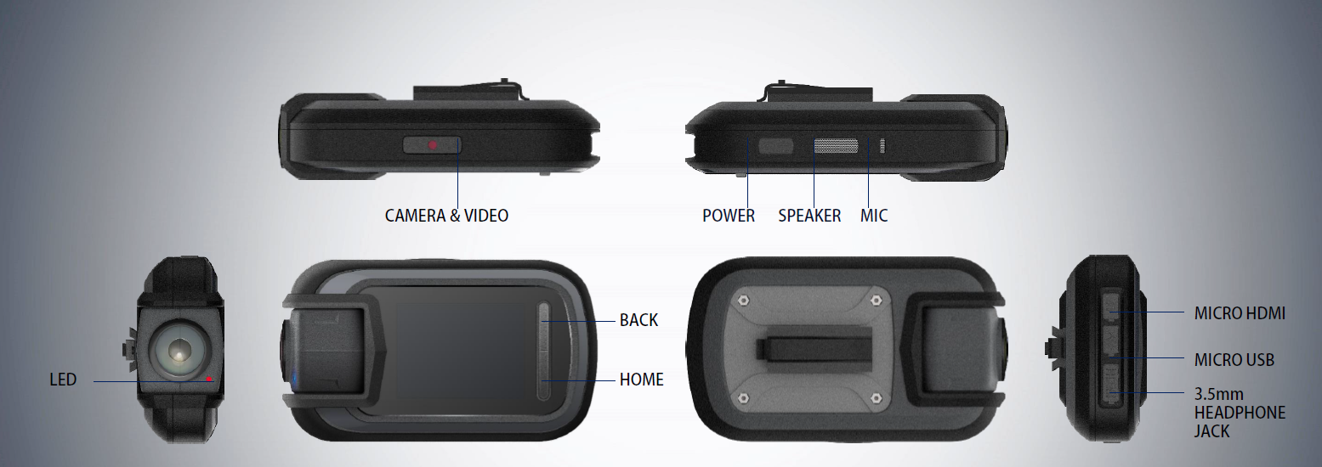
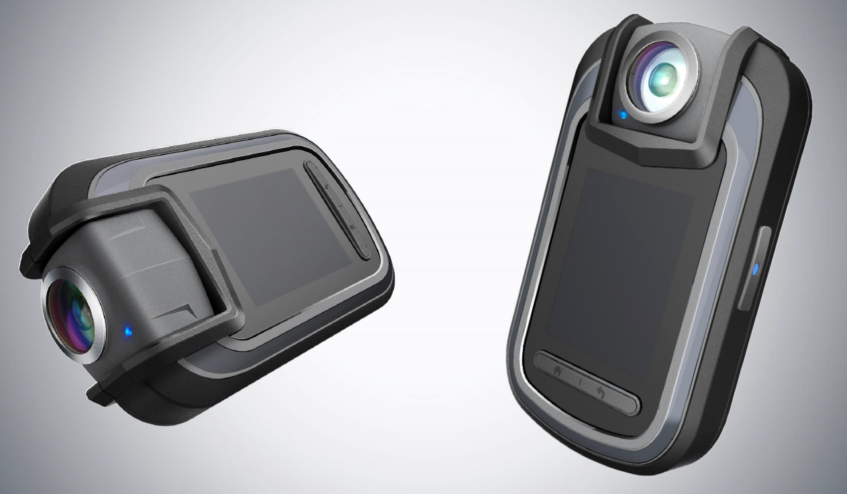
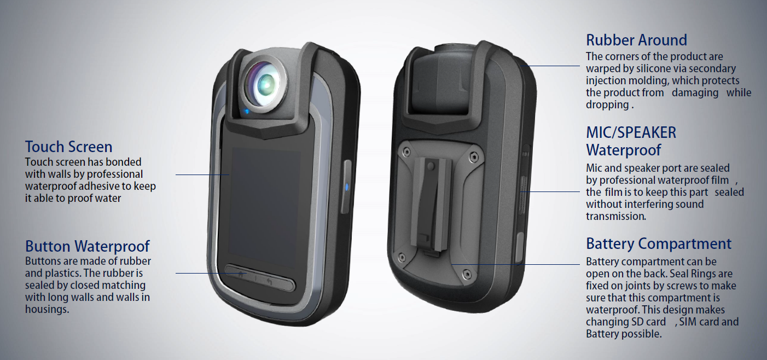
Additional imagery may be available on request: travis.reddy@stratersys.org

Tough Ink Alpha Tactical Pen:


IP67 Certified
Pressurized Ink Cartridge allows writing upside down or on a wet surface
LED Integrated into the writing point to shine light on the writing surface (no need to try and hold a torch at night)
Removable Handcuff Key or Screwdriver
Glass Breaker
Touch Screen Stylus (works on capacitive touchscreens as well)
Retractable Nib
Made from Anodized aircraft grade aluminium
RRP: $12
