Web24 Data Centre Fact Sheet
Noble Park, Melbourne VIC

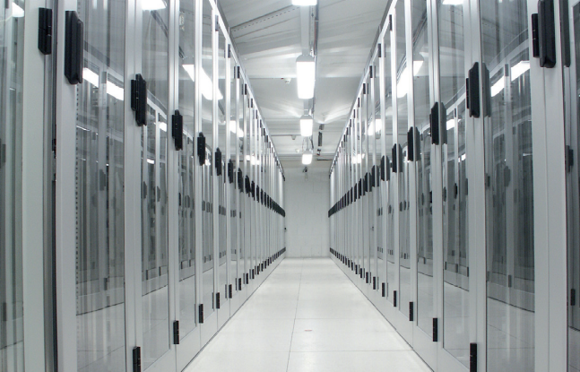  Architecture  - Purpose built data centre, constructed in 1988  - 2-hour fire rating on all data hall doors walls  - Absence of external windows and signage  Location  - Situated 24 kilometres from Melbourne C.B.D. at Noble Park, Melbourne, VIC., Australia  Dimensions  - Land 18,600m2  - Building 6,700m2  - Raised data hall+ 1,080m2  - Plant and equipment area 1,760m2  - Office area, work area and amenities 885m2  - Parking area for up to 50 vehicles  Service Level Targets  - 99.99% availability on all electrical and mechanical systems  - Ambient temperature of 22 degrees +/-2 degrees  - Relative humidity of 30-70%  Maintenance and Support  - All infrastructure components monitored 24x7 by a nationally integrated BMS  - Core infrastructure tested and maintained to manufacturers recommendations or better  Shipping and Receiving  - Loading dock available 24x7 for shipping and receiving  - Site-suitable lifting and moving equipment available  Green Initiatives  - PUE and DCIE monitored and reported  - Closed loop chilled water systems  - Sensor lighting installed in data hall  - Latest technology chiller utilising high COP  - Heat reflective painted roof  - Free Cooling | Electrical System  - 2 x 4MVA main feeds via diverse entry points and pathways  - 1800KW Diesel Rotary UPS in N+1 configuration  - On-site fuel storage sufficient for 72 hours non-stop operations  - Power allocation design of minimum 1000w per m2  Mechanical System  - Closed loop chilled water piping system installed in diverse underfloor runs  - Energy efficient chiller plant in a minimum N+1 configuration  - 48X CRAC units placement providing hot/cold aisle cooling  - Underfloor leak detection and off-floor drainage system  - Mechanical system support by diesel power generation  Fire System  - Early warning smoke detection (VESDA)  - Smoke and fire detection installed under and above floor and in roof cavity  - Dry-pipe, pre-action fire suppression  Security & Certification  - 24x7 manned security office and personnel entrance check-point  - Perimeter vehicular security check-points  - CCTV monitoring and capture of perimeter and internal access  - Proximity card access points to data hall and other secure areas  - Certification to ISO-27001 Information Systems Security Management  - Certification to ASIO T4 Intruder Resistance  - 24x7 access permitted to authorised personnel  Telecommunications  - Carrier-neutrality  - 2 diverse under-ground cable pathways to the building  - Multiple telecommunications carriers are used to supply the external data communications links, enabling external connectivity redundancy. Currently these providers are Vocus Connect, Pipe Networks, Verizon and UECOMM  Data Hall  - Minimum 600mm raised floor  - Floor rating to 1400kg per m load  - Floor tile system resistant to Zinc whiskers  - Earthing system

Web24 Internet Connectivity

Web24's network provides extensive resilience through the use of multiple diverse network carriers, multiple fiber carriers and four (4) failover / redundant BGP border routers. Our network design removes single points of failures wherever possible and introduces N+1 design principals. Switching fabric is 10GE and 1GBPS utilizing Rapid Spanning Tree to ensure layer 2 redundancy. Firewalls (not shown in this diagram) use statefull failover to secondary HSRP devices. Web24 has maintained 100% network availability since the introduction of our multiple diverse network carriers.
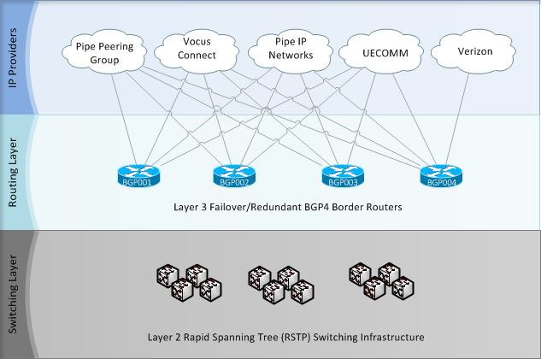

Managed Backup Services

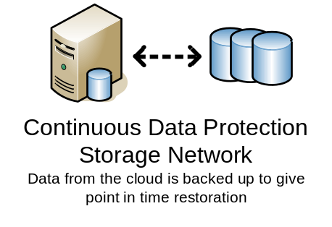

Managed CDP Backups

All Web24’s server solutions, both dedicated and virtual, have an optional Managed Backup service available. This service takes advantage of R1Soft’s CDP, an industry leading backup software solution.

Alterations to the server are recorded in Continuous Data Protection (CDP) backups. These backups can occur on a daily or 4 hourly basis, depending on preference. This allows for a point in time restoration of individual files or the entire server. Backups are kept for a period of 14 days for daily* and 3 days for 4 hourly backup*.

These backups are stored on a Network Attached Storage (NAS) network which is reachable via a private network connection. The Server and NAS communicate through the ‘back end’ private network, which is highly secure and not accessible through the Internet.

Restorations are available upon request, through Web24’s Support team. One restoration per month is included. Further restorations are chargeable at standard rates.

Offsite Backup

Virtual and Dedicated Server systems utilising a Managed Backup service also have an option of having data stored offsite.

These offsite backups are rotated between Web24’s data centre and office. Media is stored in a fireproof safe. The rotations are available on a monthly, bi-monthly, and weekly rotation schedules*.

Offsite restoration is chargeable at standard rates.

* Custom backup policies and retention schedules can be accommodated by request to sales@web24.com.au

