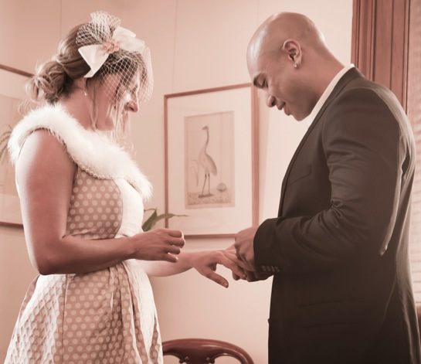
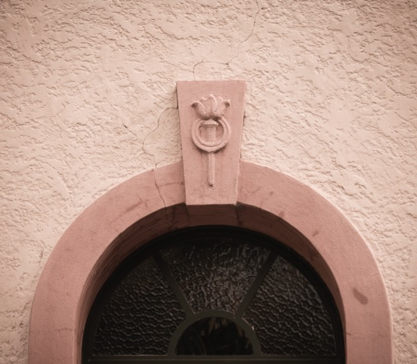
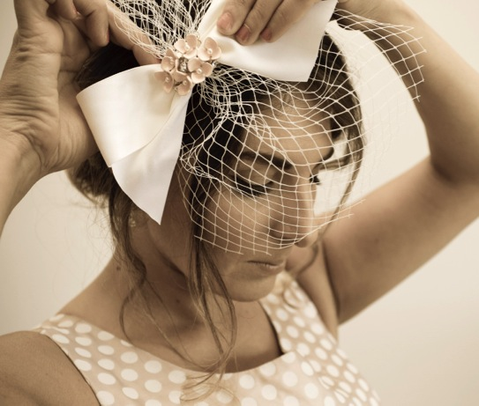
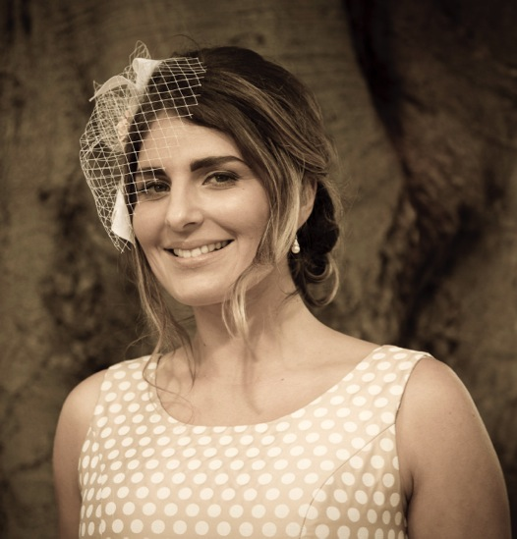
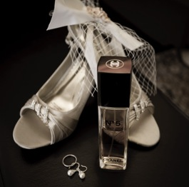
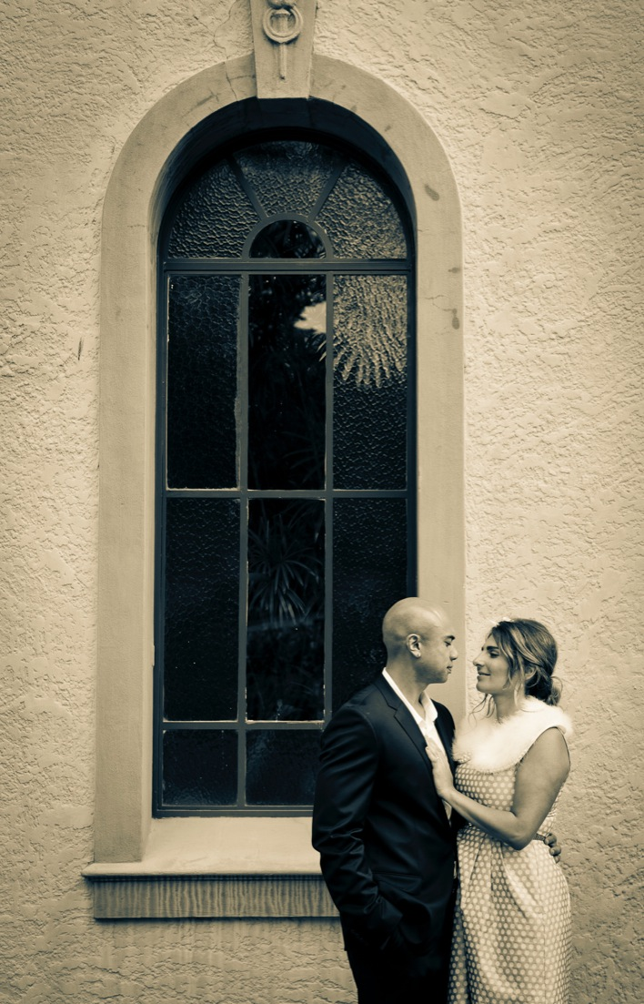
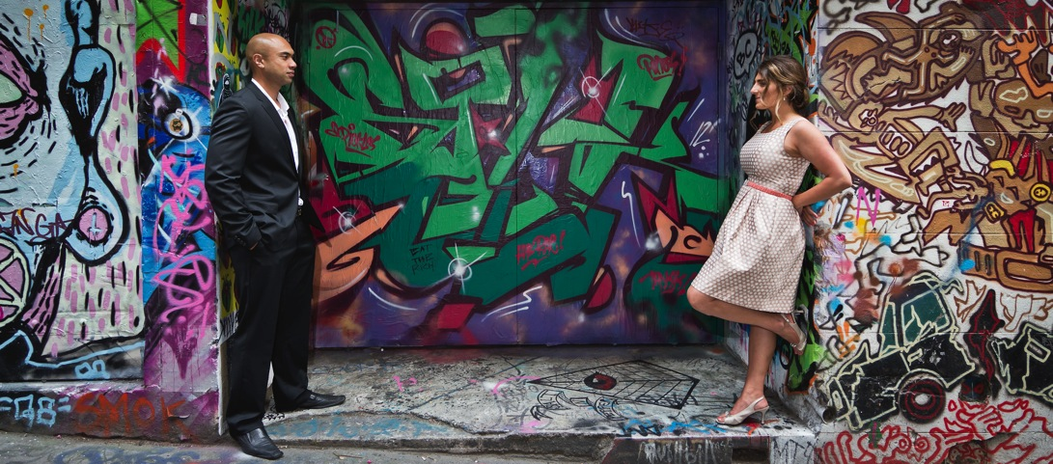
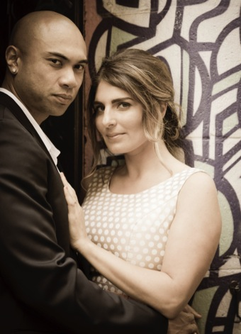
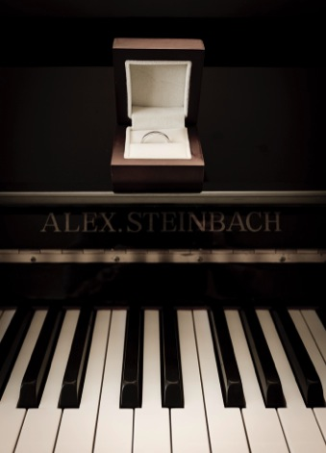
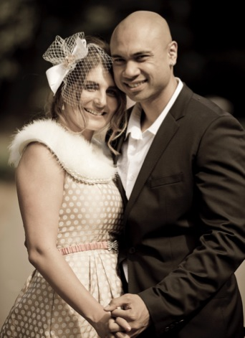
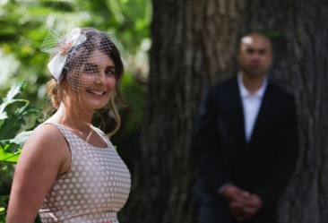
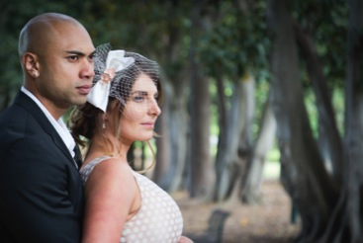
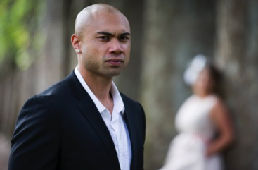
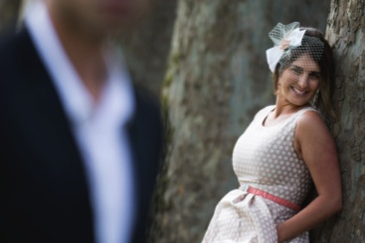

Love
is all
you need.
Style & Approach
Emily can observe and capture your wedding day in the background, quickly and quietly taking photojournalistic pictures rather than directing it if you prefer. Or she can confidently play the role of Art Director and instruct beautiful poses. Either way, what is most important is that her clients are relaxed and having a really great time on their wedding day!
Formal Photography
Many of Emily's clients book her because of the easy-going approach she has. They can get on with having a great time on their day without worrying about formal photography. However, there are occasions when clients do want formal family pictures, and Emily is more than happy to accommodate their requests.
In order to keep the disruption on the day to a minimum, we recommend that Emily photographs no more than 6 groups, and a select number of the special couple.
Image Presentation
The most professional way of presenting clients with their photographs is in an elegantly designed photo book. Emily's clients only pay one fixed price for the photography, regardless of how many images taken. There are no hard sell procedures to go through, and the completed book is prepared within 2-6 weeks after the wedding day.
Time of Year
Signature pictures can be taken on overcast days or winter months. Don’t worry if the sky is not perfectly blue. In the end, regardless of the weather – it's the timeless mood of the day that Emily strives to capture.

+

Emily’s approach…

Enjoy your special day!
What client’s are saying…
“Words can’t express my thanks Em, I am absolutely in awe of my photos!
You’ve captured my wedding day perfectly; couldn’t ask for anything more.”
- Bel, Yarraville

"Thanks so much for photographing our special day, you did an amazing job and made everyone feel so comfortable. The amount of comments we have had on the photos so far has been wonderful and we couldn't be happier!"
- Belinda,
West Footscray

+

Price: $1650
($2080 value)
- Up to 4 hrs of coverage
- Regular (A4) Album with Lay-flat 300g paper, printed cover, dust jacket, presentation box, up to 32 pages
- Web Gallery (online for 6 weeks) & Social media
- High Resolution Digital Negatives*

Price: $2300
($3440 value)
- Up to 6 hrs of coverage
- Regular (A4) Album with Lay-flat 300g paper, printed cover, dust jacket, presentation box, up to 42 pages
- Slideshow
- Pre-wedding shoot
- Web Gallery (online for 6 weeks) & Social media
- High Resolution Digital Negatives*
* Approx. 1200x1800 jpeg at 240 pixels per inch. Suitable for prints up to 8x10inch. No watermarks
No
Price: $3650
($5540 value)
- Up to 8 hrs of coverage
- Signature Grand (A3) Album with Lay-flat 300g paper, frosted page, choice of premium linen or leather cover, presentation box, name embossing, up to 52 pages
- Custom Thank-you Cards with envelopes (50)
- Client for life (no sitting fees)
- Second photographer
- Fusion Slideshow (still + moving images)
- Pre-wedding Shoot
- Web Gallery (online for 6 weeks) & Social media
- High Resolution Digital Negatives*
Gold
Platinum
Signature

Wedding Packages

Pricelist 2013
+
Engagement Session/Pre-wedding Shoot
- $290 for up to 2 hours of photography on location
Digital Negatives
- $490
Extended Coverage
- $160 per hour
Web Gallery & Facebook posting
- $160
Slideshow
- $250
Second Photographer
- $590
Client for life
- No sitting fees for portrait sessions – Anniversaries, family portraits, etc: $390
Photo Enlargements
- Quality custom archival prints in a variety of sizes 5x7 up to 8x10 $25, 12.5x18.5 $50
- Stretched Canvas Prints for your wall Various sizes available from 16”x20” starting at $395 through to 60’’x96” $1500
- Plus many other options!
Professionally Edited Album (Regular)
- $790
Album Upgrade from Regular to Signature Grand
- From Gold Package to Signature Grand: $1150
- From Platinum Package to Signature Grand: $650
Custom Thank-you Cards
- $150 for 50 cards (174mm x 123mm) including envelopes

+
À la Carte Fees to Consider

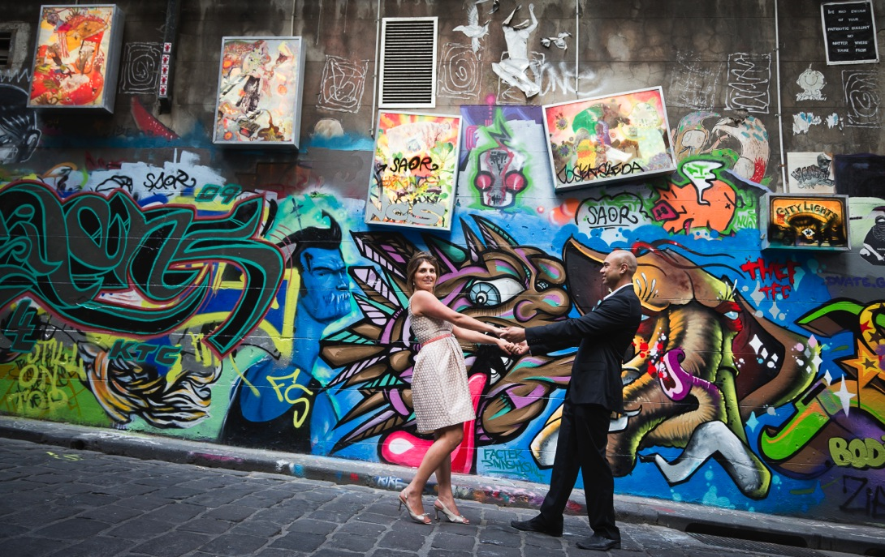

  - Elegant, stunning, fuss-free photography that doesn’t cost the earth
will capture those memories for a lifetime!

  - Wedding photography packages start from $1650 and are fully inclusive of fun-filled creative & journalistic coverage, digital negatives and professionally edited album.

  - Contact Emily today to arrange an informal catch-up, discuss your requirements and find out more about the early booking bonus!
O’Farrell Street, Yarraville, VIC, 3013
www.emilymogic.com Email: emily@emilymogic.com Mobile: 0403 311 614
+
How do you want to remember
your special day?

