Expedience takes a new approach to RFP response software and document automation.
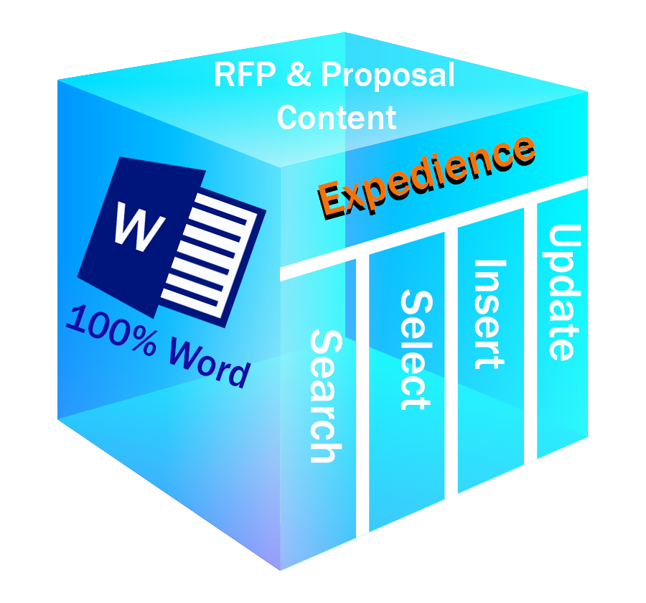
Where conventional systems in this arena have often relied on complex combinations of software tools such as backend databases, web-front ends, cloud repositories and multiple user interfaces, Expedience uses only one software platform – Microsoft Word®.

The implementation is completely developed and contained within Word with no outside software beyond Word’s native components and structures.
Expedience 100% Word-based RFP and Proposal System
This approach provides writers with a streamlined and seamless experience. From directly within Word content may be selected, updated, and formatted without ever leaving the Word environment. In effect, the software recedes into the background allowing the writer to flow through the RFP or proposal quickly and confidently; with all the tools necessary immediately available in the everyday context of Word.
The result yields dramatic improvements in speed, ease-of-use, and efficiency in accurately completing the challenging work of RFP and proposal production.

Contact Us:
Expedience Software
www.ExpediencSoftware.com
978-378-5330

