(Cover)


They have a lot going on. We’ll take it from here.

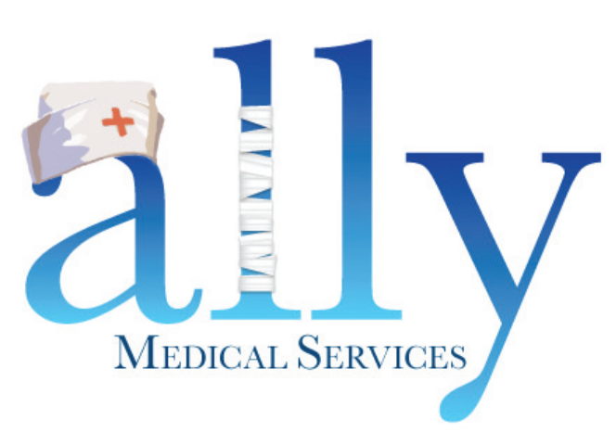
Nutrition. Our mission.

(Page 2)
Specializing in nutrition.
Your patients came to you because of your specialization. Ally Medical continues that specialized service by providing unique insight into the set-up, delivery and continued management of supplies & equipment for nutritionally compromised children living at home. We supply more than just vital medical products to families, we provide peace of mind.
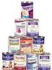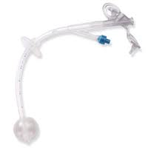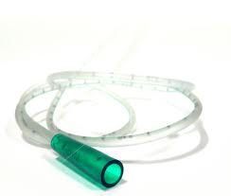


Specializing in Medicaid.
Keeping up with the changes in state Medicaid programs is a critical component to optimizing outcomes for your patients. Ally Medical has over 20 years of experience understanding the benefits, documentation and reimbursement requirements of Medicaid, state waiver programs and Managed Medicaid Replacement plans.



PHONE (866) 684-2507 • FAX (866) 695-2183 • support@Ally247.com

(Page 3)

Specializing in service.
➢ Bilingual field & support staff for friendly, accurate communication.
- Easy patient referrals via fax, phone, web or secure email.
➢ Comprehensive, rapid supply set-ups and accurate home deliveries.
➢ Coordination of documentation paperwork to meet all regulatory requirements.
➢ Medicare, Medicaid, managed care & most commercial insurances accepted.



Specializing in quality.
Accreditation is an important component of quality care. Ally Medical is accredited by the Joint Commission, the most recognized symbol of an organization’s commitment to meet health care’s highest quality performance standards.


(Back Page)


They have a lot going on. We’ll take it from here.

Nutrition. Our mission.


www.Ally247.com
4951-B E Adamo Drive, Suite 220 Tampa, FL 33605-5913
PHONE (866) 684-2507 • FAX (866) 695-2183 • support@Ally247.com

