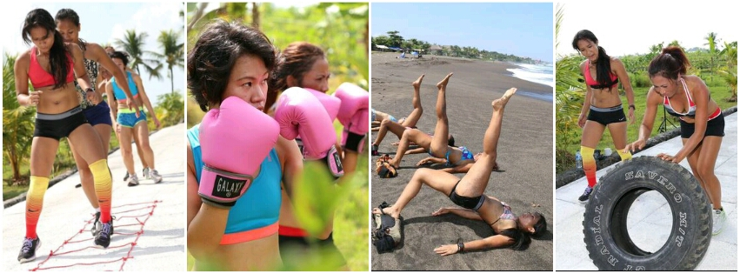
SPICY WOMEN BOOT CAMP
BALI RETREATS



Email : nineth.ninefitness@gmail.com Email : info@sharingbali.com
Mob : +62 812.8277.5371 Mob : +62 812 3761 3379
Web : www.nine-fitness.com Web : www.sharingbali.com

SPICY WOMEN ACTIVITIES
DAY | ACTIVITIES
One | 2pm : Group Transfer from Airport or nearby Hotel.  5pm : Settle into your Bungalow with a welcome Lemongrass tea.  6pm : Time to get to know each other and Introduction to the program.  7pm : Dinner Balinese Style
Two | 6am : Stretching - Assessment - All Fitness Intro  8am : Breakfast  9am : Fun Jungle Trek Fitness adventure  12n : Lunch  2pm : Body weight Management Work Shop  4pm : Muay Thai Strength & Conditioning  7pm : Dinner
Three | 3am : departure for Mt. Batur Sunrise Volcano Climb  9am : relax at the Lakeside Hot springs  12n : Lunch  3pm : Home Training Work Shop  4.30 : Pilates  7pm : Dinner
Four | 7am : Breakfast  8.30 : Interval Training on hills  12n : Lunch  2pm : Nutrition & Diet work Shop  4pm : Yoga  7pm : Dinner
Five | 6am : All Fitness - HIIT Strength & conditioning  8am : Breakfast  9am : Jungle Trek  12n : Lunch  2pm : Traditional Balinese Dance Class  7pm : Dinner
Six | 6am : Final Training - 5 Fitness Elements - Final Challenge - Fitness Performance & Review  8am : Breakfast  9am : Sister Talk / Motivational speaking  12n : Farewell - Departure to Airport or next destination.

WHAT TO PACK

Keep it simple. Travel light. Make the most of the daily laundry service.

Training sessions
4 sets workout gear as a minimum. Sports water bottle. Best to bring 2 pairs of shoes – one old pair for muddy
conditions.

Yoga & Stretch sessions
Comfortable stretch pants and Tee’s

Walks & treks
Workout gear works best. Bring gear, including sport shoes that you don’t mind getting wet and dirty at times

Shoes
We spend a lot of time outdoors, so pack suitable sandals or thongs.

Everyday
Preferably bring 2 pairs of sport shoes as this allows time for one pair to dry if necessary. Old shoes are best!

- Light weight casual clothes for the tropics. Long sleeve sweater/t and pants for the surprisingly cool evenings/early mornings. Sleep in whatever is comfortable for cool nights.
- Hat, sunglasses, sunscreen, umbrella, insect repellent, refillable water bottle – it’s the tropics.

Volcano/Hot Springs
- It’s very cool when you start, but you will soon be warm. Wear layers. A nylon wind jacket is a good idea.
- We can provide you with a walking stick (the local version – a piece of sturdy rattan)
- Swimming gear
- Daypack. Small torch, preferably headlamp. Refillable water bottle or camelpak
- Sport shoes are ok, but some people feel more comfortable in light hiking boots.

Bits & Pieces
Bring an adaptor suitable for Indonesia if you need to use your charger.

Reusable shopping bag or daypack is a good idea to help avoid plastic bags if you go shopping.
Pack the camera. Check the batteries before you leave.
There will be some time to relax, so bring a book. We also have a library of books to share

Banned Narcotics
Don’t even think about packing them! You will be terminated from the property.

Be prepared to challenge yourself and have a lot of fun.
Most importantly pack an open mind! You are about to have a very unique experience.

HANDY TRAVEL HINTS

The Airport (international)
- Ensure that your passport is valid for 6 months with 1 empty page.
Before you go through immigration you will have to pay $US35 for a visa in $AUD or $US. Cash only accepted.
- Allow rp200,000 departure tax (around $20)
- If you are unsure about the airport arrival process you might want to use one of the VIP arrival services now available. They will meet you in the arrivals hall and escort you through the entire visa/customs/luggage process. There are many services. Google “VIP Airport service Bali” for some results. This is one example: http://voabali.com/reservations.html

Group Transfers
Your package includes group transfers to the retreat from the airport or nearby hotel at approx. 2pm on Day 1. Group
transfers at end of retreat are to airport or nearby hotel.

Money
Local currency is Rupiah and the exchange rate does fluctuate.
ATM and currency exchange is available at the airport. (no facilities at the retreat)
You will only need cash for your extras whilst on retreat.

Drinking Water
Only drink bottled water, including cleaning your teeth.

Staying In Touch
- We have mobile phone reception, but no landlines or WiFi. Ensure that global roaming is organised to your phone BEFORE you leave home. (Global roaming is expensive). Indonesia code is +62

- To use your phone with a local sim card do the following: Your phone must be unlocked and ready to accept a new sim card BEFORE you leave home . Bring the device to release the sim card on your iPhone. iPhone4 users have to have the sim card cut down – the card sellers usually do this for you. Best to buy the new sim card and phone credit BEFORE you arrive at Ayung Sari Indah. You can buy these at the airport from a kiosk that sells drinks etc. We can buy more phone credit for you as needed.

Meals
Meals are a delightful time at sharing Bali. We all eat together and our style is genuine village style Balinese food.
Spicy vegetable, fish or chicken dishes accompany rice. Fruit is served with every meal. No preservatives, nothing
packaged. Just fresh food.
For safety reasons we are unable to accept guests who have a fatal allergy to any foods. We are not equipped
to serve separate meals and as the closest hospital is 2 hours away we prefer not to put anyone at risk.
(There is an international standard clinic in Ubud).

Alcohol
The only alcohol we serve is the local beer. Bring your own wine as it is difficult and expensive to buy locally. We can
provide juices, tonic, soda etc. for you to mix with your own spirits.

Safety
Make sure you have travel insurance (compulsory for all of our guests).
Please bring a photocopy of your passport photo page for local registration purposes.
Be responsible about any medical conditions you may have. Pack your medications and prescriptions as necessary.

SPICY WOMEN BOOT CAMP
BALI RETREATS

6 Days/ 5 Nights Fitness, Fun, Friendship & Adventure
$1650 pp

INCLUSIONS
• Food and Accommodation
• Group transfers from airport or nearby hotel to retreat on Day 1
• Group transfers to airport or nearby hotel from retreat on Day 6
• All activities on the program
• Bonus Gift :
- Pair of Boxing Gloves
- Spicy Women Tank Top & Workout Towel
- 30 mins Massage
EXCLUSIONS
• Flights to/from Bali
• Travel Insurance
• Bottled drinks such as water, soft drinks, beer
• Personal laundry
• Extra tours, transport, massages, spa treatments outside the program

TERMS AND CONDITIONS
• Travel Insurance is mandatory for all of our guests
• Please confirm any special dietary needs before booking. Please note that for reasons of safety we cannot take guests who have a fatal allergy to any food/food groups. We are unable to provide separate meals
and are very aware that the closest hospital may be up to 2 hours away.
• All clients to complete a Fitness & Health Assessment from Trainer and to be completed prior to booking.

• Installment Payment is possible
• To secure your retreat we require a non-refundable
deposit of $500pp
• Final payment to be made 30 days prior to arrival date. Cancellation fees may apply
• All funds are non-refundable if a guest chooses to cancel
within 30 days of retreat start date.
• Refunds/credits will not be given after journey commencement, even if services, activities or meals are unused or cancelled for any reason
• Personal expenses to be paid in cash at end of retreat (laundry, drinks etc)
• We operate rain, hail or shine!

Further Info :

Nineth
+62 812.8277.5371
nineth.ninefitness@gmail.com
www.nine-fitness.com

