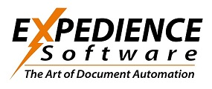
Automated RFP Response and Document Creation Software

Expedience takes a new approach to RFP response software and document automation.

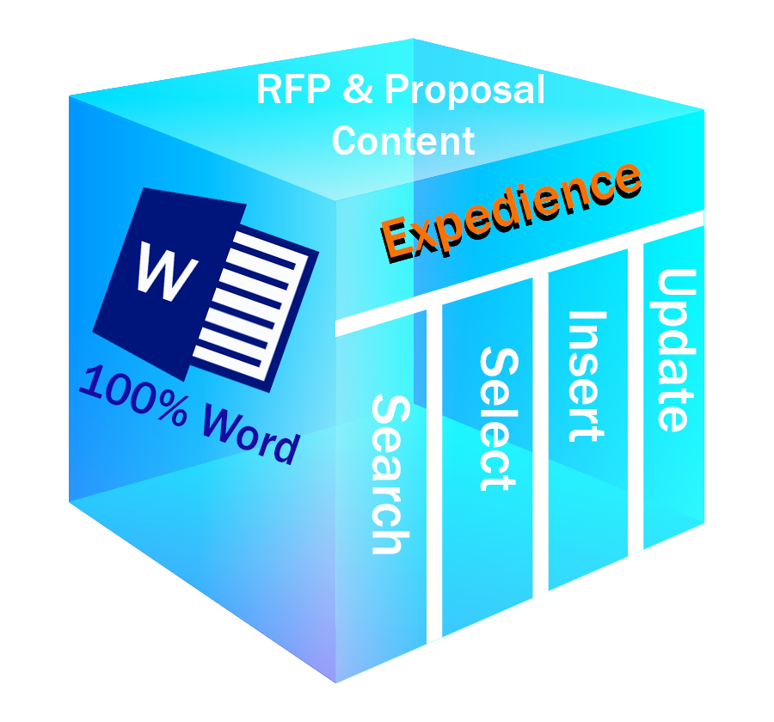
Where conventional systems in this arena have often relied on complex combinations of software tools such as backend databases, web-front ends, cloud repositories and multiple user interfaces, Expedience uses only one software platform – Microsoft Word®.

The implementation is completely developed and contained within Word with no outside software beyond Word’s native components and structures.
Expedience 100% Word-based RFP and Proposal System
This approach provides writers with a streamlined and seamless experience. From directly within Word content may be selected, updated, and formatted without ever leaving the Word environment. In effect, the software recedes into the background allowing the writer to flow through the RFP or proposal quickly and confidently; with all the tools necessary immediately available in the everyday context of Word.
The result yields dramatic improvements in speed, ease-of-use, and efficiency in accurately completing the challenging work of RFP and proposal production.

The Expedience Ribbons

There are three distinct Word ribbons that form the capabilities of Expedience. They are:
Content
Portfolios

RFP Content Portfolio Ribbons
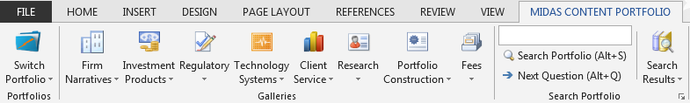

The Content Portfolio ribbons put all your reusable RFP and Questionnaire elements into a simple interface directly in your current Word document.
The Portfolio Ribbon can automatically search, format and insert answers directly into your RFP.
The information you need is always available immediately in Word.

Key Benefits:
- Fully customizable Microsoft Word Ribbons.
- Easy Search and Content selection
- Organized in up to 8 drop-down Galleries per Portfolio with as many Portfolios as necessary.
- Edit and Update directly from the current document
- Supports all of Word’s graphics, tables, embedded objects, video and more.


Style Palette Ribbon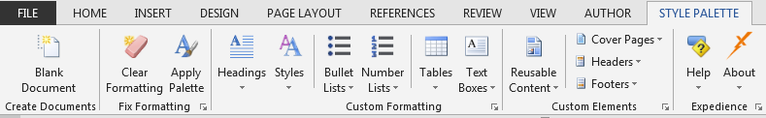
Style
Palette

The Style Palette Ribbon gives you precise control over all the major building blocks of your document.
Fonts, Tables, Text Boxes, Color schemes, pre-formatted cover pages, headers and footers. Even elements such as custom bullets, and complex lists.
You and your users will never again be at the mercy of Word’s idiosyncrasies in handling these objects. Also, you may enforce a standard look-and-feel across all your key documents.
Consistency and reliability of your formatting results are ensured with the Style Palette.
Key Benefits:
- Corporate headers, footers, and boilerplate now just a click away.
- Numbered lists and bullets made easy and consistent.
- Fixes and cleans frustrating formatting problems.
- Dynamic menus put favorite styles at your fingertips.
- Enforces proposal-specific formatting requirements.
- Ensures consistency of corporate styles.

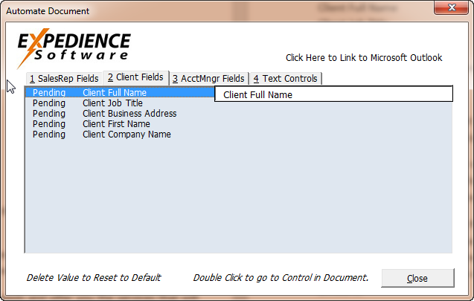
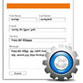
Automation Studio
Automation
Studio

The Automation Studio creates compelling, beautifully formatted, On-Demand proposals using your styles and content elements.
The Studio also ensures that your document is finished correctly with names, addresses and other open fields replaced appropriately.
A simple to use form is presented to handle these replacements.
One-click integration with Outlook updates fields in a single step.
Excel charts and worksheets may be viewed and inserted directly from the Studio Ribbon.
Key Benefits:
- Add automation to any document.
- Generate custom documents with automated templates.
- Process content placeholders with automated prompts
- Run dynamically created forms.
- Customize finishing steps to ensure document accuracy.

Content Review and Compliance
Expedience provides a straightforward process for content review, approval and updates. Content records may be sent to subject experts and compliance officers in based on a variety of defined criteria, such as a review schedule or specific individual. Once properly approved, records may be updated to Expedience for use by the proposal team.

Technical Requirements
Software: Microsoft Word – 2007, 2010, 2013
Microsoft Windows
Hardware: Modern processor and memory configuration sufficient to run Word

About the Founders
Mellisa Mabon– Before Expedience, Melissa was the co-founder of Pragmatech Software (1994), inventors of The RFP Machine and Proposal SmartDocs. She holds two Master’s Degrees from Columbia University (M.A, M. Phil.) and has worked extensively in the fields of expert systems and applied logic. She was named New Hampshire Entrepreneur of the Year in 2002.
Brooke Savage – Brooke was also a co-founder of Pragmatech Software. He was a proposal writer and RFP team leader for many years in the software industry. In the late 1970’s he programmed client presentation and proposal software for CIGNA before the advent of Microsoft Office. This led to a career-long interest in providing writers with tools to improve their daily work experience.

Contact:
Expedience Software
www.ExpediencSoftware.com
978-378-5330

