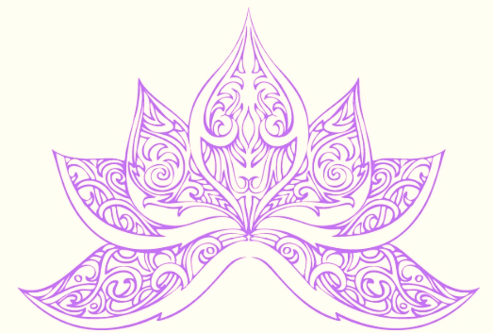
BodywoRx Aesthetics Clinic
Between 6th St (Najda)
& 8th St (Al Salam)
Opposite Al Dana Girl's School
PO BOX 128270
Abu Dhabi, UAE
T: +971 2 641 9961
E: info@bodyworx.ae

BodywoRx
Laser Hair Removal



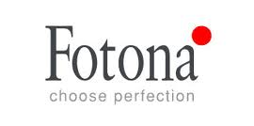

Laser Hair Removal Price List

Upper Lip 250
Back of Hands 480
Chin 300
Chin and Neck 550
Chin and Beard 500
Beard Definition 640
Neck & Beard Definition 750
Full Beard 800
Lower Half Face 700
Lower Half Face and Neck 800
Full Face 850
Neck (Women) 320
Full Neck 680
Full Face and Neck 1000
Full Breast (Women) 300
Chest (Men) 1600
Buttocks 1040
Lower Back 1500
Upper Back 1500
Full Back 2000
Abdomen 1100
Underarms 600
Half Arms 880
Full Arms 1440
Half Legs 1800
Thighs 2100
Full Legs 2600
Bikini 650
Bikini + Underarm 1050
Full Bikini 1200
Full Bikini + Underarm 1600
Full Body 6400




Remove unwanted hair
quickly and more effectively
with laser hair removal
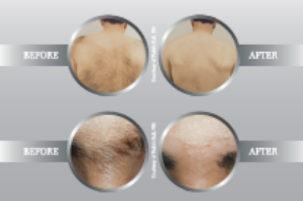
The deep penetration of Nd:YAG laser ensures it reaches even the deepest follicles, while its low absorption in all skin types ensures the surrounding tissue is preserved. This guarantees safe, fast and effective hair removal, even in the darkest skin types, without the epidermal damage other light-based treatments inherently cause. The procedure is quick and largely pain-free. You will be able to return to your normal activities immediately.
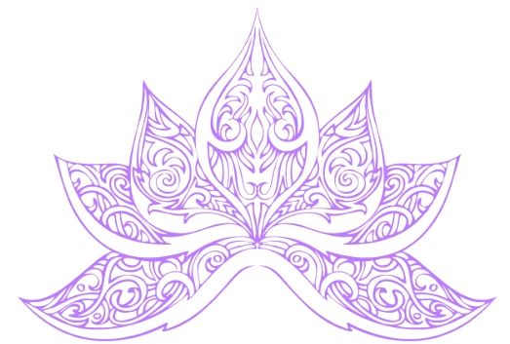
Because hair grows in cycles, it takes several treatments for complete removal. The outcome also depends on hair quality and the quantity of hair follicles, along with the metabolism and hormonal level of each individual. As a guide, however, four to six treatments are usually all that are required to effectively remove all the hair.

Almost our entire body is covered with hair. Most of it is fine and pale, however we almost all have darker, coarse hair in places we wouldn’t want or expect. It may be a question of aesthetics or hygiene; in any case, this excess body hair is often considered as embarrassing and bothersome, especially in places like legs, bikini line, neck, arms and armpits, chest and back.
Laser hair removal is becoming more and more mainstream with women as well as men; it is one of the most popular aesthetic treatments in practices all over the world. No one really wants to have more discomfort, ingrown hair and irritated or infected skin, which is the usual consequence of shaving, plucking, waxing… and it has to be repeated over and over again. Laser hair removal is a long-lasting, comfortable solution!
Laser hair removal is a much faster and more efficient procedure than most other available treatments. Laser light targets hair follicles and eliminates or significantly impedes hair from growing back.

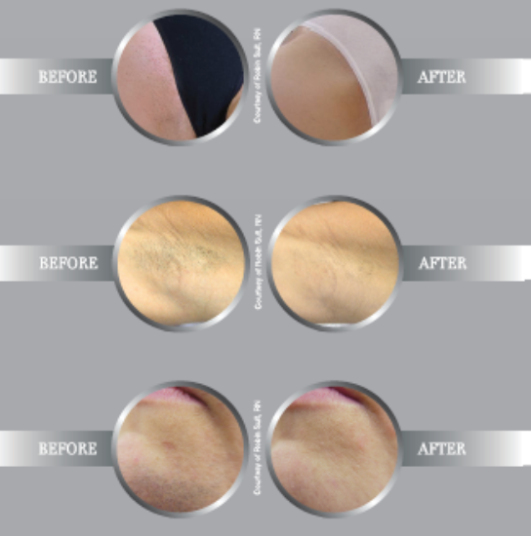
Advantages of Laser Hair Removal
Safe and effective
Fast and convenient
Long lasting results
Suitable for all skin types
No pain, ingrown hair or infected skin
Suitable for larger and smaller areas
Laser Hair Removal

