Dear Designer
Thanks for taking a look!
The brief is:
Develop a vector library of designs which have a consistent theme throughout and are easy to modify or replicate. In other words, that they contain a 'style sheet' or 'theme' which can be consistent for each vector created.

In terms of ‘look and feel’ we are looking for something quite simple but with a bit more colour and crispness than these ones but for the purposes of giving the designer an idea, this is the kind of thing we are looking for.
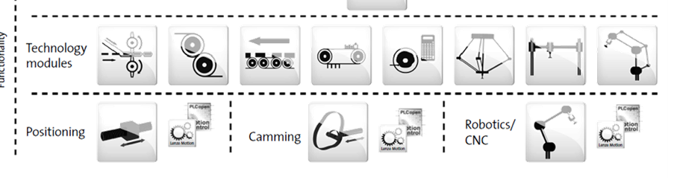
Vector Graphics to create:
Machine Items
- Single pocket collator. This is a special conveyor with pockets for positioning products in an exact known position for the robot to pick them up like the image. The vector should resemble a conveyor with pockets and be shown at an angle so that the pockets can be seen (somewhere in between the 4th vector along on the top row above and the orientation of the actual collator below)
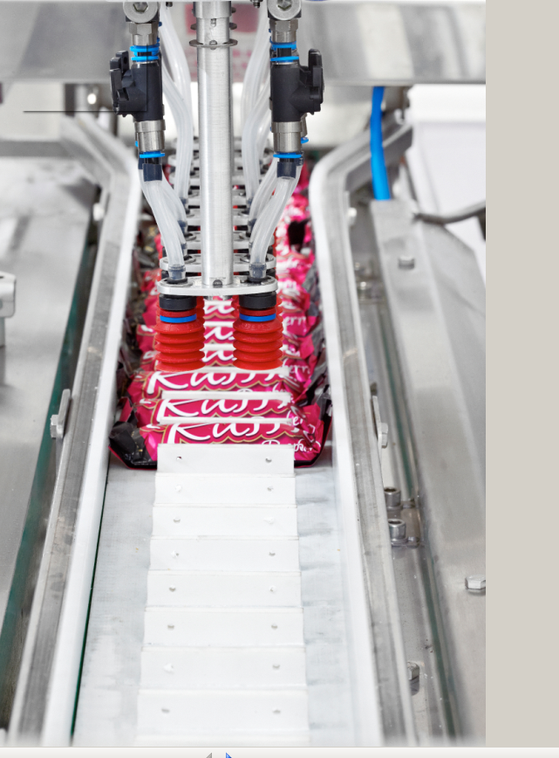
- Twin Pocket collator – same as item 2 but with an identical unit very close beside it.

- Delta Robot with single pick gripper like the one below but with the design template theme
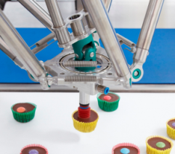
similar design vector…………………………

- Robot with multipack gripper
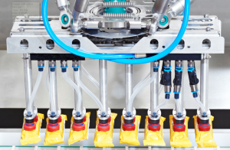
I don’t have an icon for this but here’s a real life example:

- Robot with mechanical gripper for heavier items (up to 15Kg)
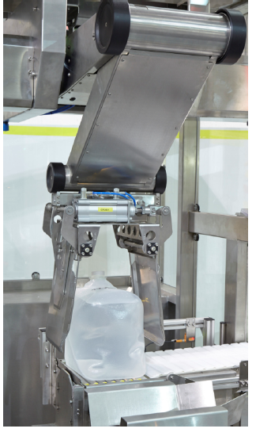
I don’t have an icon for this but here’s a real life example:

- Pick and Place Robot (these are the machines that move the grippers)
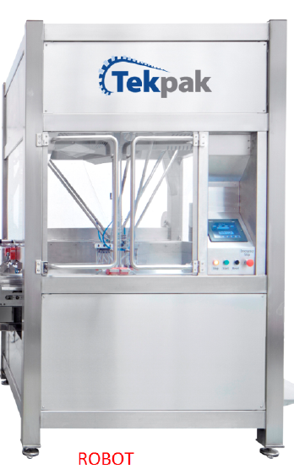
- Pick and Place Robot Twin version

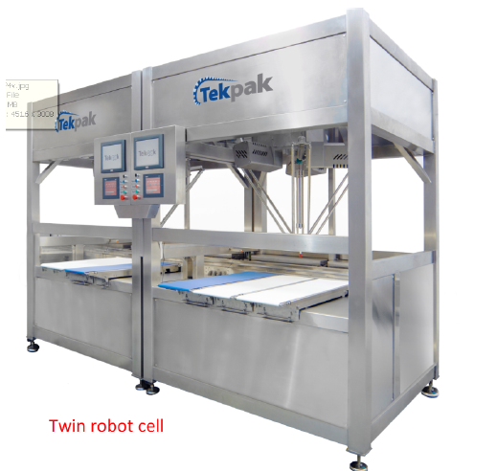

- Boxes moving along a conveyor belt

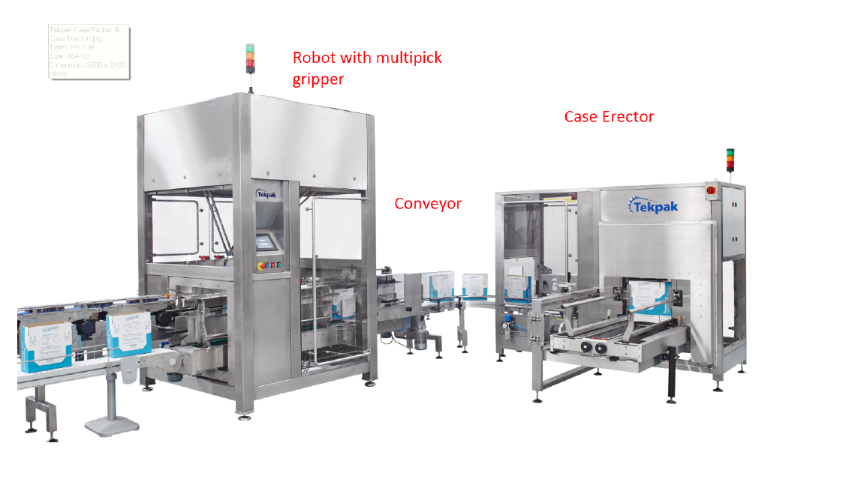
- Checking for presence of 4 bottles inside the box.

