Hi Harith,
I thought it made sense to select your design as the winner and then make the final changes directly with you. I have also put these in this word document so that my instructions are crystal clear.
Harith, can you please read these instructions carefully. Our other correspondences seem to have been a bit miscommunicated.
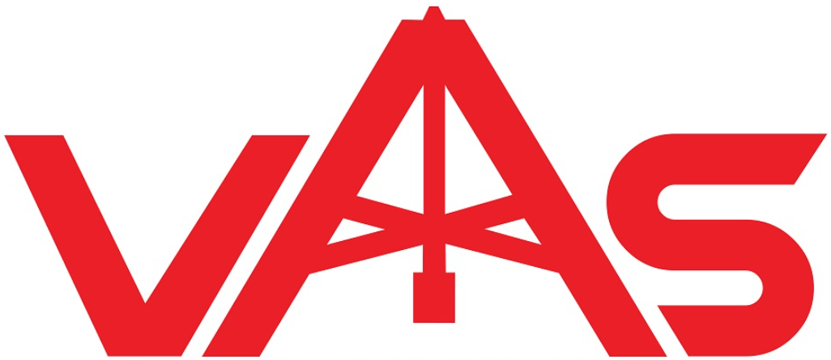

In regards to my selected design No 4277344 (see above), thankyou for removing the black border. However, the following steps still need to be done:
- I still need you to change the colour to dark red (as previously advised). Your current colour is a bright red and I need you to darken it. I have asked for this twice now. Please let me know if there is a problem with reviewing my uploaded files? The colour I sent in my contest brief was from the below diagram:
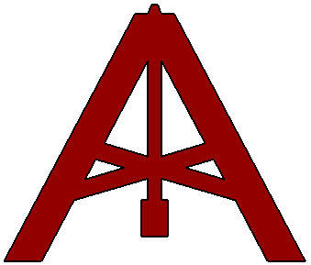

- I would like to compress / widen the image to the proportions shown below. My reasoning for this is that I don’t want the A to be too ‘vertical’. Also, I think it looks better when it is stretched sideways.
I did this by just clicking on a corner of the copied version of the image and dragging the cursor sideways. You will notice that the below VAS symbol is a lot wider than the image at the top.
(this is a wider version from the top image)

- When you have made the above two changes, the resulting image is the first final version I want to keep. Let’s call this Logo No A.

- Next, I would like another logo. Let’s call this other one, Logo B. Essentially, all I want for this second logo is for you to take the final version of Logo A (i.e. after you have changed the colour and widened it – see point 3 above) and just put the clear middle lines back into the V and the S. In other words, can you follow the same clear lines approach as per logo’s 4274350 and 4274301.
Therefore, Logo B will essentially be the same shape as the final Logo A but will have clear lines inside both the V and S letters.

- When you have finished the above work, two final version logo’s will be done:
  - Logo A (no clear lines in the V and S symbols) and
  - Logo B (clear lines will appear in the V and S symbols)

Thanks for all your great work Harith.

Cheers
Tom

