Comprehensive Services
Business Development
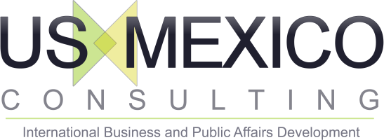

our Three step process

Once you have made the decision to grow your business internationally we follow a very simple and cost efficient path.
After our initial contact and agreement:
- Gather necessary information.
- Perform an onsite company readiness check and presentation.
- Develop and provide an international strategic path forward.

Let us manage the entire process for you from strategy to successful execution.
We will assemble and coordinate the needed team of specialists for the project and provide the necessary business contacts for your international growth.

©InterService Integrators, LLC.

Your international business development process begins with us

Our effective, innovative growth approach helps midsize organizations accelerate and compete in a global world

SUCCESSFUL LOW COST,
LOW COMPLEXITY,
WORLD CLASS,
CLOUD BASED BUSINESS APPROACH

901 S. Mopac Hwy. Suite 230
Austin, TX 78746
Phone (512) 306-2499
usmexicoconsulting.com


Should we Expand?
It depends: US Mexico Consulting can assist you in an initial analysis to see if your company is prepared financially to expand and if the current infrastructure is adequate for international operations. We look at human resources, technology, operations, systems, processes and do a complete SWOT analysis of your current operation.
- Have you maximized your current opportunities? Is your company mature for this endeavor?
- Have you discussed with all invested parties and taken all feedback into consideration?
- What are your short, mid and long term goals for growth?
If you are not ready for international expansion today, we will design the path to help you get there.

How do we expand?
One of three ways:
- Green pasture-organic growth. Evolve your current business internationally, or create a new business from scratch
- Joint Venture (JV) - partner with another entity in country of expansion
- Merger or Acquisition (M&A) - merge or acquire a new entity in country of expansion

Which Expansion Opportunity is best for my company?
Each opportunity has its own pros and cons for growth which can be largely dependent on the country of expansion and your budget. Some countries are business friendly for new business creation and growth while others are more optimal for international businesses to join, merge or acquire established companies in country.
To determine the best way forward, it is good practice to seek counsel on your different options. Our networks specialize in all categories needed for international expansion, and our consultants coordinate with each specialist to work in unison for your best interest.

WorkING with Specialists
We have spent years developing relationships with accounting, legal and financial specialists’ necessary for international growth. We have business associates located on both sides of the border, positioned for cost and time efficiencies and with the expertise you need to succeed in your growth plans.
Instead of parading individual groups of specialists in front of you, each with its own sales pitch and service offerings, we introduce and manage the entire relationship and service. With a single point of contact and negotiated rates for your benefit, we keep your costs at an optimal level.

Cultural Managment
In addition to international business consulting services, we have expertise in the cultural intricacies of international business and offer ITIM America training.
We have more than 20 years of experience consulting and training Fortune 500 companies, small and midsize companies as well as individuals looking to improve their international business skills.
There is significant evidence that cross-cultural training and knowledge lead to more successful international business relationships and they are key to success for mergers and acquisitions as well as joint ventures.
“Your Success Drives our Success.” It is our goal to be a long term partner in your international growth strategies and development. Contact us today to get started.

Offices in Houston, New York City, San Antonio, Monterrey, Guadalajara and Mexico City.

Headquarters
US Mexico Consulting
901 S. Mopac Hwy
Suite 230
Austin, TX 78746
Phone (512) 306-2499
info@usmexicoconsulting.com
Usmexicoconsulting.com

©InterService Integrators, LLC
Company Name
Street Address
Address 2
City, ST ZIP Code
Phone (555)555-0125
Fax (555)555-0145
Web site address

