  LMS |  | 
 | The Right Learning Management System Managing teaching and learning workflows has never been smoother with ITWORX Education LMS.
Who: K-12 schools, network of schools, districts, and states.  What: Manage teaching and learning workflows.  Why: A unified system for digital work exchange that provides students and teachers with a single, easy, and dependable solution to manage academic and administrative needs.  Aspects: Assignments,  Lesson Planning, Individual  Learning Plan, Gradebook, Assessments, Behavior, Attendance, Content Library, Virtual Classes, e-Portfolio, Calendar, Communication & Collaboration, Parent Portal, and Administration.  Dependencies: None.  Integration: Third-party SMS/SIS, content management systems, or other tools and systems, school or university websites or portals. | 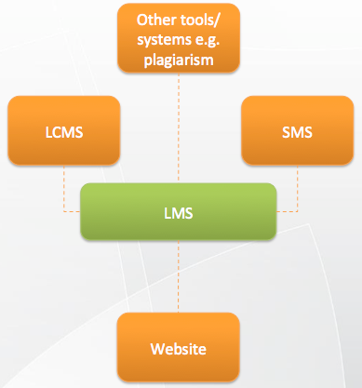 |  | Teachers and students certainly have enough to worry about without having to focus on technology. Quizzes, tests, grading, instruction time, assignments — the list goes on.  When a smooth and workable technology system is in place, the focus isn’t on the technology, it’s on teaching and learning. The technology becomes a platform from which to operate, and attention moves from learning how to operate the tool to actually getting the job done. With increased testing requirements, students have less time as it is; with greater demands placed on teachers, their time has never been more valuable.  The right learning management system allows a smooth and effortless classroom workflow so that the job of teaching and learning can be accomplished in not only a distraction‐free environment, but with productivity tools that actually guide education along a path of better learning. A well‐built, reliable and feature‐rich LMS allows students and teachers that pathway forward.
 | Bringing Order. With so many acronyms, understanding technology can feel like so much alphabet soup. But with the right Learning Management System, alphabet soup turns into alphabetical order. Integration of student and content management systems and other tools provide a hub for students and educators to log in, track their work, and easily communicate.
www.itworx.education  ITWORX Education - Addressing the needs of K-12 institutions worldwide.  © Copyright 2014 ITWORX. All rights reserved. |  |  | 