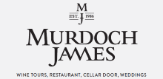 | (whole header should be the soft grey of the logo background - you can make it a grey solid colour or be creative and try something like fading the grey out to an almost white… or put watermark wine glasses etc in the header) For the writing on the right you need to keep the font similar to the logo. | New Zealand’s best wine experience  +64 6 306 9165  284 Dry River Rd, Martinborough, New Zealand
Home About Us Buy Wine Wine Tours | Accommodation Restaurant Weddings & Events | Wine Club Resource Centre Contact
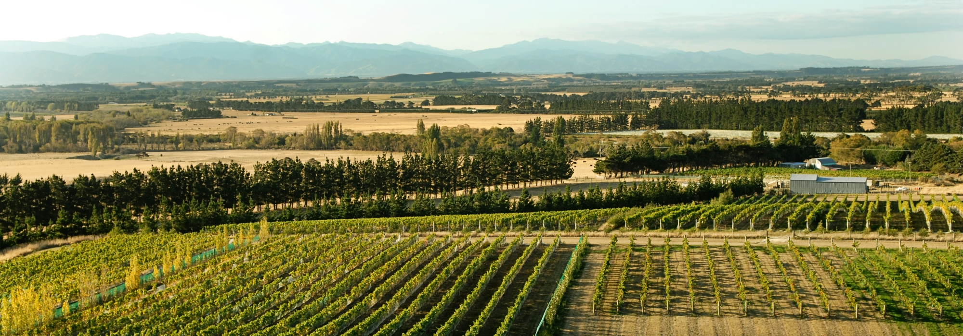
For the gallery image above you can use any photos from the ones called “Martinborough vineyard”

Buy Wine  Image: use image attached called Buy Wine (you may need to crop these images – be creative! - maybe wash out the colour a bit. Image can take the full space with the heading over the top or you can try and put all 6 of these boxes on one line if the photos fit better. Should look like a link button. Text will only be in a rollover – see Resource Centre section below – only want to show one rollover) | Wine Tours  Image: use one of the images attached called Wine Tours  (Same instructions as Buy Wine) | Accommodation  Image: image attached called Accommodation  (Same instructions as Buy Wine)

Restaurant  Image: use one of the images attached called Restaurant (Same instructions as Buy Wine) | Weddings & Events  Image: image attached called Weddings & Events  (Same instructions as Buy Wine) | Resource Centre  Image: image attached called Resource Centre (please show the rollover option with this link button – rollover should be a very light almost black and white version of the image and the text should show in a transparent BUT easy to read text block with an arrow or something to show it is a rollover to link to a page in the website. Text for rollover is: The Resource Centre has Murdoch James Estate Accolades, Media bottle & label photos, Tasting Notes, Image Library, Testimonials & more…

Need a different look from the above 6 boxes for the info below please
What’s Happening at MJE…  Image: there are several images for “MJE Happening” attached. Some are bottles and some are vineyard images – you can make a collage of these possibly – bottles over the background scenery – be creative!  Exciting times at Murdoch James Estate… we’ve just revealed our new branding and the website has a fresh new look to reflect this. MJE is looking forward to an eventful and prosperous year so please come and visit us when you’re next in the Martinborough region. | Facebook feed  (just have the heading Facebook feed and leave blank space – No words, No images)  _______________________________________  Wine Blog  (words only below – no image – each is a different blog entry)  Boutique vineyards excluded from Air New Zealand in-flight and airport lounge wine selections…  No need to take your wine on holiday now!...  Sheep versus Machines - Who Wins?... | Join us…  Join the Murdoch James Image:  Estate Wine Club today wine glass.jpg  and receive a “buy one get  one free” Grape to Glass  Wine Tour Voucher. JOIN (button)  __________________________________  Gift Vouchers…  Give the gift of New Image:  Zealand's best wine grapes.jpg  experience! Vouchers  include accommodation  and wine tour options.  GIFT (button)

Footer
Home  About Us  - The Vineyard & Terroir  - Winemaking  - The Team  - Photos  - 莫多克酒庄 | Resource Centre  -Tasting Notes  - Image Library  - Accolades  - Videos  - About Us Info  - Testimonials | Buy Wine  - Our Wines  - Distribution  - Online Shop  - Terms & Conditions  Wine Tours  - Grape to Glass Tour  - Casual tastings/ Cellar door | Accommodation  - The Winemakers Cottage  - Packages / Special Offers  Restaurant  Weddings & Events  Wine Club | Contact  Murdoch James Estate  Phone: +64 6 306 9165  284 Dry River Road  Martinborough, New Zealand  (Google map here of above address)  Social media icons

-

