Why is Wolverine a great place to work and intern?
About Wolverine
Trading LLC
Wolverine
Trading Internship




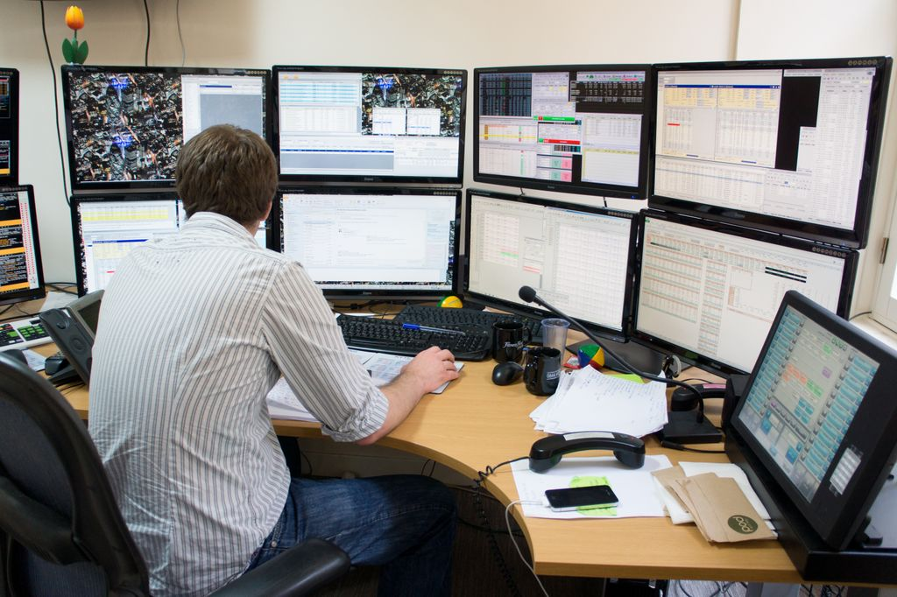
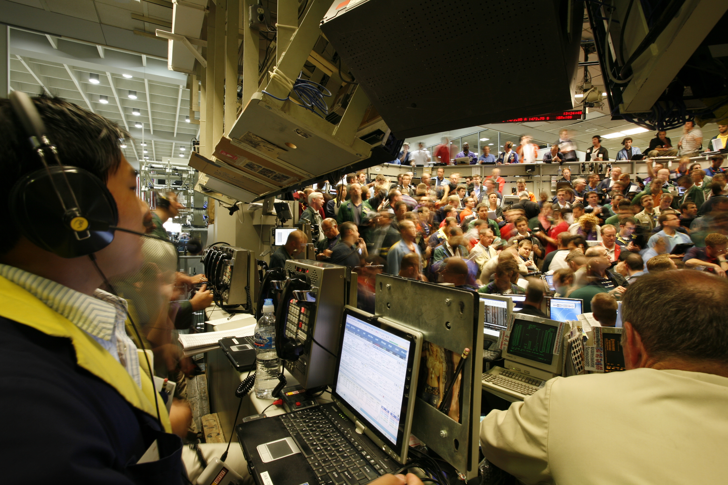
- Full time employment for successful interns

- Exposure to top leaders at the firm (manager mentors, partners)

- Furnished intern housing provided in downtown Chicago

- Full calendar of social events such as monthly expiration parties, intramural sports, team dinners, music festivals and sporting events in Chicago

- Every day is casual Friday

- Food for thought: Our brains need fuel to take on a challenging day so our kitchen chefs provide us with free breakfast, lunch and snacks throughout the day
Founded in 1994, Wolverine is a diversified financial institution specializing in proprietary trading, asset management, order execution services, and technology solutions. We are recognized as a market leader in derivatives valuation, trading, and value-added order execution across global equity, options, and futures markets. With a focus on innovation, achievement, and integrity, we take pride in serving the interests of both our clients and workforce. Wolverine is headquartered in Chicago, with branch offices in New York, San Francisco, and London.
175 W. Jackson
2nd Floor
Chicago, IL 60604
Phone: (312) 884-4000
www.wolve.com

175 W. Jackson Blvd.
Chicago, IL 60604
www.wolve.com
A Trader’s Day
Qualifications
- Working toward a degree in engineering, computer science, finance, economics or mathematics
- Junior or graduate standing
- History of academic excellence
- Demonstrated interest in trading, financial markets, and technology
- Excellent quantitative and problem solving skills
- Entrepreneurial and self-motivated
- Strong communication skills and a desire to work in a team environment
- 3-month commitment
- Basic knowledge of C++, C#, the .NET framework, and SQL is a plus
Wolverine Trading’s internship program for Trading Associates offers qualified candidates a unique opportunity to learn about the financial markets from an industry leader. Founded in 1994, Wolverine Trading engages in market-making and arbitrage across global markets. Continuously growing and stable, Wolverine provides a unique opportunity to learn from the experts in proprietary trading.
Our 12 week summer internship program serves as a primary source of hiring full time trading associates. All employees and interns have access to our full-time education department and Director of Education. We are constantly creating new curriculum that informs and leads to collaborative innovation at the firm.

For more information on open positions, or to submit your resume, please visit our website www.wolve.com
The typical day for a trader involves staying current on the markets and quickly reacting to changing and unexpected market conditions. Our traders are constantly innovating to improve our existing trading logic and to develop new trading algorithms. Collaboration and the development of unique strategies, in addition to the review and analysis of the markets and our own trading results, is an everyday occurrence as we strive for improved profitability and better market efficiency.
Trading Associate Summer Internship
Trading LLC

TITLE

