“ResConnect” business summary
Start up software solution for tourism operators. Catering for high-end, complex tour operations by providing a multi-faceted system.
System encompasses bookings, vehicle allocation, crew rostering, same-day or multi-day tours, point-to-point services and private charter.
Integrations between tour operators, public booking websites, agent-login website, APIs and connected EFTPOS.
The logo must be simple and work as an Application icon for the software products.
Company will use blue and orange as the primary website colours.
Branding vision
Modern, integrated, connected system. Travel/transport theme.
Concept 1

- Tourism/travel (idea from train network maps)
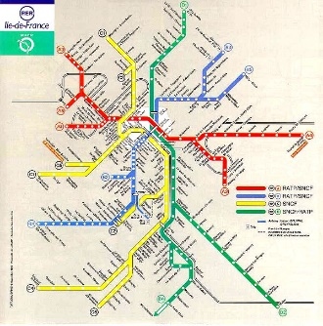
- Integrated (connecting/cross-overs)
- Initials “RC”

Concept 2

- connected/integrated
- Central framework
- Navigation/direction (compass)
- Getting from A to B


This the logo of another company that we like. It is simple, colourful and captures the concept of getting passengers from A to B.

