The Great Dale House Car
www.greatdalehousecar.com
This is a vintage Great Dale House Car we are restoring that is a 1965 Dodge Coronet 440 with a custom RV shell. We will be replacing the RV skin and restoring the car exterior. We want to keep a red color to match the interior. All windows and structure will remain the same except for the items marked in the pictures below.
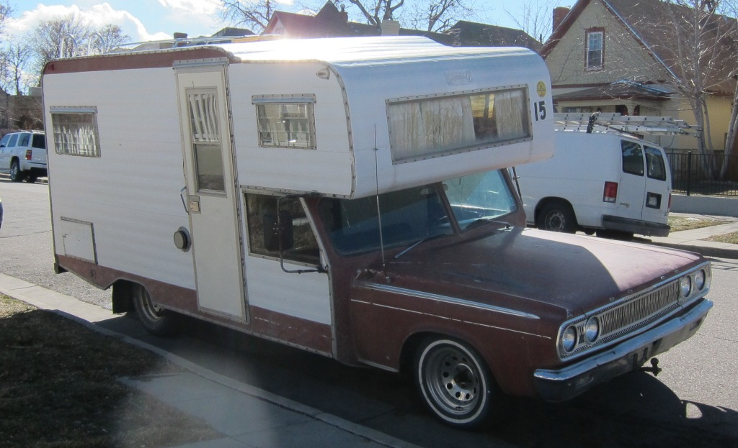
This will be removed

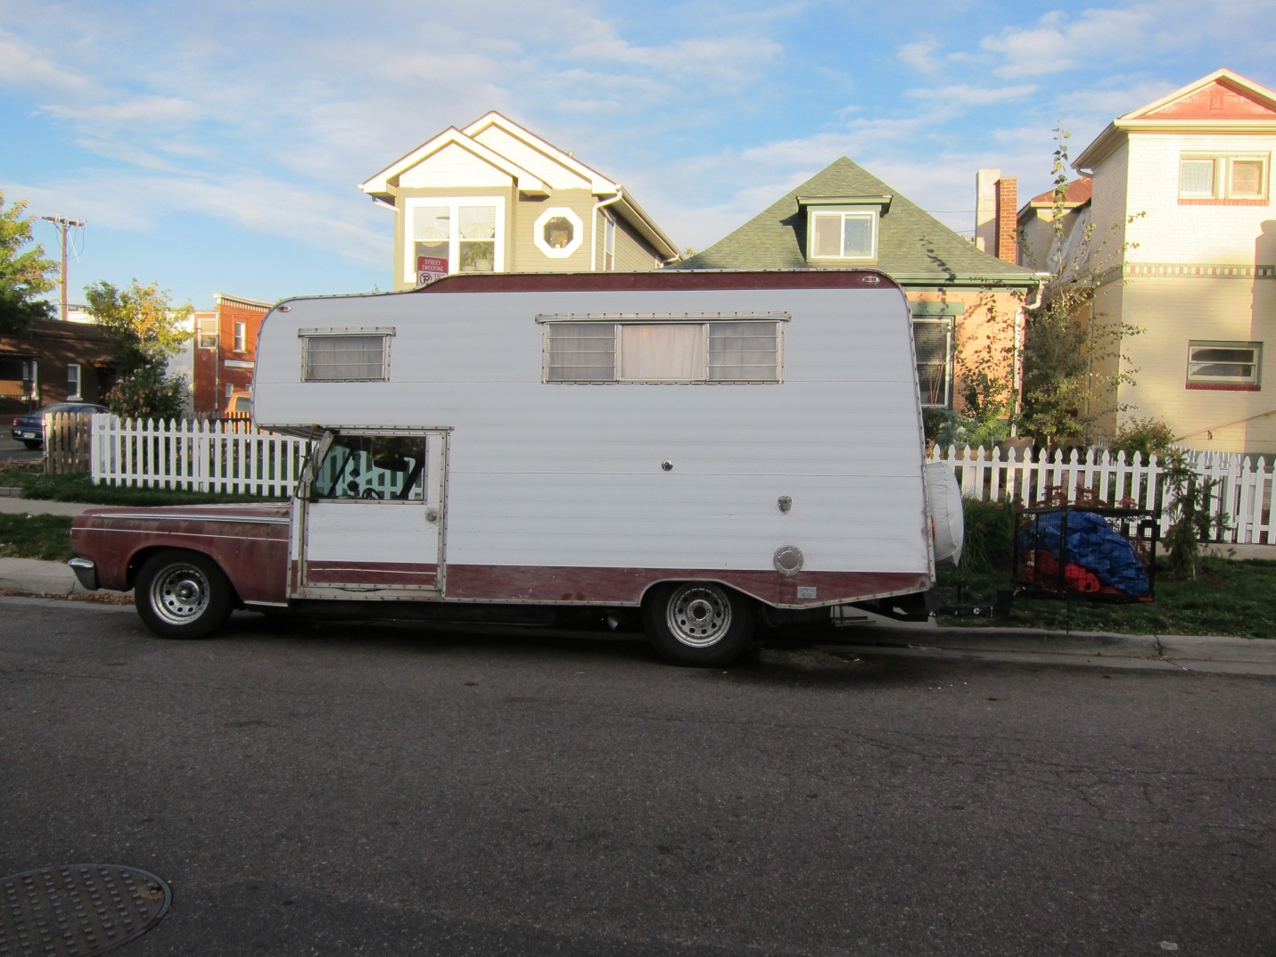
This Storage pod will be skinned the same as the RV and need a design as well

This Cover will be removed

This gas cover will be similar but will be located 1-2” higher

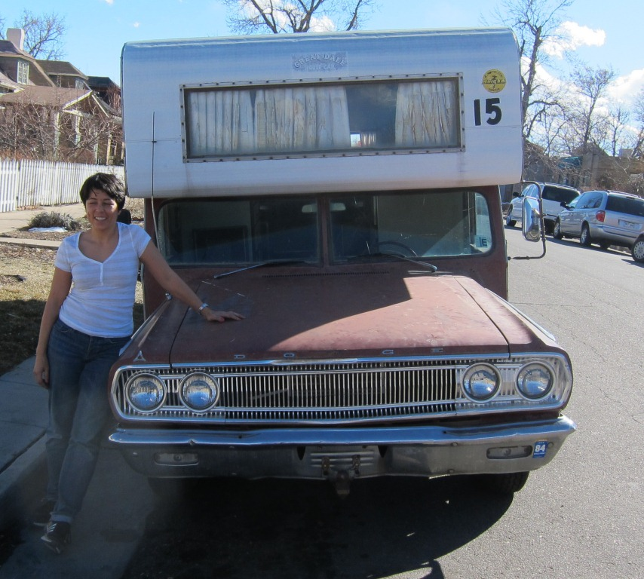
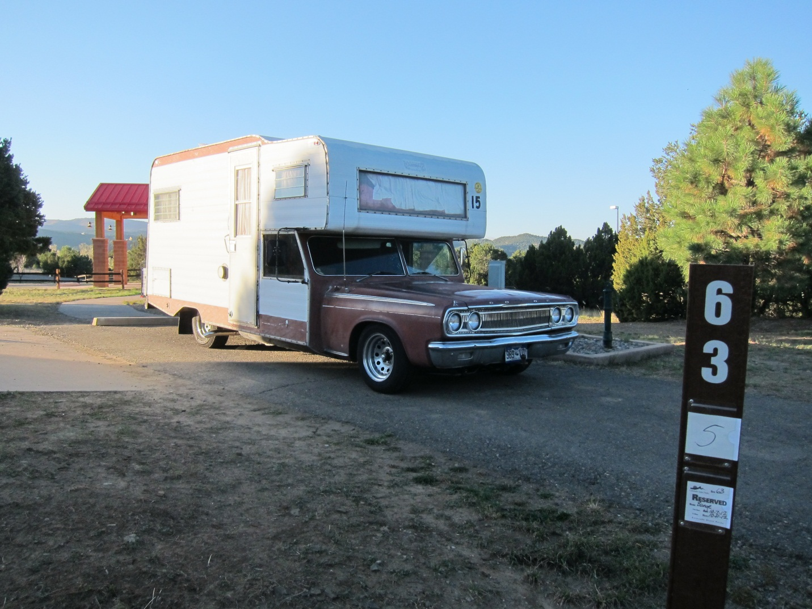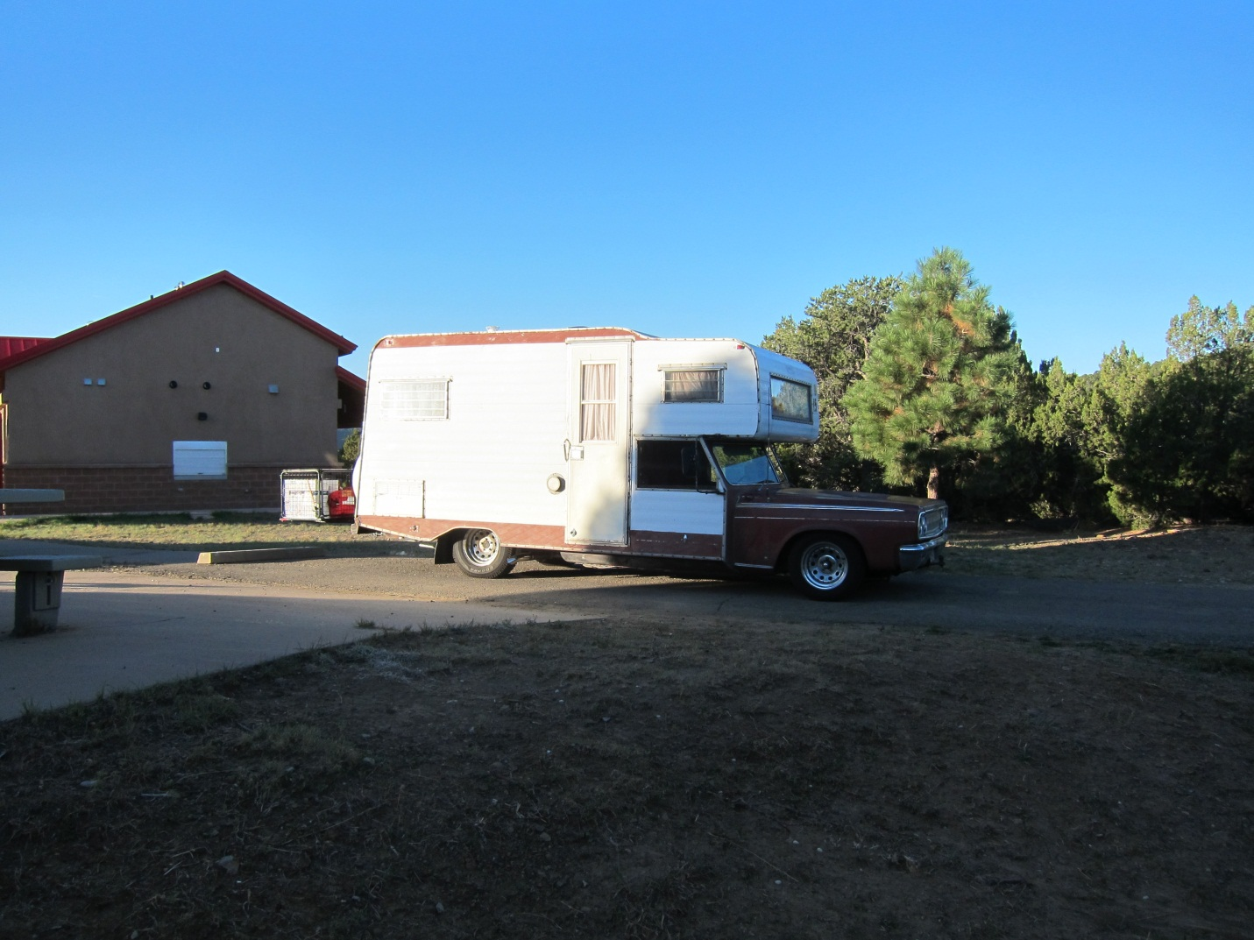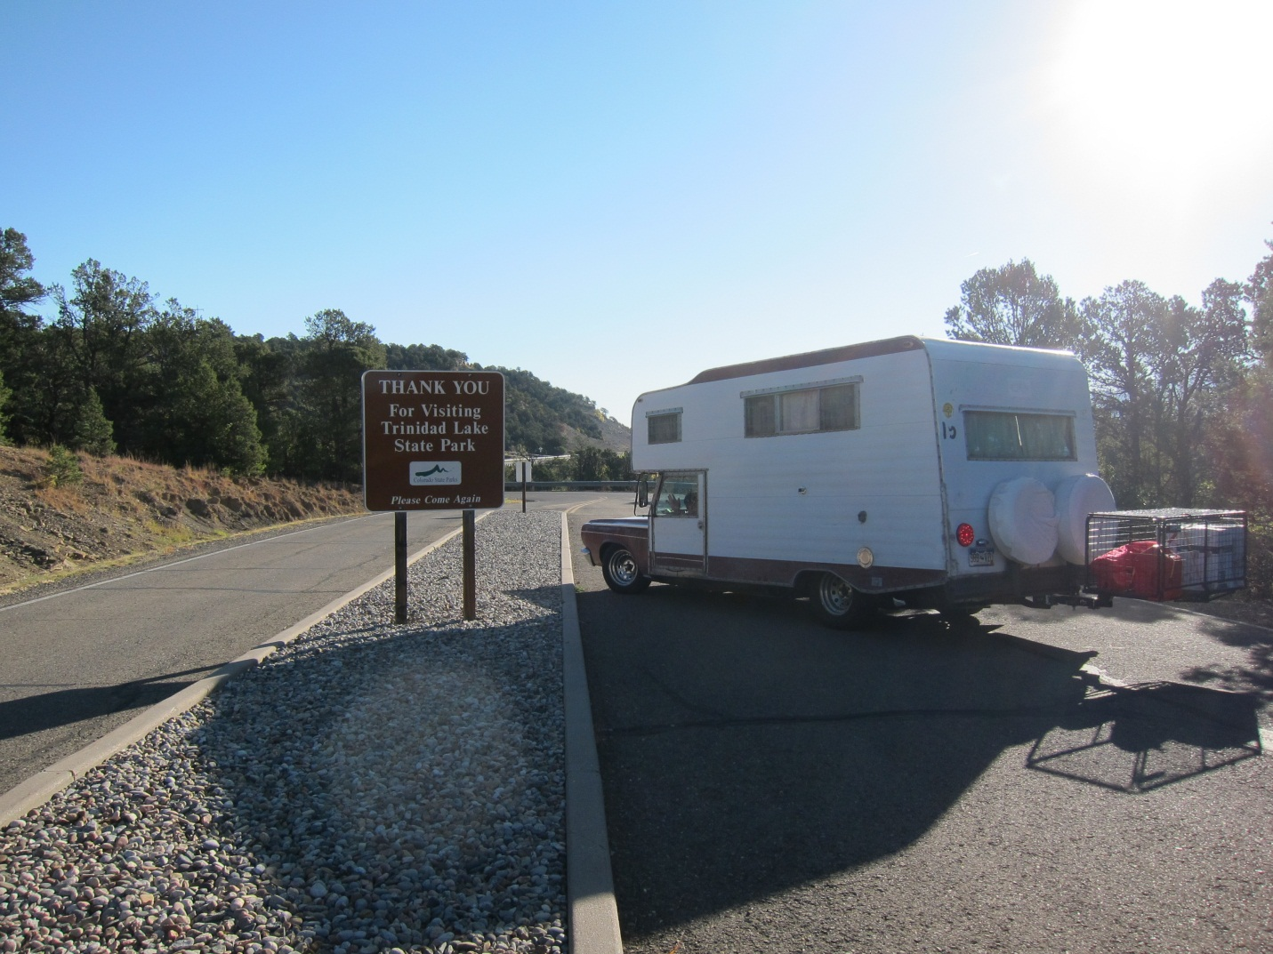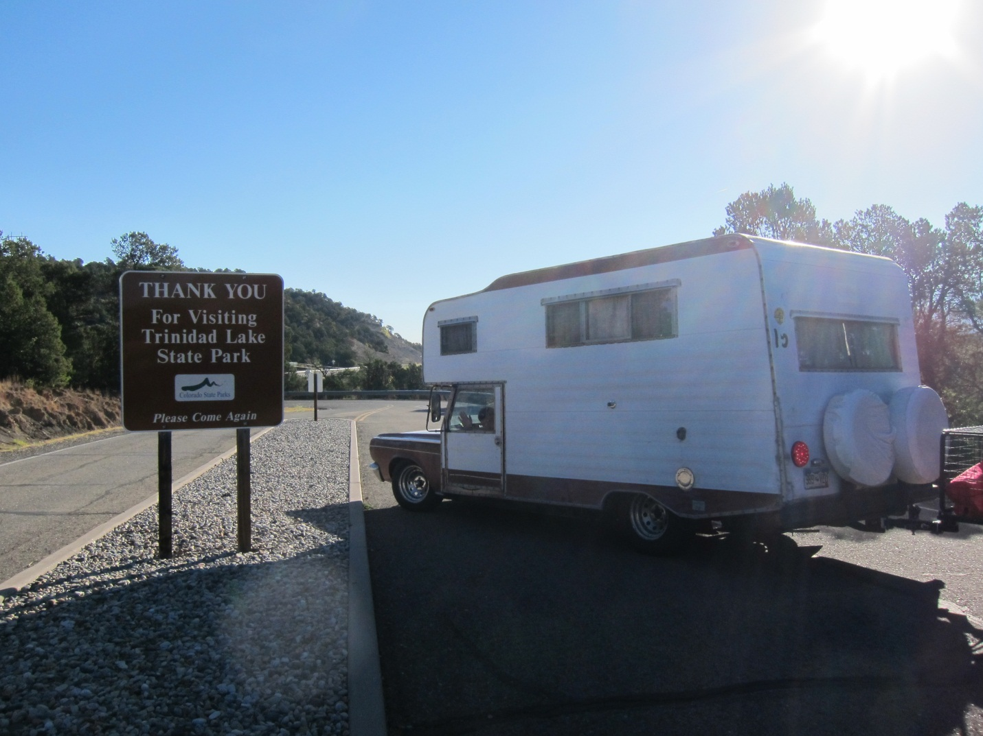
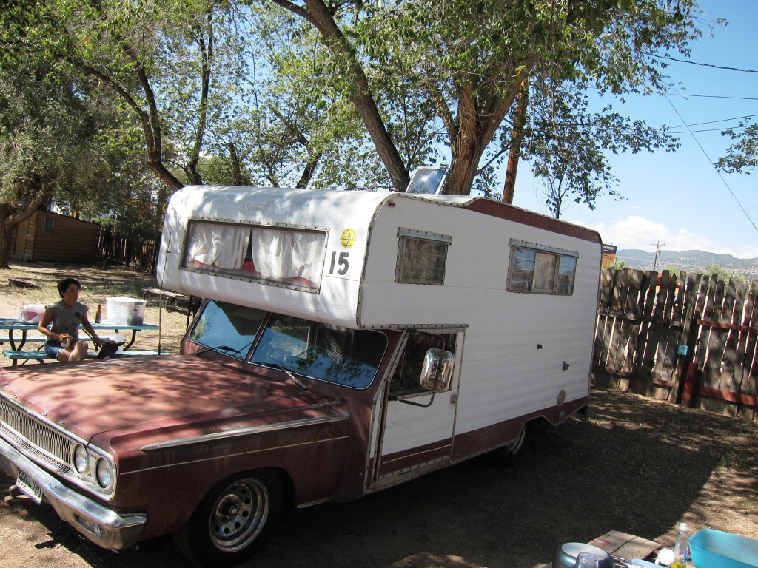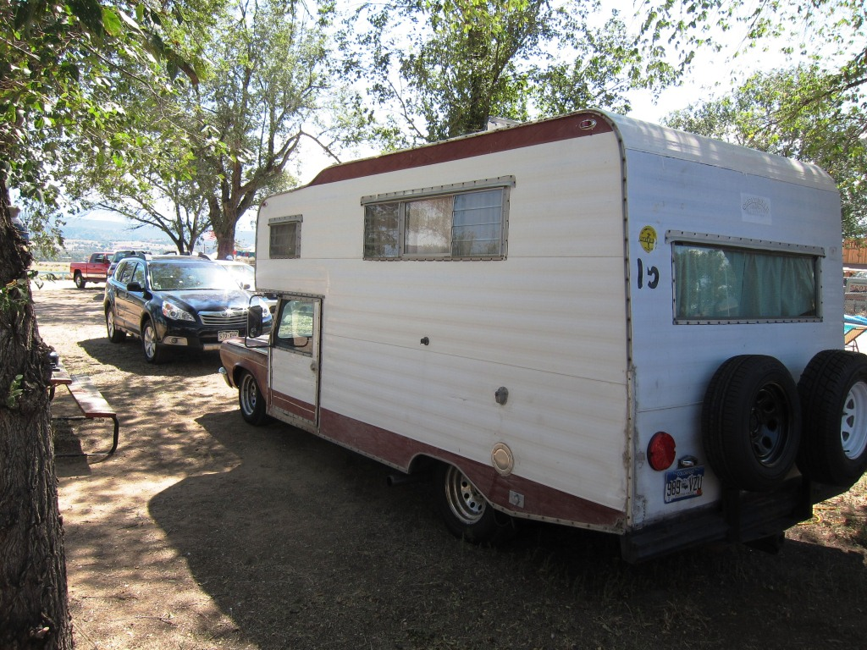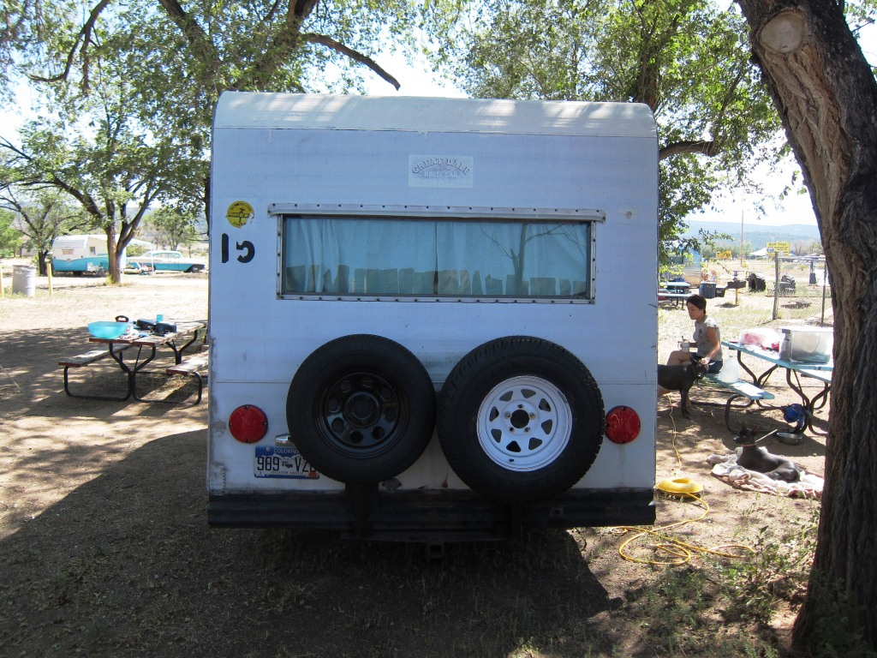
We haven’t decided on car or truck style mirrors

Car Features
This is close to the original car. We like the color and the rims
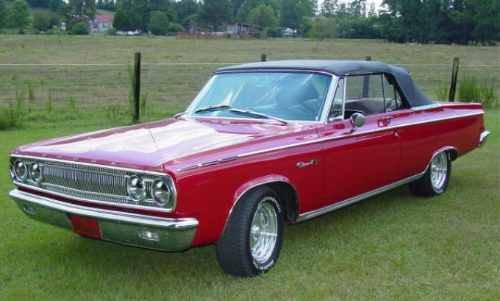
We like the rims of this car but not the color
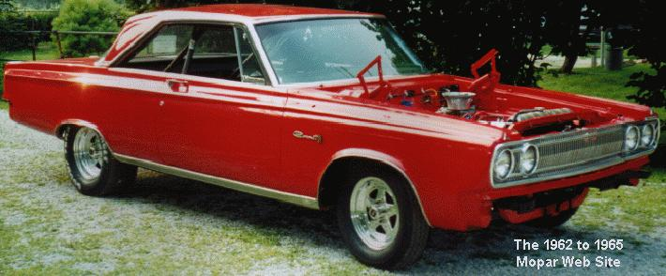

We will be adding a scoop like this car has.
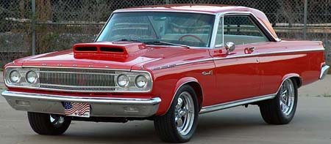

We’re looking for a complementary color to the dashboard.
http://www.oldride.com/library/1969_dodge_coronet.html
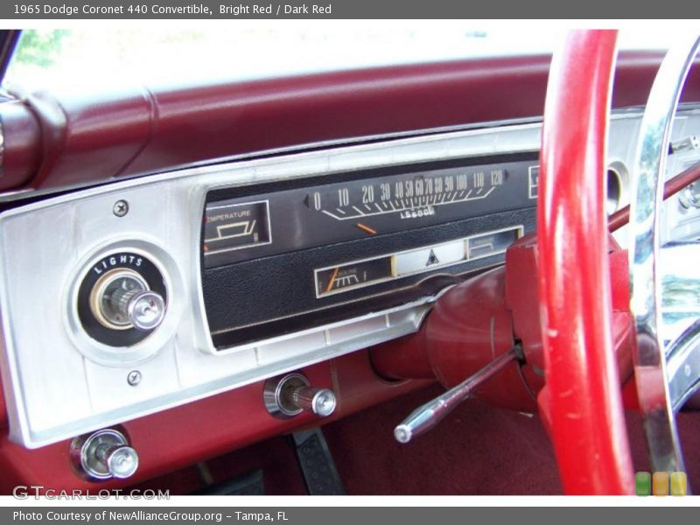

Possible Rim Designs
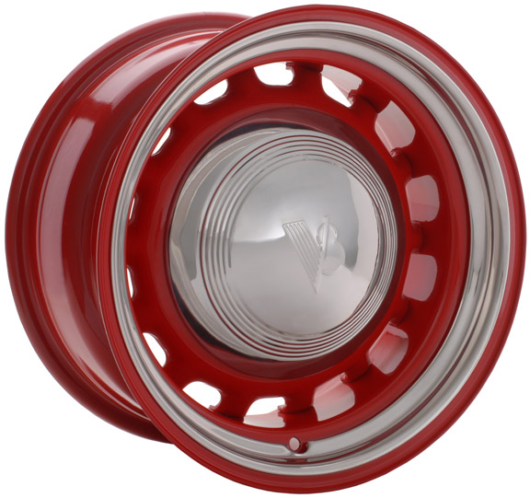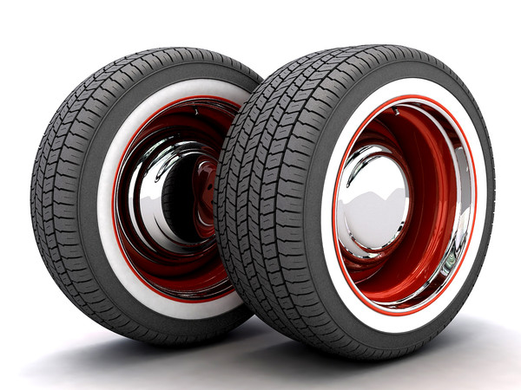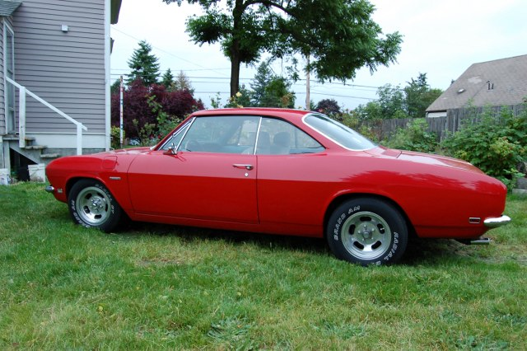
RV Features
This would be the material for the new exterior skin on the RV
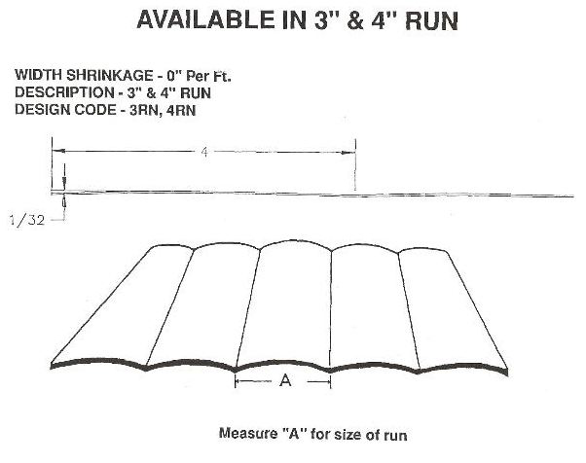

We like the wing design and the panel elements
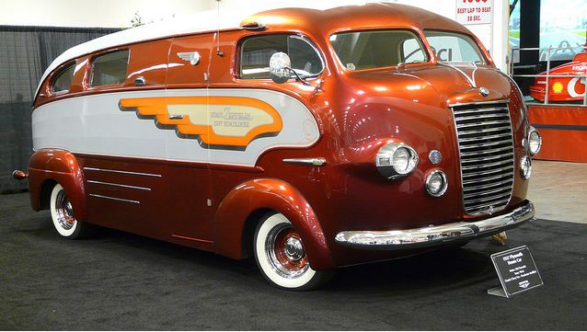

Like the zig zag and dual colors giving the impression of speed and sleekness
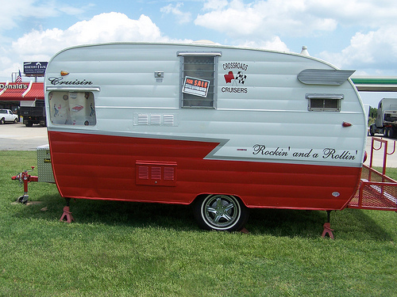
Like the zig zag and dual colors giving the impression of speed and sleekness
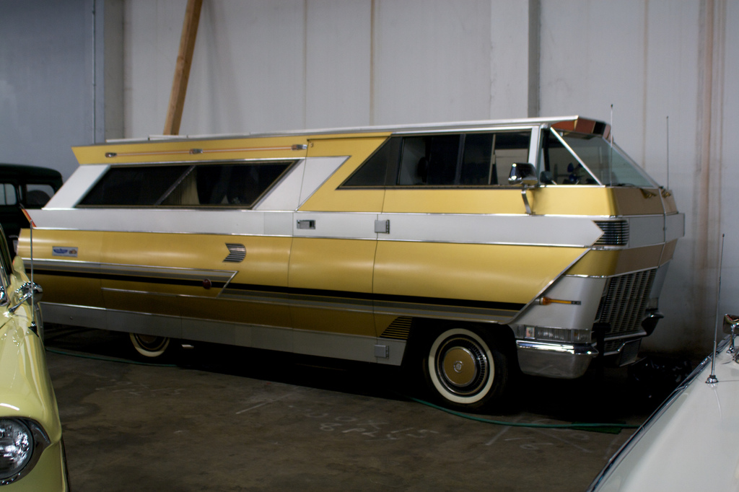

Like the zig zag and two tone color
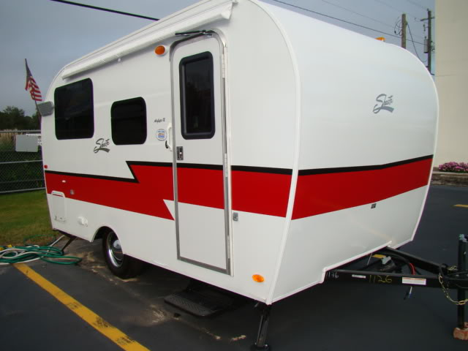
We will have an awning like this. This is also the skin which can be 3” or 4”
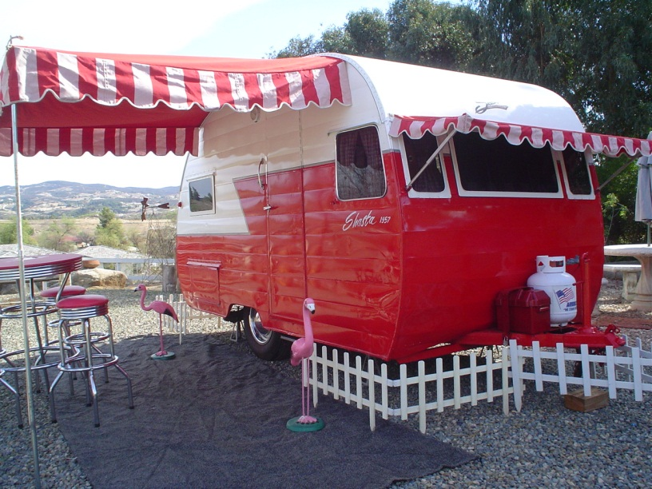

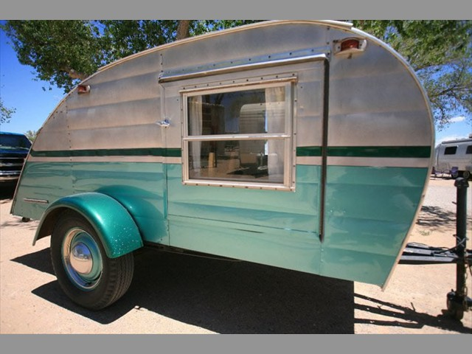
We really like the polished metal and two colors
