
Vision
A Professional Coach; At Home, At Practice, At Play.
Mission
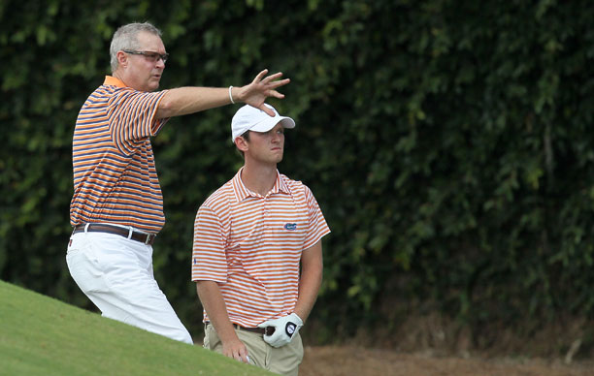
Provide technology-based solutions that help individuals improve their physical wellness and performance at their convenience.
Target Market
- Individual athletes/Physical therapy patients
- Seeks to improve in their selected activity
- Doesn’t aspire to be a professional
- Enjoys friendly competition

End User Value Proposition
You may not play as well as a pro. But you will improve and play better than your friends.

Competitive Advantage
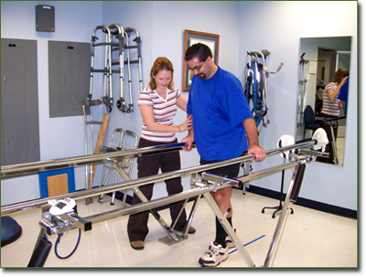
- Early market entry
- Cost effective for the individual
- Real-time, interactive analysis
- Portable
- Use your actual equipment

Products
- Performance Measurement/Feedback Systems
- Web Services
  - System Enhancements
  - Expert Performance Comparisons
  - Competitions
- Hardware Systems

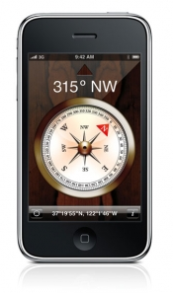
Enabling Technologies
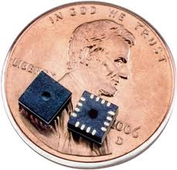
In less than 20 years, MEMS (micro electro-mechanical systems) technology has gone from an interesting academic exercise to an integral part of many common products. MEMS sensors are used in technologies including cell phones, automobiles, medical devices and even the most advanced aircraft.

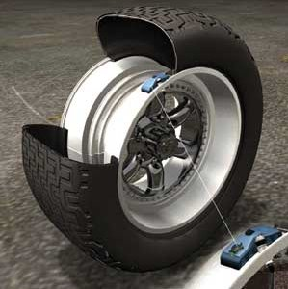
The anticipated 2013 market for MEMS is over 1 trillion dollars and is the result of advancements in integrated circuit technologies that reduced the size of large mechanical systems to less than the size of a dime. Most of the MEMS-based products that exist today would not be possible without the advancement of MEMS sensors.

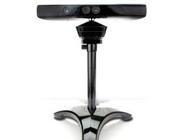
Praecedo believes that another new sensor driven market is in the early adoption phase. Affordable, evolutionary 3D vision technology enhancements have entered the marketplace in the past 2 years. Microsoft’s Kinect represents an early implementation of 3D vision technologies driven by a new family of sensors. In addition, early adopters are investing in technologies to overcome the Kinect’s limitations and provide viable alternatives.

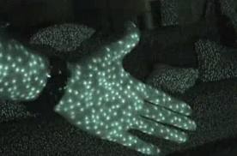
Praecedo principals possesses over 30 years of sensor and system development experience. We are positioned to develop solutions based on new vision sensor technology. We also possess the capability to develop an IP portfolio that corresponds to our vision and mission statement. We believe that these technologies can create significant value in our target markets.

Contact Information
Mark Everly, CEO
Praecedo
1881 Winding Ridge Circle SE
Palm Bay, FL 32909

T. 321-917-5361
F. TBD
www. praecedo.com
Mark.A.Everly@praecedo.com

