
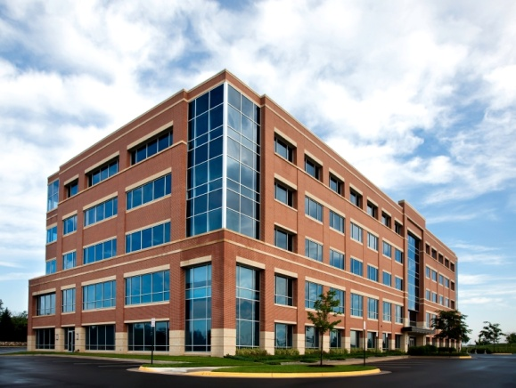

712 3RD AVE BROOKLYN NY 11232
TELEPHONE 718-788-3585 FAX 718-513-5060
WWW.NEXTCENTURYINSURANCE.COM
DEBBIE@NEXTCENTURYINSURANCE.COM
ASK FOR DEBBIE BROWN
Commercial Property Insurance
Commercial property insurance covers damage to or loss of the policyholder’s property. At Next Century Insurance we help you select the right coverage for: Buildings, Contents, Vehicles, Machinery, Valuables, Mobile Property, and more…
We work with a wide variety of companies that can handle virtually all of your commercial property insurance needs. Leveraging our experience in the New York insurance market, we will guide you through the process of finding the coverage that best suits your business. If you are already insured, in most cases we can provide alternatives with substantial savings while maintaining your present levels of coverage.

Homeowners/Rental Insurance
At Next Century Insurance we know owning a home is a big investment and it has never been more important to shield that investment from the many eventualities that can arise. Homeowners insurance is a smart, convenient way to help you protect the things that are most important to you. Talk to one of our agents to find options on how to insure your home and personal belongings today.
- Single and Multi-family home insurance
- Co-op and Condominium & Apartment Insurance
- Renters Insurance
- Investment Property Insurance
- Primary and Secondary Residence Insurance
Next Century Insurance can help you find the insurance coverage that works for you. Our approach to homeowners insurance gives you the following:
- Broader, more responsive coverage tailored to the particular needs of your home and your belongings
- Special policies for condominiums and co-ops & Apartments
- Vacation homes and secondary residence coverage with provisions you simply can’t find in “cookie-cutter” policies

