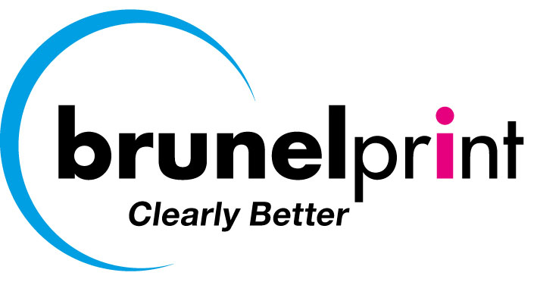

Project: BrunelPrint Look book creative brief.

What is?

BrunelPrint is a successful, long established (100 yrs) Offset and Litho Digital Printer, which has evolved and invested in new, “state of the art” digital printing and finishing technology. The company is now looking to exploit this enhanced capability in the commercial print sector.

What if?

We were really able to excite potential customers by sending them a visually stunning and tactile look book demonstrating digital print capabilities ( pantone quality + white ink) on a range of great substrates ( papers, foils and plastics) with incredible finishes ( sensory raised print, glitter, spot UV varnish, engraving, watermarking, and cut outs – see attached docs Scodix & Motion Cutter)

Why is a Look Book needed?

The vast majority of UK printers can’t offer the digital printing, sensory finishing and laser cutting engraving that Brunelprint can.

Many Buyers / Advertising Agencies / Marketers and Designers will not be familiar with what can now be achieved with new digital print technology – just because it is changing so quickly.

Consequently “print” will not feature as highly, be as effective or seen as important in the execution of their marketing strategies as it could be.

What is the role of the Look Book?

To excite potential print buyers, showing them just how amazing print today can look and feel. To give them ideas as to how they might be able to use these amazing finishes to market their business/brands/products.

The call to action is for these potential buyers to want to contact BrunelPrint to find out more about other effects, which can be achieved, and how this print can be creatively and effectively used in their marketing mix.

How do we do this?

By creating a 30 sheet, 2/3rds A4, wiro bound look book.

Each sheet being printed on one side, on a different substrate (papers of different weights, coloured paper, clear plastic, lenticular plastic, foils) with a proportion of the sheets (50%) demonstrating digital white ink and various finishes (sensory raised print, glitter, spot UV varnish, engraving, watermarking, and cut outs).

The images used need to be interesting, stunning, showing sharpness, colour and detail. - ?People, ? Animals, ?A Sporting Event (s).

Each page/image needs to “flow” / follow a story line (for example one of our competitors has used a comic book story line for the imagery of its look book).

Each page will also need to incorporate at least 30 words of text to explain the substrate used and effects created.

Who are we talking too?

Creative Directors
Advertising and Design Agencies
Marketing Directors and their Marketing Managers
Small Business Owners (SME’s)
Print Buyers
Production Directors / Mangers

Probably associated with “High End” Brands, Luxury Goods, Fashion, Sport & Leisure of Real Estate.

Core Thought

I didn’t realize that print could look and feel so amazing.

Tone of Voice

Enthusiastic, Dynamic and Confident.

Mandatory Requirements

None

