
712 3rd Ave Brooklyn NY 11232
Tel:718-788-3585 Fax:718-513-5060

TAXI AND LIMOUSINE PROFESSIONALS
BLACK CAR, CAR SERVICE, LIVERY AND AMBULETTTES

GREEN CAR SHL INSURANCE
“Your one stop shop”

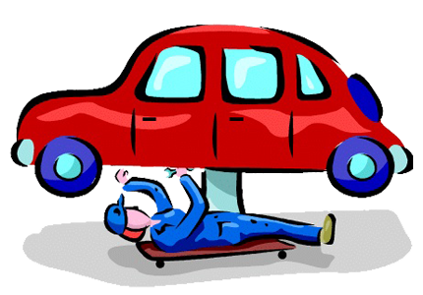
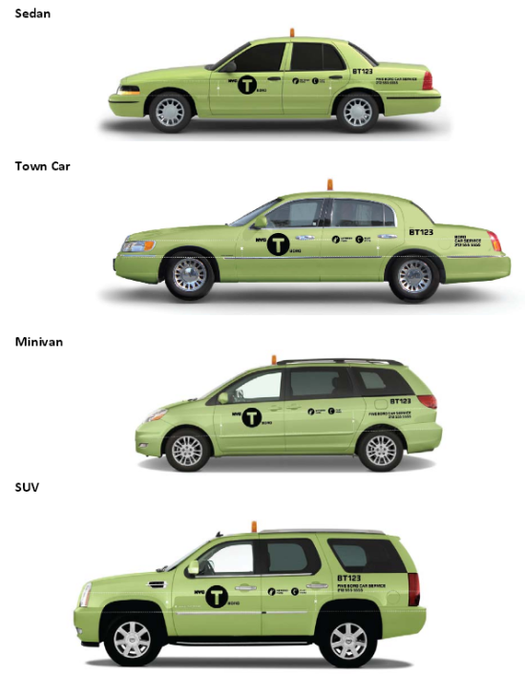
ONSITE REPAIR SHOP AND CAR WASH
- FLEXIBLE PAYMENT PLANS
- LIABILITY AND FULL COVERAGE
- CORPORATIONS, INDIVIDUALS AND WHEELCHAIR ACCESSIBLE
- DMV & TLC SERVICES
- SIX HOUR DEFENSIVE DRIVING COURSE
- CLAIM HANDELING
- WORKERS COMPENSATION
- SAME DAY INSURANCE CARDS

WE KNOW THIS IS YOUR LIVELIHOOD AND WANT TO HELP YOU GET ON THE ROAD AS QUICK AS POSSIBLE
Call us at 718-788-3585 or visit our office at 712 3rd Ave Brooklyn NY 11232
We are located on 3rd Ave between 22nd ST and 23rd ST
Monday-Friday 9am till 5pm
Ask for Debbie Brown
Email: Debbie@nextcenturyinsurance.com

