THE PALACIOS MONEY TREE!

Election time is near, and you will get a text, phone call, or a knock on the door, from the Palacios family, wanting you to vote for their candidates.

WHAT YOUR VOTE MEANS TO THEM!
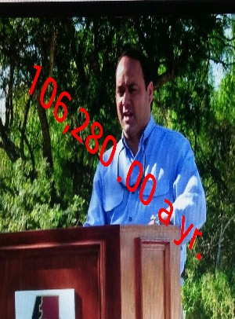
County Commissioner Sits on Edinburg Economic Was justice of the Peace

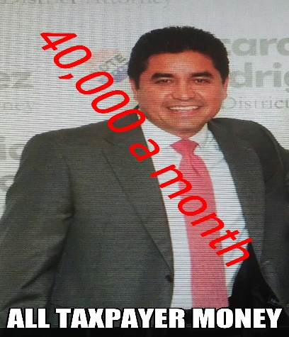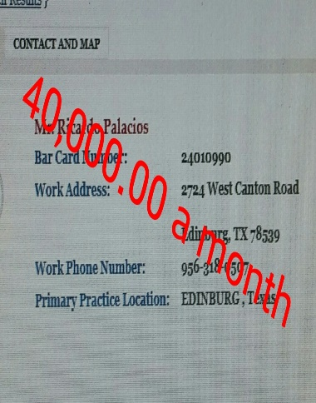
Ricardo’s sister Edinburg School Attorney for other districts Edinburg City Attorney
School Attorney!

