Project – Trigild Website

Summary: Trigild is a full service commercial real estate and advisory firm that is based in San Diego, but has offices and properties across the continental U.S. as well as Puerto Rico and the U.S. Virgin Islands. The current website was completed almost 3 years ago and is need of a refresh. We will utilize the existing Wordpress CMS system, but require a new design.
Industry:
Commercial Real Estate. For this design, focus on the Hospitality Asset Class. The design will be extended to Commercial/Residential and to Fiduciary Services
Audience: Owners/Investors, Banks/Lenders, Legal Professionals
Objectives:
- Show the depth and breadth of Trigild’s capabilities in a variety of asset types, for varying clients.
- Generate qualified leads via newsletter and contact us
Corporate colors:
Deep blue and gold
Design considerations:
- Use strong, dark colors. Want a dynamic, modern, powerful looking B2B site.
- Tell the story with lots of strong images, but also SEO friendly.
- Dark background, in keeping with corporate colors, is preferred.
Reference websites
http://www.gfhotels.com/
home page only: http://www.chrco.com/
Calls to action:
- Subscribe to our newsletter
- Contact us
- Call for a FREE consultation

Navigation – Use this exact content
Home Page
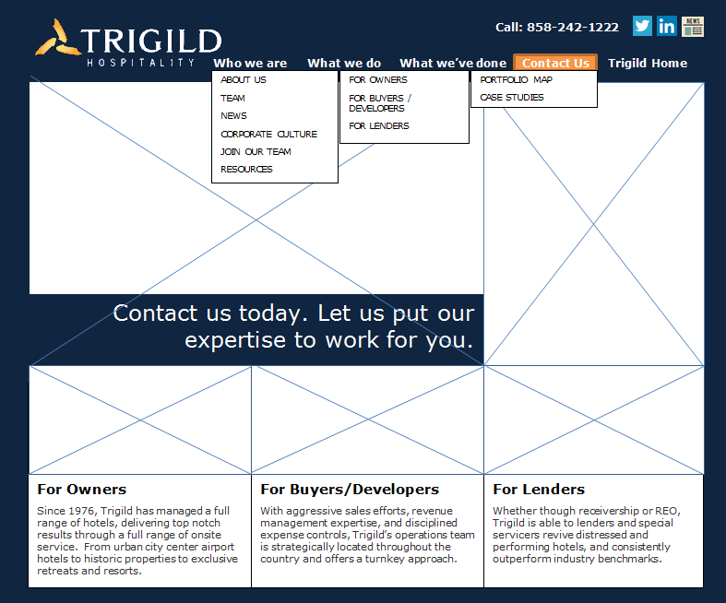

Subnavigation – Who we are – News
Structure how you think best. It does not have to be left hand nav. Include treatment for in the news section and Trigild Project Update Newsletter Section. Please make more graphic heavy, but integrate the content.
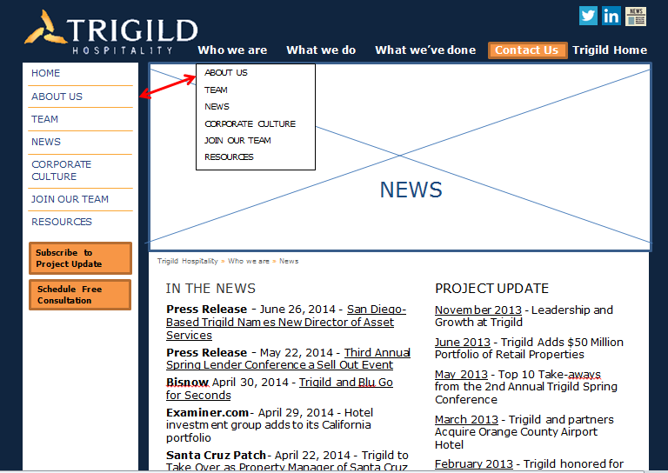
Sample copy for page:
IN THE NEWS

Press Release - June 26, 2014 - San Diego-Based Trigild Names New Director of Asset Services

Press Release - May 22, 2014 - Third Annual Spring Lender Conference a Sell Out Event
Bisnow April 30, 2014 - Trigild and Blu Go for Seconds
Examiner.com- April 29, 2014 - Hotel investment group adds to its California portfolio
Santa Cruz Patch- April 22, 2014 - Trigild to Take Over as Property Manager of Santa Cruz Hotel
GlobeSt.com- March 10, 2014 - Trigild Taps Atlas on $100M Hotel Portfolio
PROJECT UPDATE
November 2013 - Leadership and Growth at Trigild
June 2013 - Trigild Adds $50 Million Portfolio of Retail Properties
May 2013 - Top 10 Take-aways from the 2nd Annual Trigild Spring Conference
March 2013 - Trigild and partners Acquire Orange County Airport Hotel
February 2013 - Trigild honored for nearly $100 million Lease Negotiation
Subnavigation – What we do – for owners – Asset management, Advisory.
There is sample copy for you to use, but please make the pages graphic heavy as well.
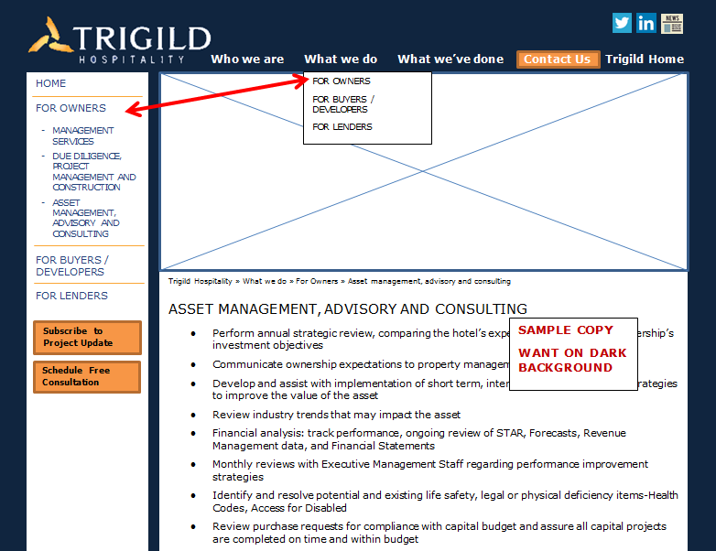
FOR OWNERS
Sample copy for page:
ASSET MANAGEMENT, ADVISORY AND CONSULTING
- Perform annual strategic review, comparing the hotel’s expected performance to ownership’s investment objectives
- Communicate ownership expectations to property management
- Develop and assist with implementation of short term, intermediate, and long term strategies to improve the value of the asset
- Review industry trends that may impact the asset
- Financial analysis: track performance, ongoing review of STAR, Forecasts, Revenue Management data, and Financial Statements
- Monthly reviews with Executive Management Staff regarding performance improvement strategies
- Identify and resolve potential and existing life safety, legal or physical deficiency items-Health Codes, Access for Disabled
- Review purchase requests for compliance with capital budget and assure all capital projects are completed on time and within budget
- Determine appropriate franchise affiliation for property
- Track new properties being considered for development

Subnavigation – What we’ve done – portfolio map.
Note – this map is a wordpress plugin visit their website for customization options – WP Google Maps - http://www.wpgmaps.com/

