A Revolutionary State-of-the-Art
Healthy Vending System

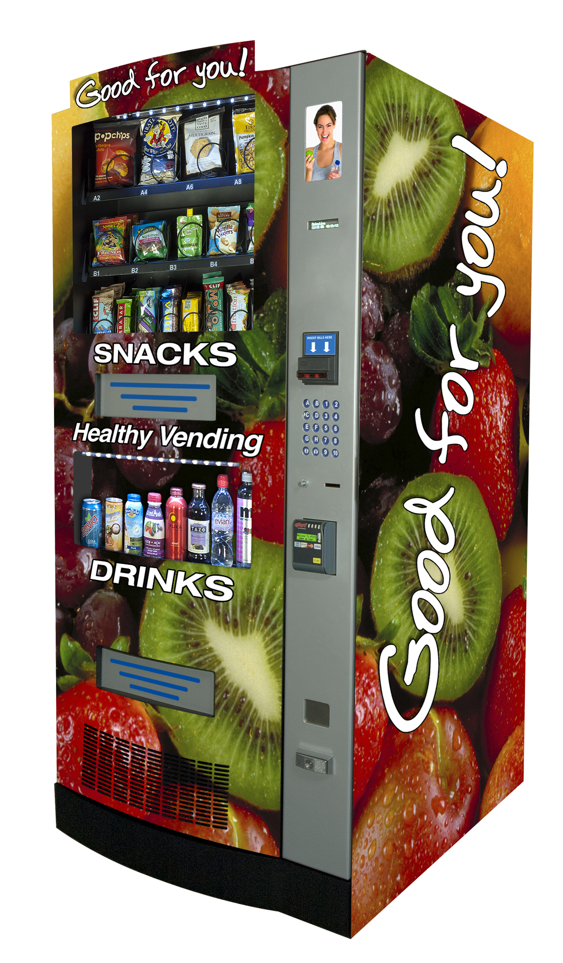
Star City Healthy Vending
540-725-7777
www.starcityhealthyvending.com

Keep your employees in the office!
Keep your customers happy!
Vends a Large Variety of Healthy Snacks & Drinks!

Nutrition Bars • Chips & Pretzels • Fruits
Candy Bars & Gum • Cookies Cereal & Granola Bars • Seeds, Nuts & Jerky
Crackers • Non-Dairy Smoothies • Water
Carbonated Soda • Tea & Coffee
Non-Carbonated Juices • Energy Drinks



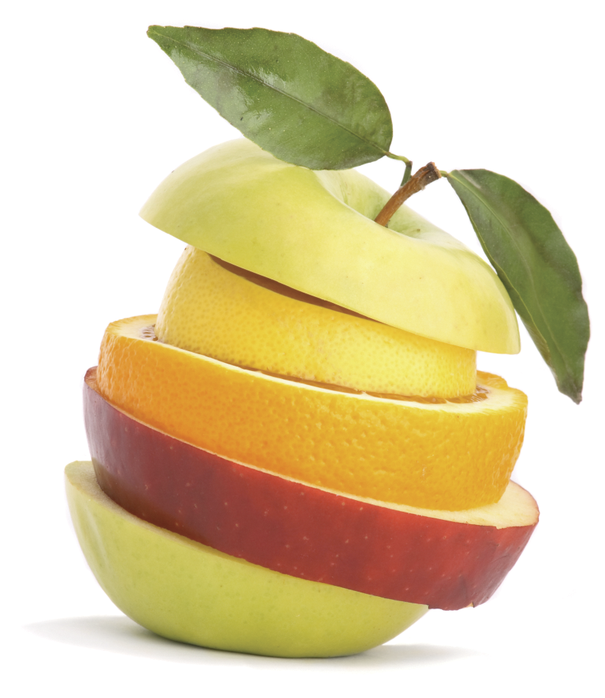

Now YOU Can Provide Better “Fuel” For Those You Depend On Most!

Tired & Unproductive
Employees Are No
Longer An Issue!
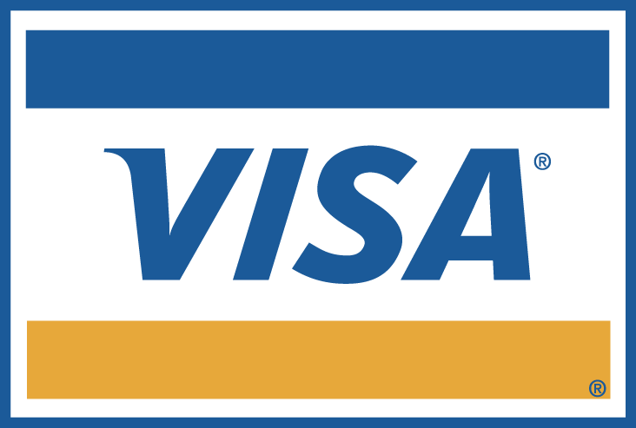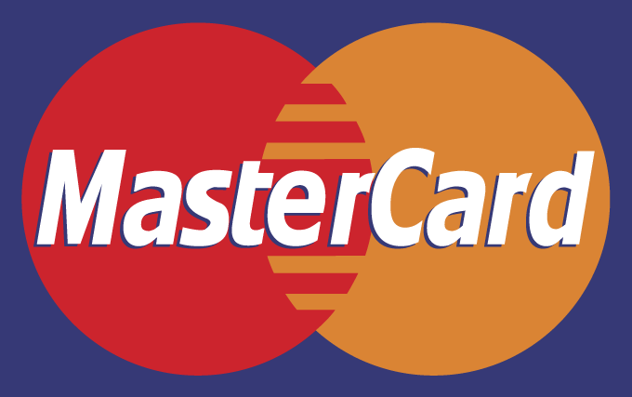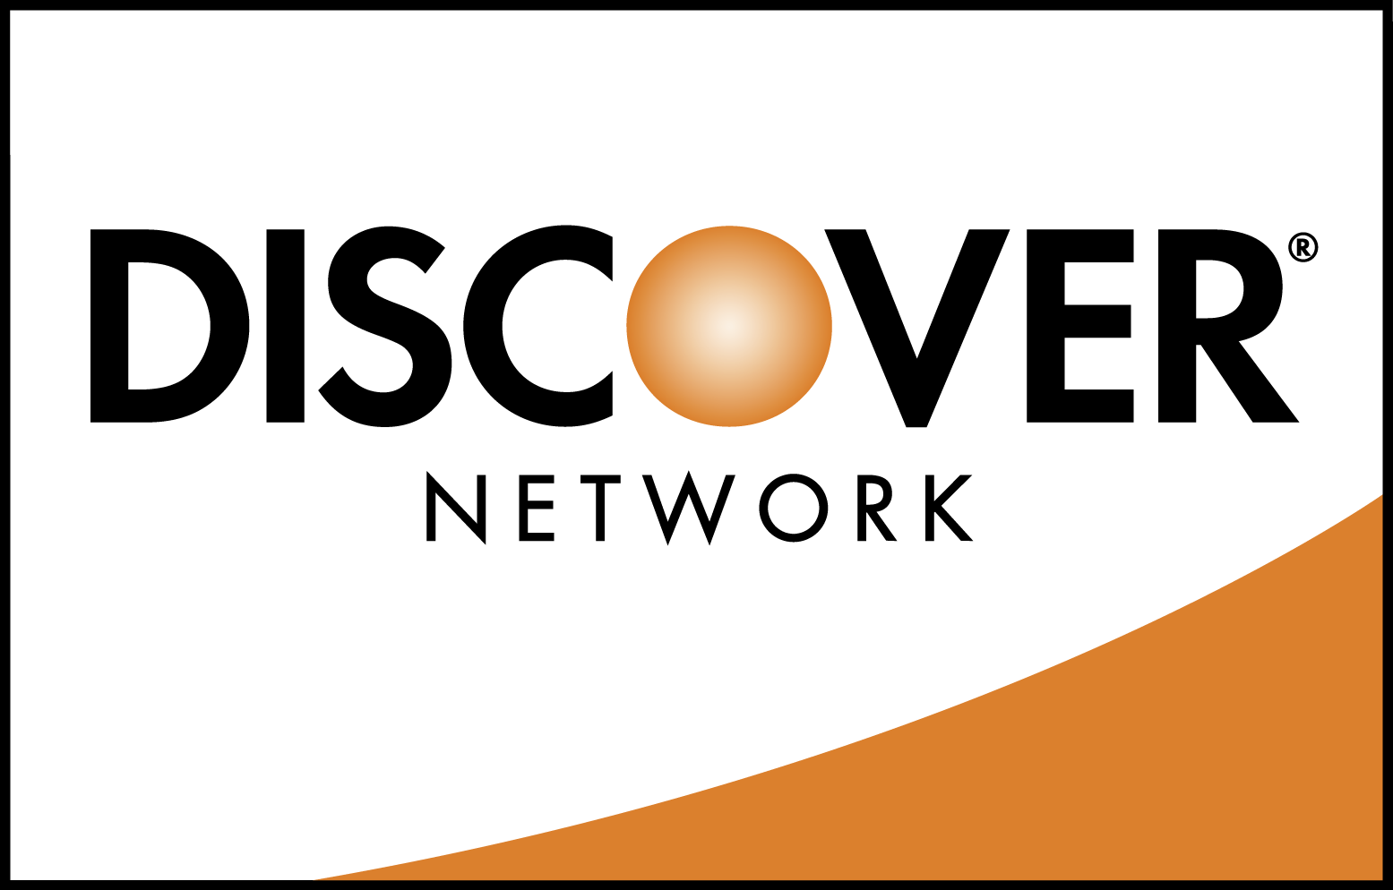
Machine accepts all major credit cards

Finally... Healthy Options For Employees
And Customers!

Now You Can Provide
High-Demand, Name-Brand Healthy Products That Everyone Will Appreciate!
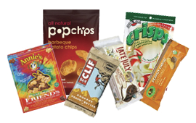
Healthy Snacks
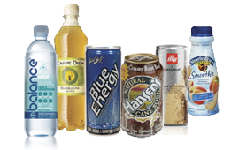
Healthy Drinks

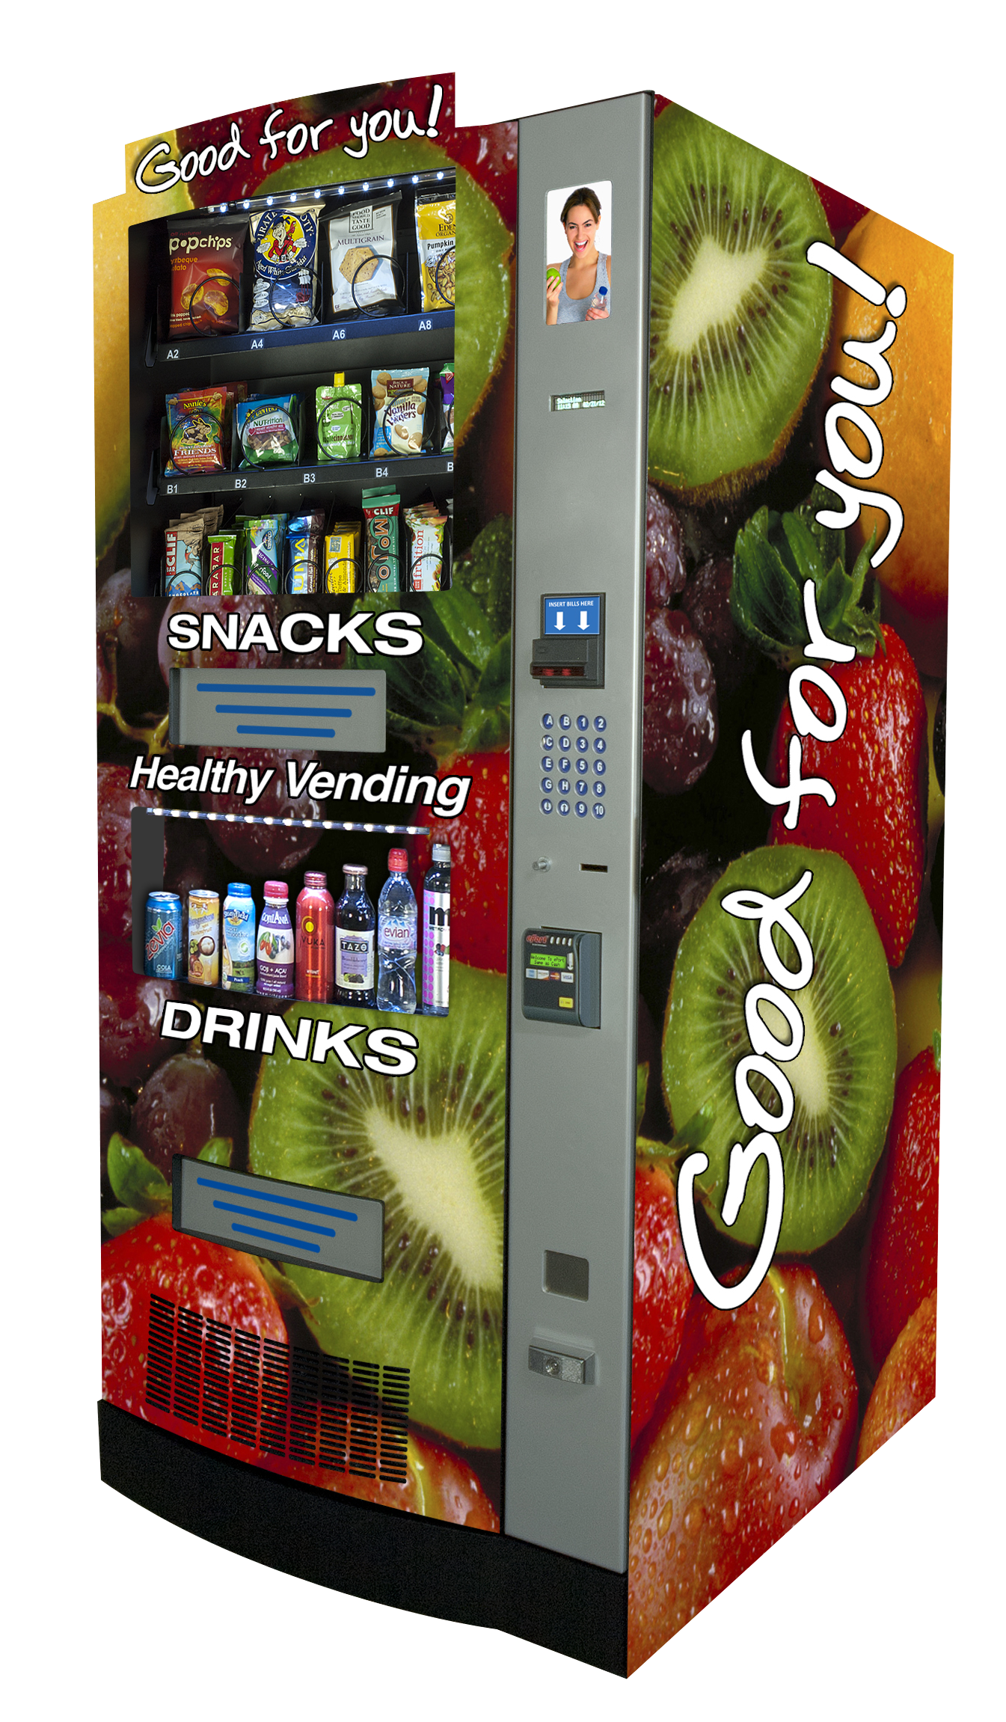
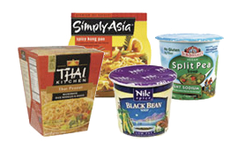
Healthy Entrées & Side Dishes
(with Entrée/Side Dish Vendor)

Benefit from the many advantages...

- Keep Hungry Employees On-Site By
“Dining At Their Desk”
- Promote Healthier Lifestyles & Eating Habits
in the Workplace
- Improve Company Morale by Providing Healthy Products That Are Easily
Accessible & Affordable To Everyone
High-Capacity Product Centers Holds Up To 337 Products!
Credit/Debit Card Capability For Ease & Convenience!
Remote Machine Monitoring Ensures Timely Service!
LED Illuminated Product Windows Well Lit During The Evening!
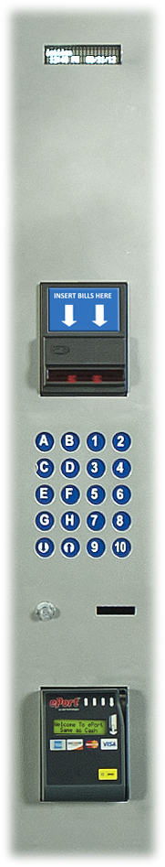
CFC Free Modular Cooling System Environmentally Safe; Electrically Efficient!

Fully Electronic
Payment/Media Console!!

- Credit/Debit Card Reader
- $1, $5, $10 & $20 bill acceptor/stacker
- Coin co coin changer
- Pricing from .05¢ to $99.95
- Easy-touch 20-button keypad
- Individual electronic pricing for each selection
- Computerized cash, vend & sales record
- Customer-friendly LCD display

Vending System
Specifications
Height 72" Depth 30"
Width 36" Weight 590 lbs.
Selections Healthy Snacks- 21;
Healthy Drinks- 8;
Voltage 110-120VAC | 60 Hz - 4.5A

Specifications subject to change without notice

