Sustainable Grazing
Happier Cows = Healthier Milk and Cleaner Streams
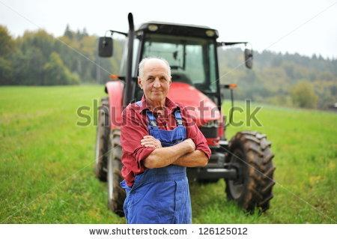

Who We Are
Carlisle Dairy Farm is a third generation dairy farm located on 64 acres in the Cumberland Valley. We raise holsteins to produce milk and also raise hens for eggs. We sell much of our milk, as well as cheese, yogurt and baked goods directly from the farm.

What Have We Done
At Carlisle Dairy Farm, we take care of our animals and our animals help us take care of the land. Corn and other grains are not a natural part of a cows’ diet, so we don’t feed them that. Instead, we let them roam the pastures eating grass and other plants. We move the cows from pasture to pasture on a thoughtful schedule to prevent overgrazing, and this reduces soil erosion and water pollution. Our animals are happier and our land and water is healthier.

When and Where We Did It
In 2010, we had our cows in a stall barn and corn or soybeans in our fields. We looked into switching some of our acreage from crops to pasture and soon realized that it would beneficial to our cows and our soil. We then installed fencing to divide the fields into smaller paddocks and in spring 2011, we planted a seed mixture containing plants that provide the nutrition our cows need and that provides support for the soil.
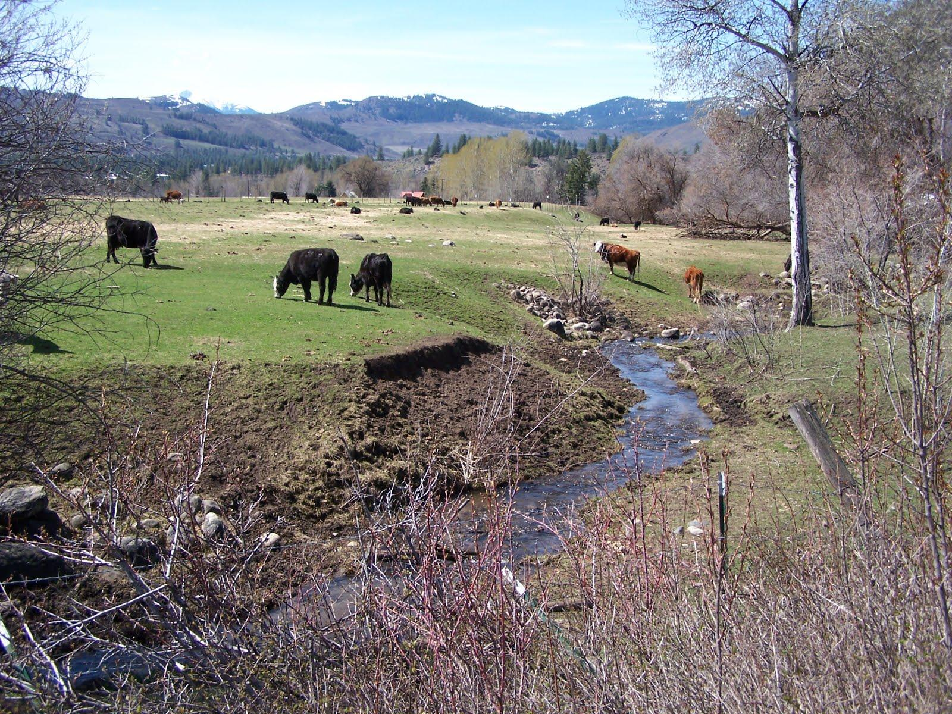 | 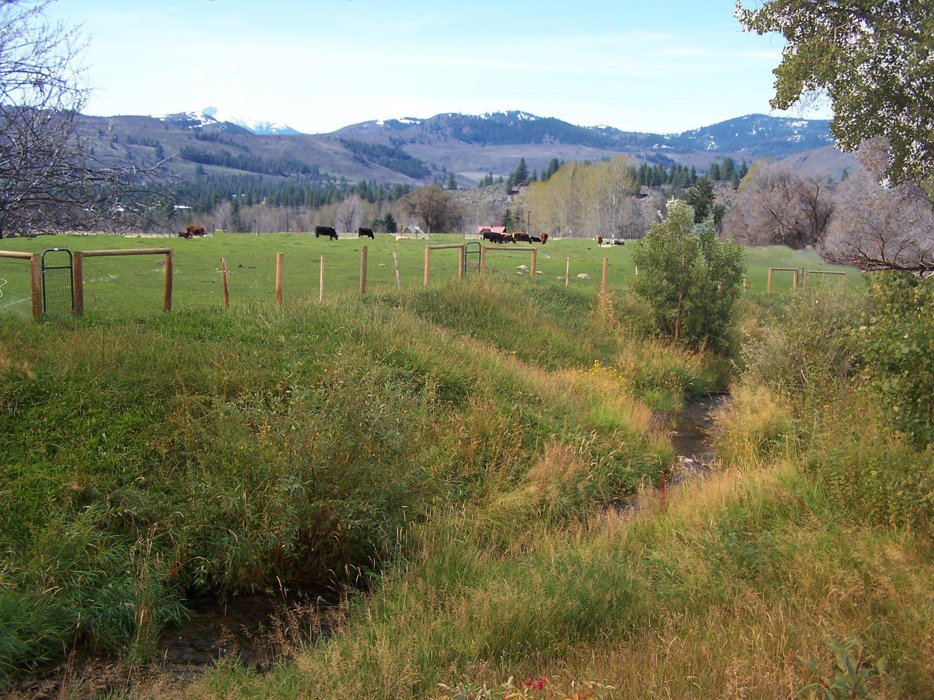
“Before” | “After”

Why You Should Care
At Carlisle Dairy Farm, we believe that the care of land and water contributes to the care and safety of your family. When you buy from Carlisle Dairy Farm, you are helping us to do our part to make clean, healthy food available to you without harm to the environment.
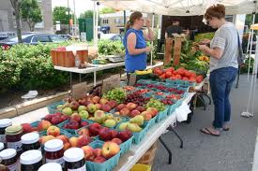 | 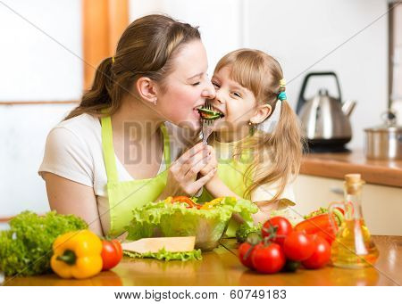
Fresh and locally produced food from our farm tastes better, and it’s better for our local economy and environment. | Fresh food is healthier for kids of all ages than processed food.
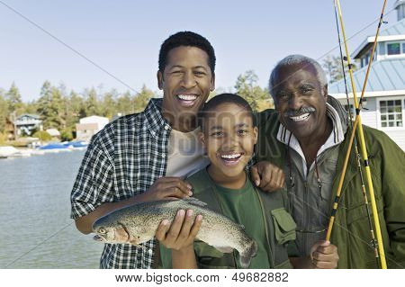 | 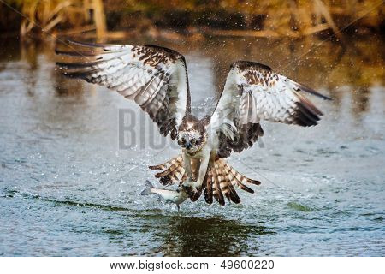
As a result of the improvements described here, the waterways that run through our farm are cleaner, benefitting everyone downstream. | Our wildlife neighbors appreciate the cleaner waterways even more than you do!

