FRONT VIEW:

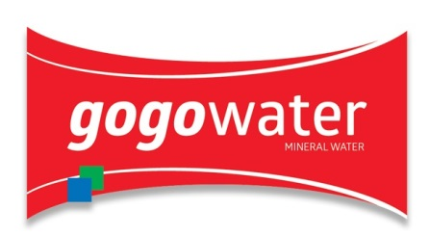

FEEDBACK:
- Add 500 ML to the bottom of the front view
- Remove CA and MG from the front view
- Remove “CALCIUM & MINERAL” portion
- Change tagline from “MINERAL WATER ON-THER-GO to NATURAL MINERAL WATER ON-THE-GO

500 ML
BACK VIEW:

Gogowater : Natural Mineral Water-On-The-Go

Best Before:  3 Months After MFG  Store In A Cool Dry Place  Away From Direct Sunlight  Produced under hygienic conditions. | Produced in Ghana By GOGO Beverages Ltd  P. O. Box SK 984  Tema  Location:  Akotoshie - Medie  Medie – Adjen Kotoku Road  Accra, Ghana  Phone: 0269394993 | 0546638665  info@gogowaterghana.com  www.gogowaterghana.com

